Cardiff, Wales, United Kingdom
Wales's compact, walkable capital packs a Roman fort, a fairy-tale Victorian castle, and a buzzing waterfront into one very manageable shore day.
⚓ Docked — Queen Alexandra Dock · 🕒 Typical call: 8-10 hrs · 💷 Currency: British Pound (GBP) · 🗣️ Language: English (Welsh spoken)
✍️ MY DAY IN PORT (FILL IN)
Ship / Date
In port | arrive ______ · all aboard ______
Booked excursion
Notes / meeting point
GETTING ASHORE
- Docking: Queen Alexandra Dock, Cardiff Bay — ~1 mile (1.4 km) from city centre
- Walk to centre: 20-25 min on foot; free port shuttle usually provided
- Best For: History, architecture, Welsh culture, easy walkability
- Don't Miss: Cardiff Castle's opulent Victorian apartments and St. Fagans open-air museum
GETTING AROUND
- 🚕 Taxi: ~£7–10 — The port is under a mile from the city center; a taxi ride is quick and affordable. All Cardiff taxis are required to ac
- 📱 Rideshare: ✅ Uber, Bolt
- 🚌 Hop-on hop-off: ✅ City Sightseeing Cardiff
TOP THINGS TO DO
- Cardiff Castle & Victorian Apartments — Cardiff Castle sits at the heart of the city, blending Roman walls, a Norman keep, and extravagant Victorian Gothic interiors…
- St. Fagans National Museum of History — One of Europe's finest open-air museums, St.
- Cardiff Bay Waterfront Walk — The revitalised bay area is just steps from the ship.
- Caerphilly Castle Day Trip — Just 8 miles north of Cardiff, Caerphilly is the largest castle in Wales — famous for its dramatic moat, water defences, and a…
- National Museum Cardiff — Free entry to Wales's national collection of art (Impressionist paintings, Welsh artists), archaeology, and natural history.
BEST WALKS
- Bay to Castle City Walk: 3.5 miles • 1.5-2 hrs • Flat & easy — Walk the full story of Cardiff from the waterfront to the medieval heart of the city, taking in the…
- Arcades & Market Stroll: 1 mile • 45 min • Flat — Weave through Cardiff's beautiful Victorian and Edwardian shopping arcades, finishing at the indoor…
WEATHER · DAYLIGHT · MONEY
Month | High °F | Low °F | Rainy days
May | 61 | 47 | 12
Jul | 69 | 56 | 14
Sep | 65 | 53 | 12
Daylight: May 5:21AM–8:58PM · Jul 5:13AM–9:22PM · Sep 6:48AM–7:26PM
cruiseports.org/cardiff · Confirm terminal & all-aboard time with your ship

Cardiff, Wales, United Kingdom — Port Map
Red = walkable sights · Amber = excursions farther out · P = cruise terminal
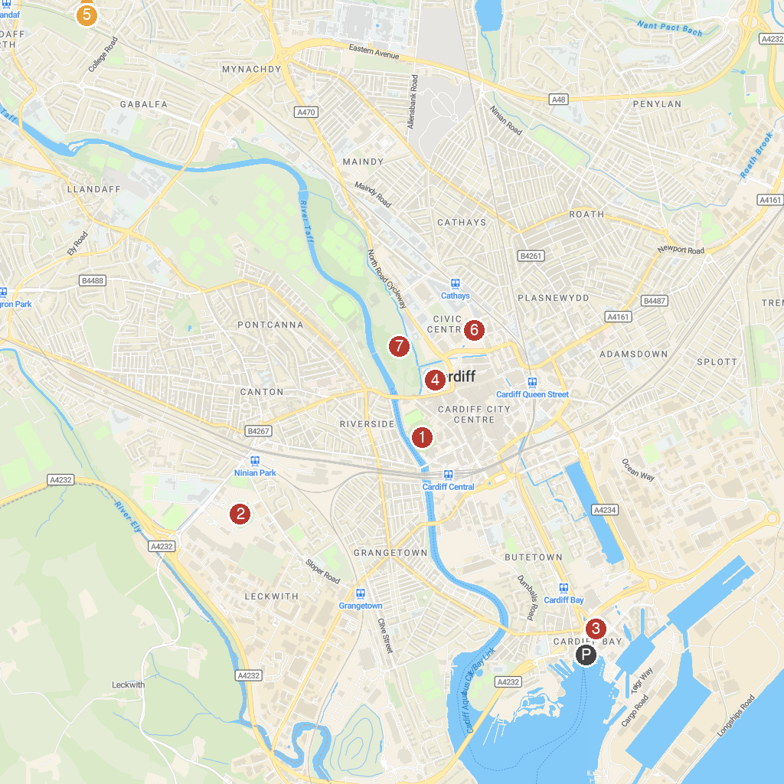
MAP KEY
1. Barry Castle | 5. Cardiff Castle
2. Principality Stadium | 6. Caerphilly Castle
3. Cardiff City Stadium | 7. National Museum Cardiff
4. Wales Millennium Centre | 8. Bute Park
P. Cruise port / terminal
Map © MapTiler © OpenStreetMap contributors · cruiseports.org

