Mindelo, São Vicente, Cape Verde
Where West Africa meets Portugal — Mindelo is a sun-bleached port city famous for morna, the soulful music of Cesária Évora, pastel colonial streetscapes, and one of the Atlantic's most scenic natural harbors.
⚓ Docked (Porto Grande) · 🕒 Typical call: 7-9 hrs · 💶 Cape Verdean Escudo (EUR widely accepted) · 🗣️ Portuguese & Cape Verdean Creole
✍️ MY DAY IN PORT (FILL IN)
Ship / Date
In port | arrive ______ · all aboard ______
Booked excursion
Notes / meeting point
GETTING ASHORE
- Docking: Porto Grande pier, 1 km walk to city center
- Walk to Center: ~10–15 min on foot; taxis at port gate
- Best For: Culture, music, beaches, island hiking
- Don't Miss: Live morna at a Mindelo bar or café
GETTING AROUND
- 🚕 Taxi: €1.50–€5 (150–500 CVE) to city center — Taxis wait outside the terminal gate. There are no meters — negotiate the fare before you get in. Euros are widely accep
- 📱 Rideshare: ❌ not available
TOP THINGS TO DO
- Mindelo City & Morna Music Walk — Explore the Palácio do Povo, Mercado Municipal, and the Torre de Belém harbor replica.
- Monte Verde Summit — São Vicente's highest peak (750 m) rewards with panoramic views of Mindelo harbor and, on clear days, the green ridges of Santo…
- Day Trip to Santo Antão — A 1-hour ferry from Mindelo drops you on one of the Atlantic's most dramatic islands — steep ribeiras (valleys), terraced farms…
- Baía das Gatas & Salamansa Beaches — A 20-minute taxi ride to the natural lagoon beach at Baía das Gatas or the windsurf-friendly sands at Salamansa.
- Sea Turtle Snorkeling at São Pedro — The sheltered waters around São Pedro (southwest coast of São Vicente, near the airport) host green sea turtles, often drawn…
BEST WALKS
- Porto Grande to City Center: 1 km · 10–15 min · flat waterfront — Follow Av.
- City Center to Praia da Laginha: 1.5 km · 20 min · flat coastal path — From Praça Amilcar Cabral head north along the waterfront to Mindelo's popular city beach.
WEATHER · DAYLIGHT · MONEY
Month | High °F | Low °F | Rainy days
May | 77 | 70 | 0
Jul | 81 | 73 | 1
Sep | 84 | 77 | 6
Daylight: May 6:08AM–7:03PM · Jul 6:14AM–7:16PM · Sep 6:28AM–6:41PM
cruiseports.org/cape-verde-islands · Confirm terminal & all-aboard time with your ship

Mindelo, São Vicente, Cape Verde — Port Map
Red = walkable sights · Amber = excursions farther out · P = cruise terminal
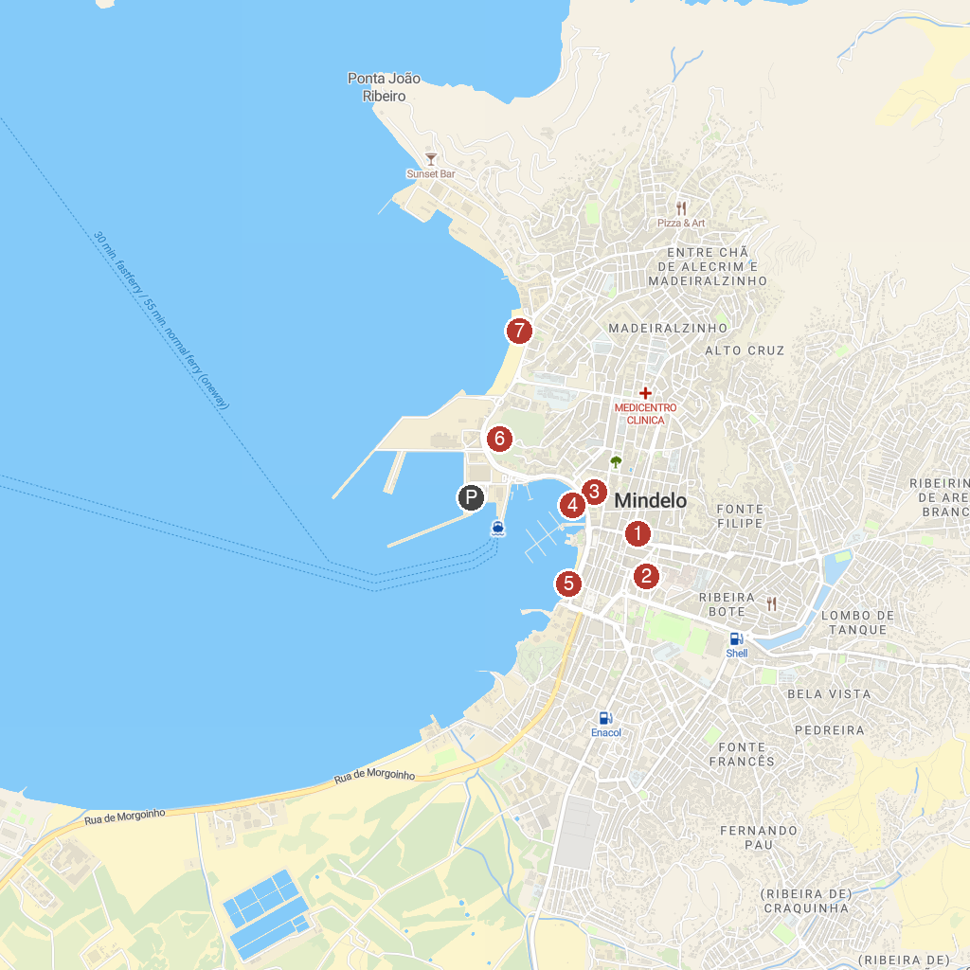
MAP KEY
1. People's Palace | 5. Belem Tower Replica | Museum of the Sea
2. Núcleo Museológico Cesária Évora | 6. Fortim do Rei
3. Zoom Zoom Mindelo | 7. Laginha Beach
4. Mansa Floating Hub
P. Cruise port / terminal
Map © MapTiler © OpenStreetMap contributors · cruiseports.org

