Cape Town, Western Cape, South Africa
Framed by the flat-topped silhouette of Table Mountain and fronted by one of the world's most beautiful natural harbours, Cape Town delivers bucket-list scenery the moment your ship ties up at the V&A Waterfront.
⚓ Docked — V&A Waterfront · 🕒 Typical call: 8-12 hrs · 💵 South African Rand (ZAR); cards widely accepted · 🗣️ English, Afrikaans, Xhosa
✍️ MY DAY IN PORT (FILL IN)
Ship / Date
In port | arrive ______ · all aboard ______
Booked excursion
Notes / meeting point
GETTING ASHORE
- Docking: Cape Town Cruise Terminal (E-Berth, Duncan Dock) — adjacent to the V&A Waterfront harbour precinct
- Walk to centre: Short walk/shuttle to Waterfront shops & restaurants; 20-min Uber to City Bowl
- Best for: Mountain hikes, wildlife, history, wine tasting
- Don't miss: Table Mountain cable car or hike; Robben Island ferry
GETTING AROUND
- 🚕 Taxi: R80–R200 (~$4–$11) — Metered taxis available at the cruise terminal. Short 15-minute ride to the city center or V&A Waterfront. Agree on fare
- 📱 Rideshare: ✅ Uber, Bolt
- 🚌 Hop-on hop-off: ✅ City Sightseeing Cape Town
TOP THINGS TO DO
- Table Mountain Cable Car — Ride the revolving cable car to the 1,086 m summit for sweeping views over the Cape Peninsula, harbour, and Robben Island.
- Robben Island — Board the ferry from the V&A Waterfront for a guided tour of the island where Nelson Mandela was imprisoned for 18 years.
- Boulders Beach African Penguins — Drive 45 minutes to Simon's Town to walk among a colony of African penguins on a sheltered beach.
- Cape Point & Cape of Good Hope — Journey to the dramatic tip of the Cape Peninsula — sheer cliffs, wild ocean, and the famous Cape Point lighthouse.
- Cape Winelands — Stellenbosch & Franschhoek — Head 40 minutes inland to the Cape Winelands for estate tastings, award-winning restaurants, and mountain scenery.
BEST WALKS
- V&A Waterfront & Clock Tower Stroll: 1-2 hrs · Easy · Free — Explore the working harbour directly from the terminal.
- Green Point to Sea Point Promenade: 2-3 hrs · Easy · Scenic — Uber or walk to Green Point and follow the paved Sea Point Promenade along the Atlantic Ocean.
WEATHER · DAYLIGHT · MONEY
Month | High °F | Low °F | Rainy days
May | 67 | 54 | 8
Jul | 62 | 49 | 9
Sep | 64 | 52 | 8
Daylight: May 7:31AM–5:53PM · Jul 7:49AM–5:55PM · Sep 6:45AM–6:37PM
cruiseports.org/cape-town · Confirm terminal & all-aboard time with your ship

Cape Town, Western Cape, South Africa — Port Map
Red = walkable sights · Amber = excursions farther out · P = cruise terminal
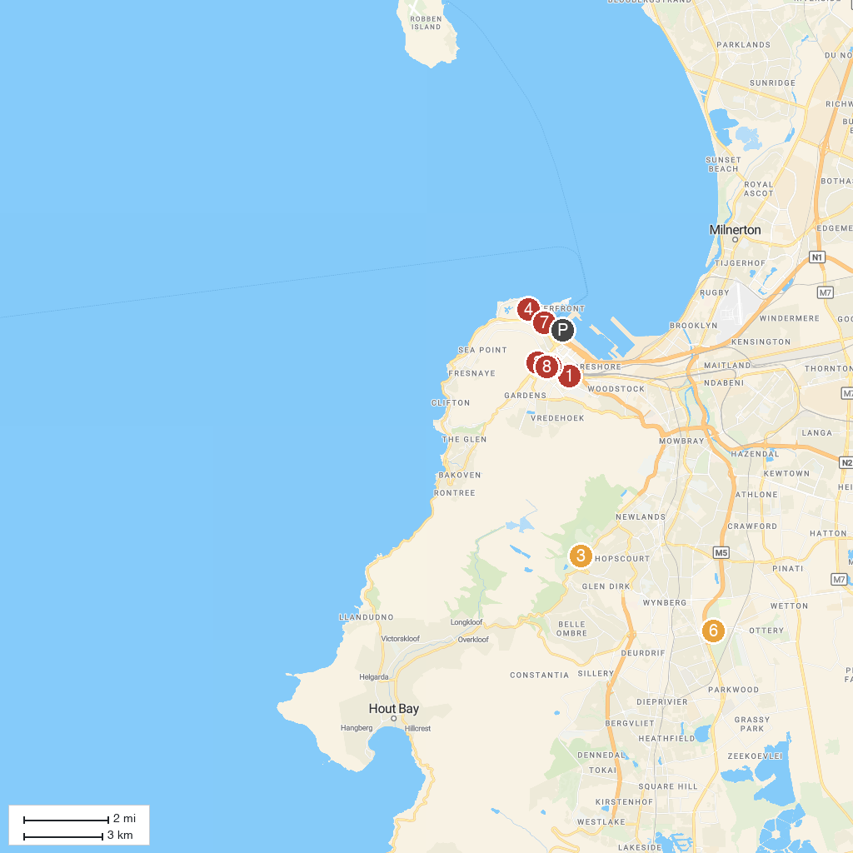
MAP KEY
1. Castle of Good Hope | 5. Greenmarket Square
2. Iziko Bo-Kaap Museum | 6. Royal Cape Golf Club
3. Kirstenbosch National Botanical Garden | 7. Two Oceans Aquarium
4. DHL Stadium | 8. The Cape Gallery
P. Cruise port / terminal
Map © MapTiler © OpenStreetMap contributors · cruiseports.org

