Cape Girardeau, Missouri, USA
A quintessential Mississippi River town where sweeping floodwall murals tell the river's story — and Civil War earthworks, historic mansions, and a walkable downtown are all steps from the dock.
⚓ Docked at Riverfront Park · 🕒 Typical call: 7-10 hrs · 💵 US Dollar · 🗣️ English · 🌊 Mississippi River cruise port
✍️ MY DAY IN PORT (FILL IN)
Ship / Date
In port | arrive ______ · all aboard ______
Booked excursion
Notes / meeting point
GETTING ASHORE
- Docking: Ships tie up directly at Riverfront Park — no tender, walk straight off
- Walk to center: Downtown & floodwall murals are 2-5 min on foot from the dock
- Best For: History buffs, mural lovers, easy walking, American river culture
- Don't Miss: Mississippi River Tales floodwall murals & Fort D Civil War earthworks
GETTING AROUND
- 🚕 Taxi: Varies — Traditional taxis are available in Cape Girardeau. Contact local companies directly for rates; rideshare apps typically
- 📱 Rideshare: ✅ Uber, Lyft
TOP THINGS TO DO
- Mississippi River Tales Floodwall Murals — Walk along the iconic painted floodwall — a series of large-scale murals depicting the Mississippi's history from Lewis & Clark…
- Fort D Civil War Historic Site — One of four Union earthwork fortifications built in 1861 to defend Cape Girardeau, Fort D is well-preserved and free to visit.
- Glenn House Victorian Mansion — A beautifully preserved 1883 Victorian home open for guided tours.
- Trail of Tears State Park — About a 20-minute drive north of port, this state park commemorates the forced relocation of the Cherokee Nation in 1838-39…
- Red House Interpretive Center & Downtown Walk — A faithful replica of city founder Louis Lorimier's 1797 home and trading post, where Meriwether Lewis met Lorimier during the…
BEST WALKS
- Riverfront & Floodwall Murals Walk: 1.5 miles · Easy · 45-60 min — Start at Riverfront Park where your ship docks, then walk south along the Mississippi River Tales…
- Historic Homes & Museums Loop: 1 mile · Easy · 1-2 hrs — From the pier, walk to the Red House Interpretive Center, then on to the Glenn House Victorian…
WEATHER · DAYLIGHT · MONEY
Month | High °F | Low °F | Rainy days
May | 77 | 59 | 13
Jul | 88 | 72 | 11
Sep | 82 | 65 | 6
Daylight: May 5:49AM–8:00PM · Jul 5:49AM–8:17PM · Sep 6:40AM–7:05PM
cruiseports.org/cape-girardeau-mo · Confirm terminal & all-aboard time with your ship

Cape Girardeau, Missouri, USA — Port Map
Red = walkable sights · Amber = excursions farther out · P = cruise terminal
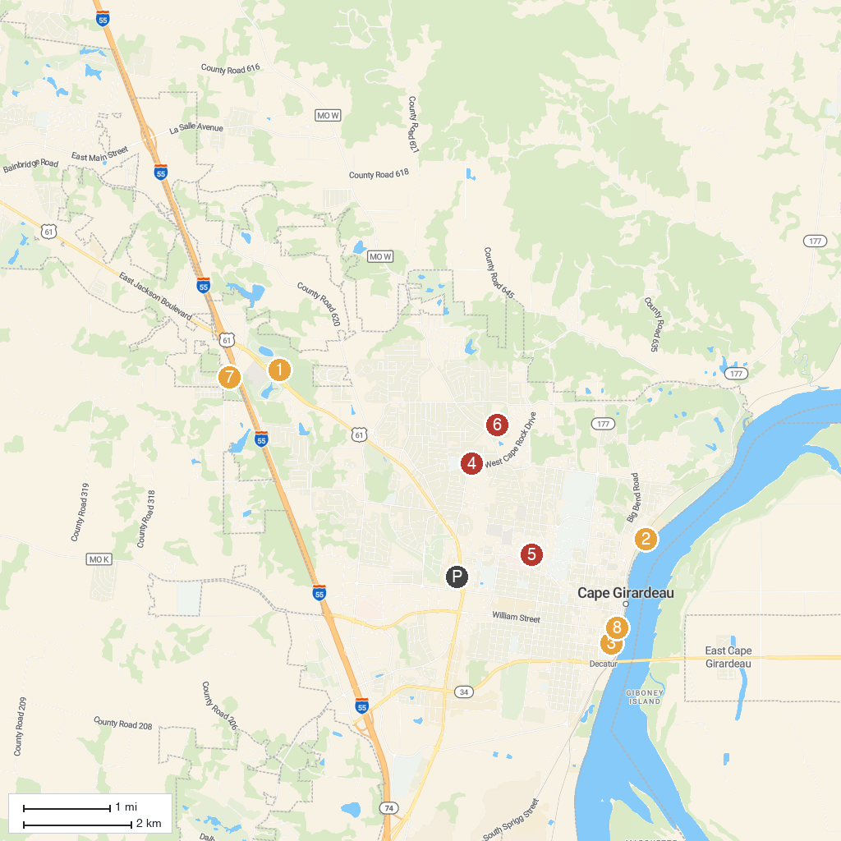
MAP KEY
1. Cape Girardeau Conservation Nature Center | 5. Capaha Park
2. Red Star Access | 6. Kiwanis Park
3. The Glenn House | 7. Klaus Park
4. Dennis Scivally Park | 8. Old St Vincent's Catholic Church
P. Cruise port / terminal
Map © MapTiler © OpenStreetMap contributors · cruiseports.org

