Cannes, Alpes-Maritimes, France
Synonymous with glamour and sunshine, Cannes delivers the full Riviera experience — a sweeping beachside promenade, a charming hilltop old town, and ferries to two pine-forested islands just offshore.
⚓ Tender port (most ships) · 🕒 Typical call: 8-10 hrs · 💶 Currency: Euro · 🗣️ Language: French · 🎬 French Riviera
✍️ MY DAY IN PORT (FILL IN)
Ship / Date
In port | arrive ______ · all aboard ______
Booked excursion
Notes / meeting point
GETTING ASHORE
- Docking: Most cruise ships anchor offshore and tender to the Vieux Port; smaller vessels may berth at the Port de Cannes quays
- Walk to center: Tender dock puts you directly in the Vieux Port — La Croisette is a 5-min walk
- Best For: Riviera beaches, luxury shopping, the Lérins Islands, and the Palais des Festivals
- Don't Miss: Ferry to Île Sainte-Marguerite and a stroll along La Croisette
GETTING AROUND
- 🚕 Taxi: €10–€23 — Taxis are available at the port; the city center is roughly €10–€23 depending on exact destination, with a journey time
- 📱 Rideshare: ✅ Uber, Bolt
TOP THINGS TO DO
- La Croisette & the Palais des Festivals — Walk the famous palm-lined Boulevard de la Croisette past luxury hotels and boutiques to the Palais des Festivals et des Congrès…
- Lérins Islands — Île Sainte-Marguerite — A 15-minute ferry from the Vieux Port takes you to this car-free island cloaked in eucalyptus and pine.
- Le Suquet — the Old Town — Climb the narrow lanes of the hilltop Quartier du Suquet for panoramic views over the bay.
- Antibes & Juan-les-Pins by Train — Hop the 10-minute train to Antibes to explore the medieval old town, the Picasso Museum housed in Château Grimaldi, and the…
- Riviera Beach Day — Cannes has several public sandy beaches along La Croisette and near the Vieux Port (Plage du Midi, Plage de la Bocca).
BEST WALKS
- La Croisette Promenade Walk: 3 km | 45-60 min | Flat & easy — From the Vieux Port, walk east along Boulevard de la Croisette past the Palais des Festivals, grand…
- Le Suquet Hilltop Loop: 1.5 km | 45 min | Steep lanes — From the port, duck into the Quartier du Suquet via Rue Saint-Antoine, winding up past café…
WEATHER · DAYLIGHT · MONEY
Month | High °F | Low °F | Rainy days
May | 70 | 57 | 8
Jul | 84 | 70 | 3
Sep | 78 | 64 | 6
Daylight: May 6:07AM–8:49PM · Jul 6:04AM–9:10PM · Sep 7:11AM–7:41PM
cruiseports.org/cannes · Confirm terminal & all-aboard time with your ship

Cannes, Alpes-Maritimes, France — Port Map
Red = walkable sights · Amber = excursions farther out · P = cruise terminal
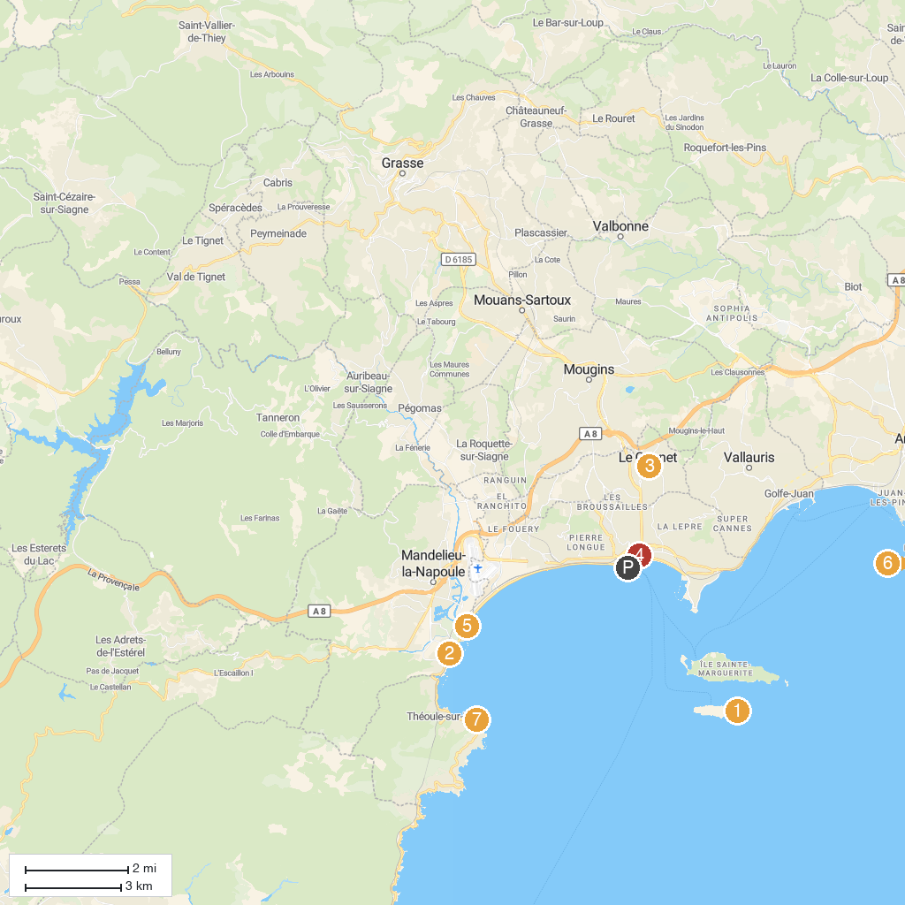
MAP KEY
1. Chapelle de la Trinité de Cannes | 5. Petit Train de Cannes
2. Château de La Napoule - La Napoule Art Foundation | 6. Mandelieu Fun Sport
3. Musée International de la Parfumerie (MIP) | 7. Posidonia - Espace Mer et Littoral
4. Musée Bonnard | 8. Départemental de la Pointe de l'Aiguille Natural Park
P. Cruise port / terminal
Map © MapTiler © OpenStreetMap contributors · cruiseports.org

