Cancun, Quintana Roo, Mexico
Gateway to the Riviera Maya, Cancun delivers ancient Mayan wonders, jade-green cenotes, and a postcard-perfect Caribbean coastline — all within reach of a single shore day.
⚓ Docked at Puerto Morelos pier · 🕒 Typical call: 8–10 hrs · 💵 Mexican Pesos (USD widely accepted) · 🗣️ Spanish (English common in tourist zones)
✍️ MY DAY IN PORT (FILL IN)
Ship / Date
In port | arrive ______ · all aboard ______
Booked excursion
Notes / meeting point
GETTING ASHORE
- Docking: Most large ships dock at Puerto Morelos, ~36 km south of Cancun's Hotel Zone
- To Hotel Zone: ~40 min by taxi or shuttle from Puerto Morelos pier
- Best For: Mayan ruins, cenote swimming, Isla Mujeres, Caribbean beaches
- Don't Miss: Chichen Itza pyramid, snorkeling MUSA underwater museum, Isla Mujeres ferry
GETTING AROUND
- 🚕 Taxi: $25–40 USD — Most cruise ships dock at Puerto Morelos, about 40 minutes from Cancun city center. Taxis have fixed rates — agree on th
- 📱 Rideshare: ✅ Uber, DiDi, inDrive
- 🚌 Hop-on hop-off: ✅ Turibus
TOP THINGS TO DO
- Chichen Itza — New Wonder of the World — UNESCO-listed and one of the most iconic Mayan sites on Earth.
- Tulum Ruins & Riviera Maya — Compact Mayan clifftop ruins overlooking turquoise Caribbean water — one of the most photographed sites in Mexico.
- Cenote Swimming & Snorkeling — The Yucatán Peninsula is riddled with freshwater sinkholes.
- Isla Mujeres Day Trip — Tiny car-free island just 13 km offshore with the best snorkeling in the bay, Playa Norte (one of Mexico's finest beaches), and…
- MUSA Underwater Museum — Over 500 life-size sculptures submerged 4–9 m off Cancun's coast, forming an artificial reef.
BEST WALKS
- Hotel Zone Beachfront Stroll: 3–4 km · Easy · Beaches & lagoon views — Walk Blvd.
- Downtown Cancun Market Walk: 1–2 km · Easy · Local food & souvenirs — Start at Mercado 28 for bargain-priced souvenirs and traditional Mexican food stalls, then walk to…
WEATHER · DAYLIGHT · MONEY
Month | High °F | Low °F | Rainy days
May | 85 | 77 | 16
Jul | 87 | 79 | 14
Sep | 86 | 78 | 22
Daylight: May 6:09AM–7:18PM · Jul 6:14AM–7:31PM · Sep 6:34AM–6:49PM
cruiseports.org/cancun · Confirm terminal & all-aboard time with your ship

Cancun, Quintana Roo, Mexico — Port Map
Red = walkable sights · Amber = excursions farther out · P = cruise terminal
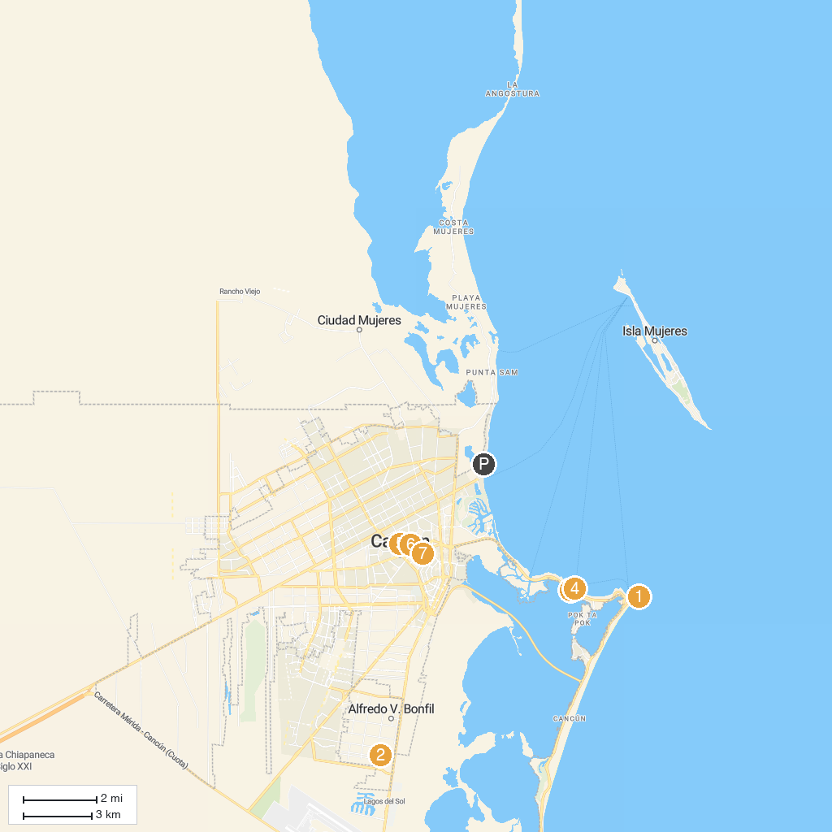
MAP KEY
1. Delphinus Punta Cancún | 5. Experiencias Cancun
2. EcoColors Tours | 6. Catedral de Cancún (La Santa Cruz y de la Santísima Trinidad)
3. Museo Maya de Cancún y Zona Arqueológica de San Miguelito | 7. Holy Family Parish Cancun
4. Columbus Romantic Dinner Cancun | 8. Planetario De Cancún Ka´Yok´
P. Cruise port / terminal
Map © MapTiler © OpenStreetMap contributors · cruiseports.org

