Camden, Maine, USA
A quintessential New England harbor town where historic windjammers crowd a compact, walkable waterfront. Camden pairs lobster shacks and indie boutiques with easy hiking above the bay.
⚓ Tender port · 🕒 Typical call: 6-8 hrs · 💵 USD · 🗣️ English · 🦞 Lobster country
✍️ MY DAY IN PORT (FILL IN)
Ship / Date
In port | arrive ______ · all aboard ______
Booked excursion
Notes / meeting point
GETTING ASHORE
- Docking: Tender — ships anchor in Penobscot Bay; tenders land at Camden Public Landing
- Walk to center: Immediate — town begins steps from the Public Landing
- Best For: Schooner sails, lobster boat tours, Camden Hills State Park hikes
- Don't Miss: A 2-hour windjammer sail out of Camden Harbor
GETTING AROUND
- 🚕 Taxi: – (minimum fare) — Several local cabs serve the area including Schooner Bay Taxi (207-594-5000), Wollfie's Wheels (207-975-1456), and Joe's
- 📱 Rideshare: ✅ Uber, Lyft
TOP THINGS TO DO
- Windjammer Sail on Penobscot Bay — Board one of Camden's historic two-masted schooners for a 2-hour day sail across Penobscot Bay.
- Lobster Boat & Lighthouse Cruise — Ride a working lobster boat out to haul traps, learn the gear, and cruise past Curtis Island Light and Rockland Breakwater Light.
- Camden Hills State Park Hike — A short drive (about 2 miles north on US Route 1) brings you to Camden Hills State Park.
- Downtown Camden Walk & Shops — Camden's compact Main Street is packed with independent boutiques, art galleries, the historic Camden Opera House, and the…
- Sea Kayaking Penobscot Bay — Paddle rentals and guided kayak tours depart from the harbor area.
BEST WALKS
- Harbor Park to Downtown Loop: 0.5 miles · Easy · 30 min — From the Public Landing, walk along the harbor past the schooner fleet, through Harbor Park, and up…
- Mount Battie Trail, Camden Hills State Park: ~1 mile round-trip · Moderate (steep) · 1.5-2 hrs — Most visitors taxi the ~2 miles north on US Route 1 to the park entrance.
WEATHER · DAYLIGHT · MONEY
Month | High °F | Low °F | Rainy days
May | 73 | 54 | 12
Jul | 87 | 70 | 14
Sep | 79 | 62 | 10
Daylight: May 5:45AM–8:08PM · Jul 5:45AM–8:27PM · Sep 6:42AM–7:08PM
cruiseports.org/camden-me · Confirm terminal & all-aboard time with your ship

Camden, Maine, USA — Port Map
Red = walkable sights · Amber = excursions farther out · P = cruise terminal
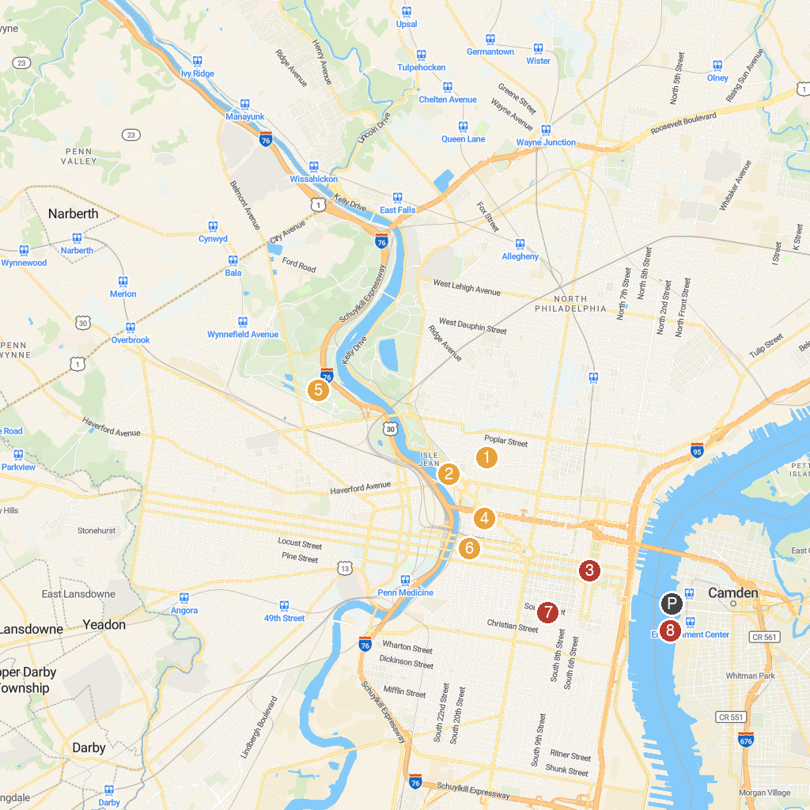
MAP KEY
1. Eastern State Penitentiary | 5. Please Touch Museum
2. Philadelphia Museum of Art | 6. The Mütter Museum at The College of Physicians of Philadelphia
3. Liberty Bell | 7. Philadelphia's Magic Gardens
4. The Franklin Institute | 8. Battleship New Jersey Museum & Memorial
P. Cruise port / terminal
Map © MapTiler © OpenStreetMap contributors · cruiseports.org

