Camaret-sur-Mer, Brittany, France
A quiet Breton fishing village punching well above its size — a UNESCO-listed Vauban fortress, Neolithic megaliths, and sea-battered cliffs at Pen-Hir all within an easy walk or short drive.
⚓ Tender (anchor & tender ashore) · 🕒 Typical call: 6–8 hrs · 💶 Currency: Euro (EUR) · 🗣️ Language: French
✍️ MY DAY IN PORT (FILL IN)
Ship / Date
In port | arrive ______ · all aboard ______
Booked excursion
Notes / meeting point
GETTING ASHORE
- Docking: Tender port — ships anchor in the bay; tender boats land at the Notic basin quay in the town centre
- Walk to centre: 2 min from tender landing to harbour promenade
- Best For: History buffs, coastal walkers, seafood lovers
- Don't Miss: Tour Vauban (UNESCO), Alignements de Lagatjar, Pointe de Pen-Hir
GETTING AROUND
- 🚕 Taxi: €5–€10 — Local taxis have a €2.20 pick-up fee plus per-km charges. A short hop from dock to town center is typically €5–€10.
- 📱 Rideshare: ✅ Uber
TOP THINGS TO DO
- Tour Vauban — UNESCO Fortress — The ochre-hued polygonal tower built 1693–1696 is one of only 12 Vauban fortifications inscribed as UNESCO World Heritage.
- Pointe de Pen-Hir & Tas de Pois — Dramatic granite headland with 70-metre cliffs plunging into the Atlantic.
- Alignements de Lagatjar Megaliths — Over 65 Neolithic menhirs (erected around 2500 BC) arranged in parallel rows just outside town — some standing up to 3 metres tall.
- Crozon Peninsula Coastal Boat Trip — Sea excursions from the harbour take you through marine caves, past natural arches, and around the wild Crozon coastline.
- Harbour Promenade & Boat Graveyard — Stroll the colourful quayside lined with seafood restaurants and art galleries, then visit the haunting 'cimetière marin' — a…
BEST WALKS
- Harbour to Alignements de Lagatjar: 2 km round-trip · 45 min · Easy · Flat — From the tender quay, walk south along the shore path past the Notre-Dame chapel and the boat…
- GR34 to Fort du Petit Gouin Viewpoint: 3 km round-trip · 1 hr · Easy–moderate · Some steps — Head north along the GR34 coastal trail from the harbour to the Fort du Petit Gouin headland for…
WEATHER · DAYLIGHT · MONEY
Month | High °F | Low °F | Rainy days
May | 61 | 52 | 13
Jul | 68 | 60 | 11
Sep | 66 | 58 | 11
Daylight: May 6:38AM–9:51PM · Jul 6:33AM–10:14PM · Sep 7:55AM–8:30PM
cruiseports.org/camaret-sur-mer · Confirm terminal & all-aboard time with your ship

Camaret-sur-Mer, Brittany, France — Port Map
Red = walkable sights · Amber = excursions farther out · P = cruise terminal
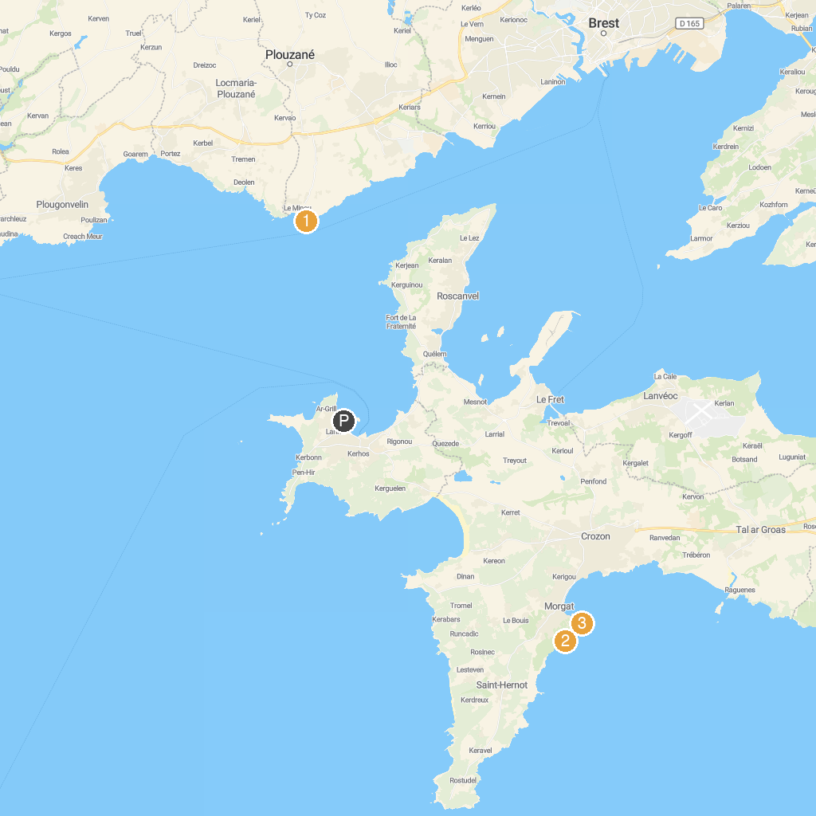
MAP KEY
1. Le Phare du Petit Minou | 5. Maison de la Fontaine
2. Musée National de la Marine | 6. Musée Mémoires 39-45
3. Plage du Bois du Kador | 7. Pont de Recouvrance
4. Fort Kador
P. Cruise port / terminal
Map © MapTiler © OpenStreetMap contributors · cruiseports.org

