Calvi, Corsica, France
Calvi pairs a dramatic Genoese citadel on a clifftop with one of Corsica's finest beaches — and tender drop-off lands you smack in the middle of it all. Most of the port's highlights are an easy stroll from the quay.
⚓ Tender port (anchor in bay) · 🕒 Typical call: 8-10 hrs · 💶 Currency: Euro (EUR) · 🗣️ Language: French / Corsican
✍️ MY DAY IN PORT (FILL IN)
Ship / Date
In port | arrive ______ · all aboard ______
Booked excursion
Notes / meeting point
GETTING ASHORE
- Docking: Tender to Quai Landry, Port de Plaisance — central marina
- Walk to center: 0 min — tenders land in the town center
- Best For: History, beach, Scandola boat trip, Corsican food
- Don't Miss: Calvi Citadel ramparts at sunset; Scandola Nature Reserve cruise
GETTING AROUND
- 🚕 Taxi: €15–€30 — Taxis wait near the marina. Useful for reaching nearby beaches (e.g., Plage de l'Arinella, ~€15–€20 return) or Notre Dam
TOP THINGS TO DO
- Calvi Citadel & Cathedral — Climb the cobblestone ramparts of this 13th-century Genoese fortress for 360° views of bay and mountains.
- Scandola Nature Reserve Boat Trip — UNESCO-listed volcanic cliffs, osprey nests, and turquoise caves accessible only by sea.
- Plage de Calvi Beach Day — Six kilometres of soft white sand backed by a pine forest, within easy walk of the tender quay.
- Notre Dame de la Serra Hike — An uphill trail (roughly 5 km round trip from town) leads to this hilltop chapel overlooking Calvi Bay and the Revellata peninsula.
- Balagne Village Tour — The hinterland villages of Lumio, Pigna, and Sant'Antonino perch on rocky hilltops above olive groves and maquis scrub.
BEST WALKS
- Marina to Citadel Loop: 1.5 km · 30-45 min · moderate uphill — From the tender quay, walk north along Quai Landry, then climb the cobbled Rue Clemenceau up…
- Beach Boardwalk Stroll: 2-4 km · 30-60 min · easy flat — Head east from the marina along the pine-fringed boardwalk skirting Plage de Calvi.
WEATHER · DAYLIGHT · MONEY
Month | High °F | Low °F | Rainy days
May | 70 | 60 | 9
Jul | 84 | 73 | 2
Sep | 78 | 68 | 6
Daylight: May 6:03AM–8:40PM · Jul 6:01AM–9:00PM · Sep 7:05AM–7:34PM
cruiseports.org/calvi · Confirm terminal & all-aboard time with your ship

Calvi, Corsica, France — Port Map
Red = walkable sights · Amber = excursions farther out · P = cruise terminal
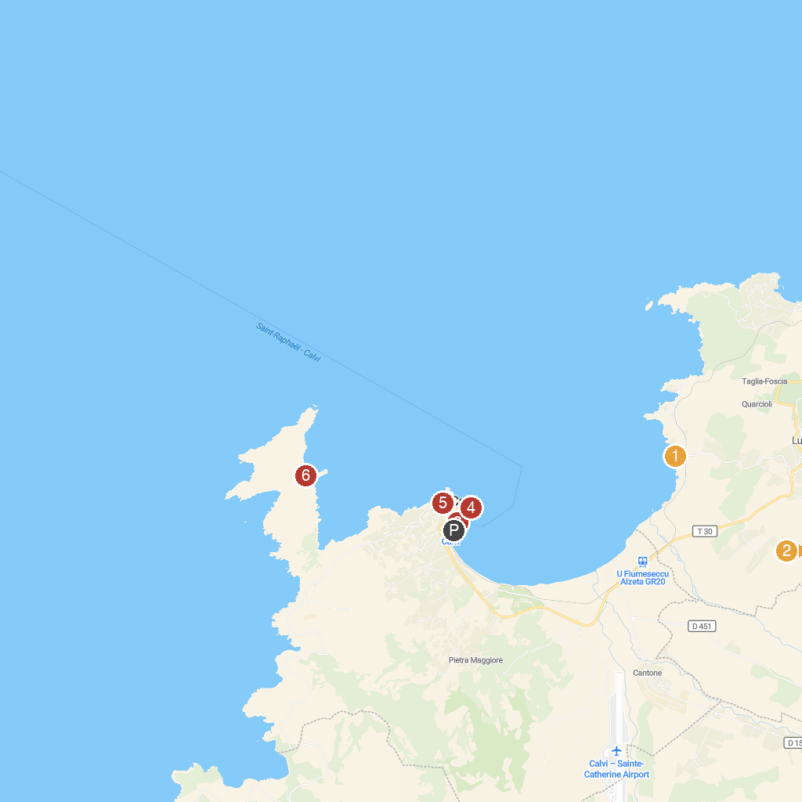
MAP KEY
1. Plage de l'Arinella | 4. Calvi Cathedral
2. Fruitier Botanical Garden | 5. Plage du Roncu
3. CALVI EVASION - Promenades en Mer | 6. Plage Oscelluccia
P. Cruise port / terminal
Map © MapTiler © OpenStreetMap contributors · cruiseports.org

