Calais, Hauts-de-France, France
Gateway to France across the Channel, Calais pairs a dramatic WWII history with Rodin's most famous bronze and a quirky mechanical dragon prowling the seafront. The White Cliffs of Dover are visible on a clear day.
⚓ Docked (Terminal Croisières) · 🕒 Typical call: 6-8 hrs · 💶 Euro (€) · 🗣️ French
✍️ MY DAY IN PORT (FILL IN)
Ship / Date
In port | arrive ______ · all aboard ______
Booked excursion
Notes / meeting point
GETTING ASHORE
- Docking: Alongside at Terminal Croisières, Ferry Terminal area — large ships may anchor and tender
- Walk to centre: ~20-30 min on foot; taxis and shuttle buses available
- Best For: History, art, coastal scenery, day trips to Cap Blanc-Nez or Boulogne
- Don't Miss: Rodin's Burghers of Calais at the Town Hall & the Dragon of Calais on the beach promenade
GETTING AROUND
- 🚕 Taxi: €20–€30 — Taxis from the cruise/ferry terminal to city center typically run €20–€30. Pick-up flag is ~€2.30 plus per-km rates; far
- 📱 Rideshare: ✅ Uber, Bolt
TOP THINGS TO DO
- Burghers of Calais & Town Hall — Rodin's monumental bronze stands outside the Flemish Renaissance Town Hall — one of the most famous sculptures in France.
- Cité Internationale de la Dentelle et de la Mode — Calais lace has dressed royalty and haute couture for two centuries.
- Musée Mémoire 39-45 (WWII Bunker) — Walk through one of Europe's longest accessible German Atlantic Wall bunkers, packed with original artefacts and maps covering…
- Cap Blanc-Nez & Opal Coast Drive — The dramatic white chalk cliffs of Cap Blanc-Nez rise 134 m above the Channel — on a clear day you can see the cliffs of Dover.
- Dragon of Calais Beach Promenade — The 10-metre mechanical Dragon of Calais breathes smoke and carries passengers along the seafront — half art installation, half…
BEST WALKS
- Port to Place d'Armes & Town Hall: 2.5 km · ~30 min · Easy — Walk from the Terminal Croisières along Boulevard de la Résistance into the city centre, reaching…
- Town Hall to Lace Museum & Beach Dragon: 2 km · ~25 min · Easy — From the Town Hall head north-west via Rue Dupont to the Cité de la Dentelle, then continue to the…
WEATHER · DAYLIGHT · MONEY
Month | High °F | Low °F | Rainy days
May | 60 | 49 | 10
Jul | 70 | 59 | 10
Sep | 67 | 56 | 10
Daylight: May 6:03AM–9:35PM · Jul 5:56AM–10:00PM · Sep 7:28AM–8:06PM
cruiseports.org/calais · Confirm terminal & all-aboard time with your ship

Calais, Hauts-de-France, France — Port Map
Red = walkable sights · Amber = excursions farther out · P = cruise terminal
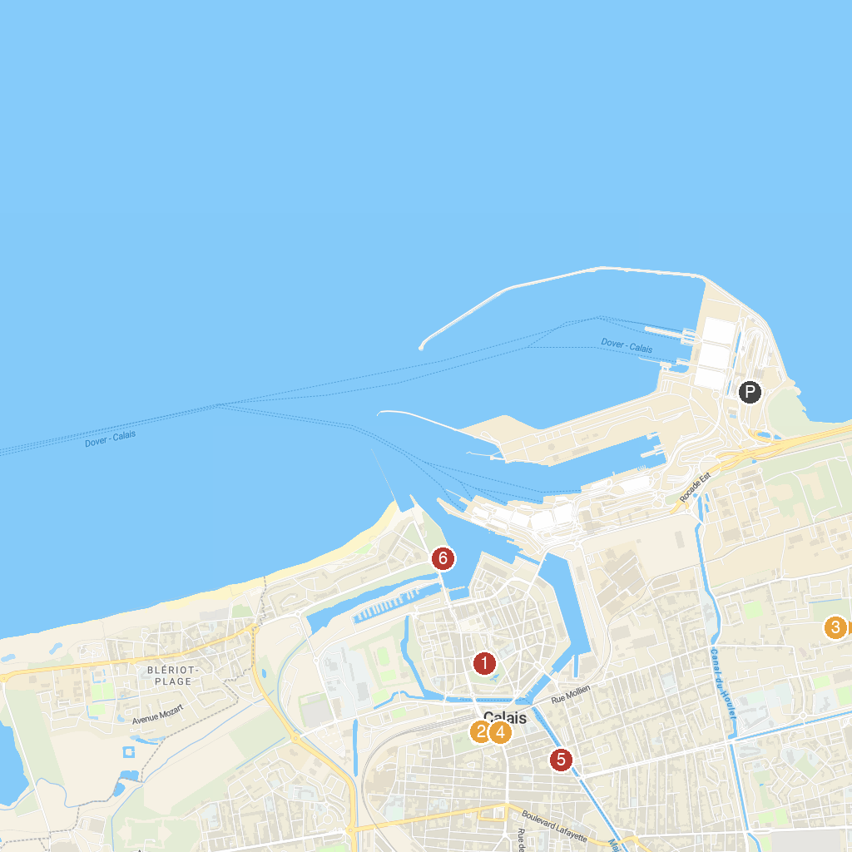
MAP KEY
1. Museum of Fine Arts in Calais | 5. City of Lace and Fashion
2. Parc Saint-Pierre | 6. Mimoyecques WW2 Fortress
3. Jardin Botanique du Beau Pays | 7. Fort Risban
4. Les Bourgeois de Calais
P. Cruise port / terminal
Map © MapTiler © OpenStreetMap contributors · cruiseports.org

