Cai Be, Tien Giang, Vietnam
Drift into the heart of the Mekong Delta on a narrow sampan, past palm-shaded canals, fruit orchards, and family workshops where coconut candy and rice paper have been made for generations.
⚓ River pier (docked) · 🕒 Typical call: 6–8 hrs · 💵 Vietnamese Dong (VND) · 🗣️ Vietnamese
✍️ MY DAY IN PORT (FILL IN)
Ship / Date
In port | arrive ______ · all aboard ______
Booked excursion
Notes / meeting point
GETTING ASHORE
- Docking: River pier on the Mekong; river cruise ships dock directly
- Walk to center: Cai Be town is steps from the pier; canals explored by boat
- Best For: Sampan rides, local workshops, cycling village paths
- Don't Miss: Cai Be Floating Market (early morning), Dong Hoa Hiep Old House
GETTING AROUND
- 🚕 Taxi: 30,000–50,000 VND (~$1–2 USD) for short hops — Locally hired motorbike taxis are available near the piers and town center for short distances. Negotiate and agree on t
TOP THINGS TO DO
- Cai Be Floating Market by Sampan — Board a small sampan at dawn to drift through the Cai Be Floating Market, where vendors sell tropical fruit and produce directly…
- Mekong Delta Workshop Trail — Visit family-run workshops producing Mekong specialties — watch coconut candy being pulled, rice paper dried in the sun, and…
- Narrow Canal Sampan Ride — Glide through a network of palm-shaded arroyos on a traditional wooden sampan, passing stilted houses, fruit orchards, and…
- Dong Hoa Hiep Ancient Houses — Explore Dong Hoa Hiep village near Cai Be, home to several beautifully preserved century-old merchant houses with…
- Cycling Through Fruit Orchards — Rent a bicycle and pedal through the shaded lanes of Tan Phong Island or surrounding villages, stopping at longan, mango, and…
BEST WALKS
- Cai Be Town Stroll: ~1 km · 20 min · flat — From the pier, walk through the riverside market area to the striking Cai Be Catholic Cathedral…
- Tan Phong Island Orchard Loop: ~3 km · 45–60 min · flat — Cross to Tan Phong Island by sampan, then follow the shaded village paths through fruit orchards…
WEATHER · DAYLIGHT · MONEY
Month | High °F | Low °F | Rainy days
May | 90 | 78 | 25
Jul | 86 | 77 | 29
Sep | 86 | 76 | 29
Daylight: May 5:34AM–6:10PM · Jul 5:41AM–6:21PM · Sep 5:45AM–5:56PM
cruiseports.org/cai-be · Confirm terminal & all-aboard time with your ship

Cai Be, Tien Giang, Vietnam — Port Map
Red = walkable sights · Amber = excursions farther out · P = cruise terminal
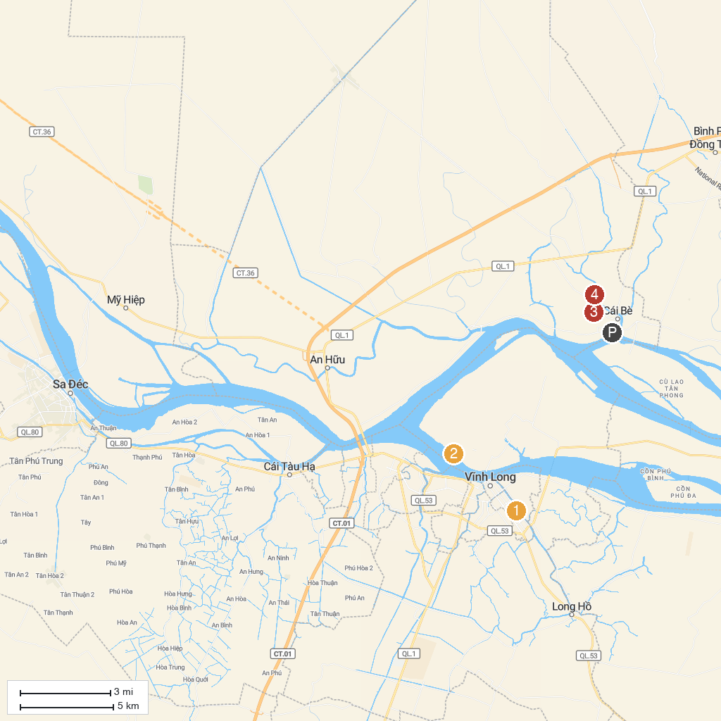
MAP KEY
1. Văn Thánh Miếu | 3. Nhà cổ Ông Kiệt
2. Khu Du Lịch Vinh Sang | 4. Ba Duc Ancient House
P. Cruise port / terminal
Map © MapTiler © OpenStreetMap contributors · cruiseports.org

