Cagliari, Sardinia, Italy
Sardinia's ancient capital rises in sun-bleached tiers above the Gulf of Angels — walkable from the pier, full of Roman ruins, pink flamingos, and the kind of lazy beach afternoon you'll talk about for years.
⚓ Docked (Molo Rinascita) · 🕒 Typical call: 8-10 hrs · 💶 Euro (€) · 🗣️ Italian
✍️ MY DAY IN PORT (FILL IN)
Ship / Date
In port | arrive ______ · all aboard ______
Booked excursion
Notes / meeting point
GETTING ASHORE
- Docking: Molo Rinascita, Porto Commerciale — no tendering; ships dock directly
- Walk to center: ~10-15 min walk along Via Roma to Piazza Matteotti; free shuttle also runs
- Best For: History buffs, beach lovers, foodies, flamingo spotting
- Don't Miss: Bastione Saint-Remy panorama, Castello district, and flamingos at Molentargius
GETTING AROUND
- 🚕 Taxi: €5–€7 — Taxis queue at the port entrance. The short ride to city center takes about 2 minutes; confirm the metered fare before d
- 📱 Rideshare: ✅ Uber
- 🚌 Hop-on hop-off: ✅
TOP THINGS TO DO
- Castello District & Cathedral — Climb (or take the free elevator) to Cagliari's walled hilltop quarter.
- Bastione Saint-Remy & Panoramic Views — This grand neoclassical bastion connects the Marina district to the Castello hilltop via a monumental staircase.
- Molentargius-Saline Regional Park & Flamingos — Just inland from Poetto Beach, this urban wetland hosts thousands of greater flamingos year-round.
- Poetto Beach — Cagliari's beloved 8km white-sand beach stretches east of the city.
- Roman Amphitheatre & National Archaeological Museum — The 2nd-century Roman Amphitheatre is partly carved into living rock on the hillside.
BEST WALKS
- Marina to Castello Hilltop: ~2.5 km | 60-90 min | Moderate (uphill sections) — Follow Via Roma from the terminal to Piazza Matteotti, then walk up through the Marina district to…
- Via Roma Waterfront Stroll: ~1.5 km | 20-30 min | Easy — A relaxed flat walk along the port-side boulevard.
WEATHER · DAYLIGHT · MONEY
Month | High °F | Low °F | Rainy days
May | 73 | 58 | 6
Jul | 89 | 72 | 0
Sep | 82 | 68 | 4
Daylight: May 6:10AM–8:29PM · Jul 6:09AM–8:48PM · Sep 7:05AM–7:31PM
cruiseports.org/cagliari · Confirm terminal & all-aboard time with your ship

Cagliari, Sardinia, Italy — Port Map
Red = walkable sights · Amber = excursions farther out · P = cruise terminal
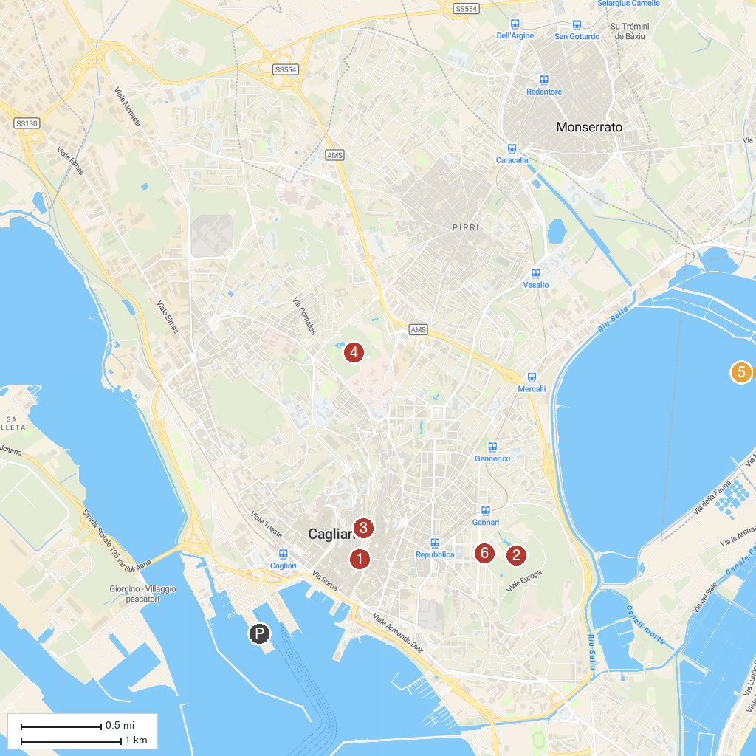
MAP KEY
1. Bastione di Saint Remy | 5. Chiesa di Sant'Andrea
2. Parco di Monte Urpinu | 6. Church of Saint Luke
3. Cattedrale di Santa Maria Assunta e Santa Cecilia | 7. Chiesa dei Santi Martiri Giorgio e Caterina
4. Monte Claro Park
P. Cruise port / terminal
Map © MapTiler © OpenStreetMap contributors · cruiseports.org

