Caen-Ouistreham, Normandy, France
Where the English Channel meets living history — Ouistreham is the front door to Normandy's D-Day beaches, the solemn American Cemetery at Omaha, medieval Caen, and the Bayeux Tapestry, all within a single shore day.
⚓ Docked (dedicated quay) · 🕒 Typical call: 8-10 hrs · 💶 Euro (EUR) · 🗣️ French
✍️ MY DAY IN PORT (FILL IN)
Ship / Date
In port | arrive ______ · all aboard ______
Booked excursion
Notes / meeting point
GETTING ASHORE
- Docking: Dedicated ISPS quay at Ouistreham; larger ships dock here, smaller vessels may dock in Caen city basin
- Walk to Centre: Ouistreham town 10-15 min walk; Caen city 15 km (free shuttle or Twisto bus line 12, ~25 min)
- Best For: WWII history, D-Day beach tours, medieval castles, Bayeux Tapestry
- Don't Miss: Sword Beach (steps from the pier), Pegasus Bridge, Mémorial de Caen, Omaha Beach
GETTING AROUND
- 🚕 Taxi: €30–€50 — Taxis from Ouistreham port to Caen city center cover ~14 km in 12–15 min. Daytime fares (7am–7pm) run €30–€40; evening r
- 📱 Rideshare: ✅ Uber, Bolt
TOP THINGS TO DO
- D-Day Beaches Full Tour — Cover the Allied landing sectors in one long day: Sword Beach (right at your pier), Juno Beach Centre, Arromanches Mulberry…
- Pegasus Bridge & Airborne Museum — About 8 km from the pier, Pegasus Bridge was seized in a glider assault minutes after midnight on June 6, 1944 — the first Allied…
- Mémorial de Caen — Europe's premier WWII memorial museum sits in Caen, covering D-Day, the Normandy campaign, and the Cold War with impressive depth.
- Bayeux & the Tapestry — Bayeux survived WWII largely intact and rewards a visit doubly — first for the UNESCO-listed Bayeux Tapestry, a 70-metre…
- Ouistreham Riva-Bella Beach Walk — Sword Beach begins steps from the cruise pier.
BEST WALKS
- Sword Beach & Riva-Bella Promenade: 1.5 km • 30-45 min • Flat seafront — Walk south from the cruise quay along the seafront to the Riva-Bella beach area.
- Caen City Highlights: 2-3 km in centre • 2-3 hrs • Mostly flat — Take the bus or shuttle to Caen, then walk from the Mémorial de Caen (allow 2 hrs inside) past the…
WEATHER · DAYLIGHT · MONEY
Month | High °F | Low °F | Rainy days
May | 62 | 49 | 11
Jul | 72 | 59 | 10
Sep | 69 | 56 | 10
Daylight: May 6:17AM–9:37PM · Jul 6:12AM–10:01PM · Sep 7:37AM–8:13PM
cruiseports.org/caen-ouistreham · Confirm terminal & all-aboard time with your ship

Caen-Ouistreham, Normandy, France — Port Map
Red = walkable sights · Amber = excursions farther out · P = cruise terminal
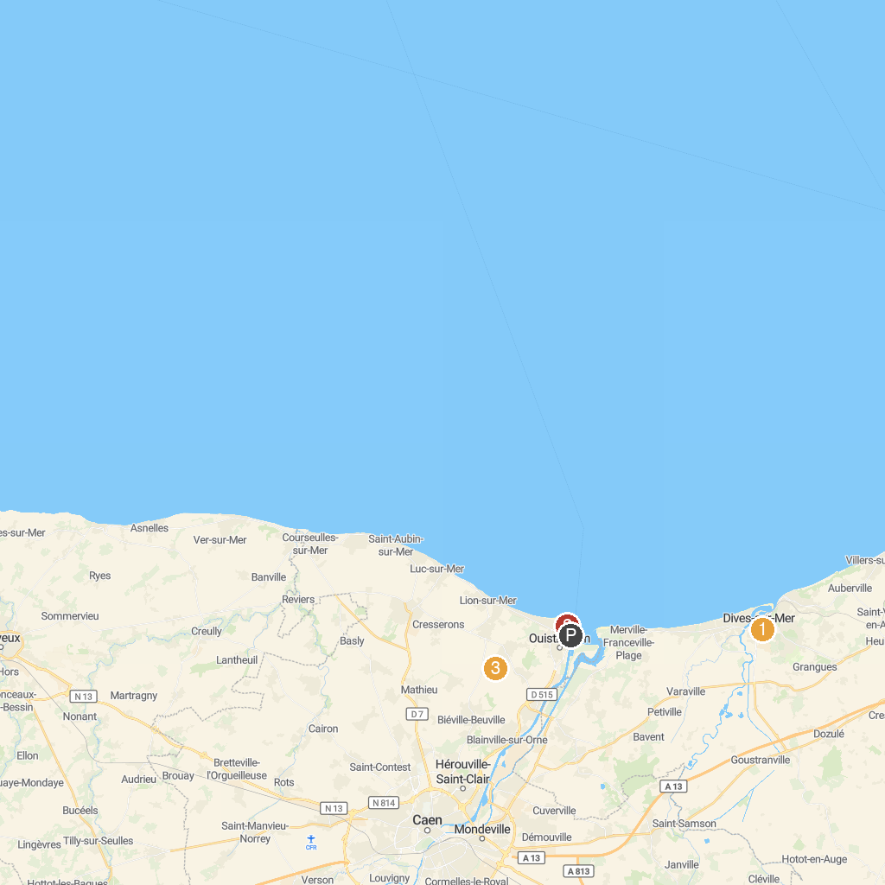
MAP KEY
1. Notre Dame Catholic Church | 5. St Peter's Catholic Church
2. Old St. Peter's Church | 6. Le Grand Bunker - Museum of the Atlantic Wall
3. Caen Castle | 7. Site fortifié Hillman
4. Abbaye aux Dames de Caen
P. Cruise port / terminal
Map © MapTiler © OpenStreetMap contributors · cruiseports.org

