Cádiz, Spain
One of Europe's oldest cities — a sun-bleached Atlantic peninsula of golden domes, salt-worn plazas, and tapas bars, and the gateway to Seville and Andalusian sherry country.
⚓ Docked (beside old town) · 🕒 Typical call: 9–11 hrs · 💶 Euro (EUR) · 🗣️ Spanish · some English
✍️ MY DAY IN PORT (FILL IN)
Ship / Date
In port | arrive ______ · all aboard ______
Booked excursion
Notes / meeting point
GETTING ASHORE
- Docking: Port (walk to old town)
- Walk to center: 5 min
- Best For: Old town · Day trips
- Don't Miss: Cathedral & Torre Tavira
GETTING AROUND
- 🚕 Taxi: €6–12 (within city) — Taxis are plentiful and metered. Short city rides are inexpensive; rates tick up at night. No rideshare apps work reliab
- 🚌 Hop-on hop-off: ✅ City Sightseeing Cádiz
TOP THINGS TO DO
- Old Town & Cathedral — The golden-domed Cádiz Cathedral, the Roman theatre, Plaza de las Flores market, and the Torre Tavira camera obscura for views…
- Seville Day Trip — Andalusia's dazzling capital — the vast Gothic cathedral and Giralda, the Real Alcázar palace, and the Plaza de España.
- Jerez: Sherry & Horses — The home of sherry — a bodega tour and tasting — paired with the famous Royal Andalusian School of Equestrian Art's dancing horses.
- La Caleta Beach & Sea Walls — The pretty city beach framed by two castles, plus a stroll along the Atlantic sea-wall promenades and the Genovés park — relaxed…
BEST WALKS
- Old town & cathedral loop: ~2.5 km · 1.5 hrs · easy — From Plaza San Juan de Dios past the market and Plaza de las Flores to the golden-domed cathedral…
- La Caleta & castles: ~2.5 km · 1.5 hrs · easy — Out to La Caleta beach between the Santa Catalina and San Sebastián castles, with sweeping Atlantic…
- Genovés Park & sea promenade: ~2 km · 1 hr · easy — The leafy botanical park and the Alameda sea-wall promenade on the city's northwest edge — shade…
WEATHER · DAYLIGHT · MONEY
Month | High °F | Low °F | Rainy days
May | 76 | 61 | 4
Jul | 86 | 69 | 0
Sep | 82 | 67 | 4
Daylight: May 7:18AM–9:25PM · Jul 7:18AM–9:43PM · Sep 8:07AM–8:32PM
cruiseports.org/cadiz · Confirm terminal & all-aboard time with your ship

Cádiz, Spain — Port Map
Red = walkable sights · Amber = excursions farther out · P = cruise terminal
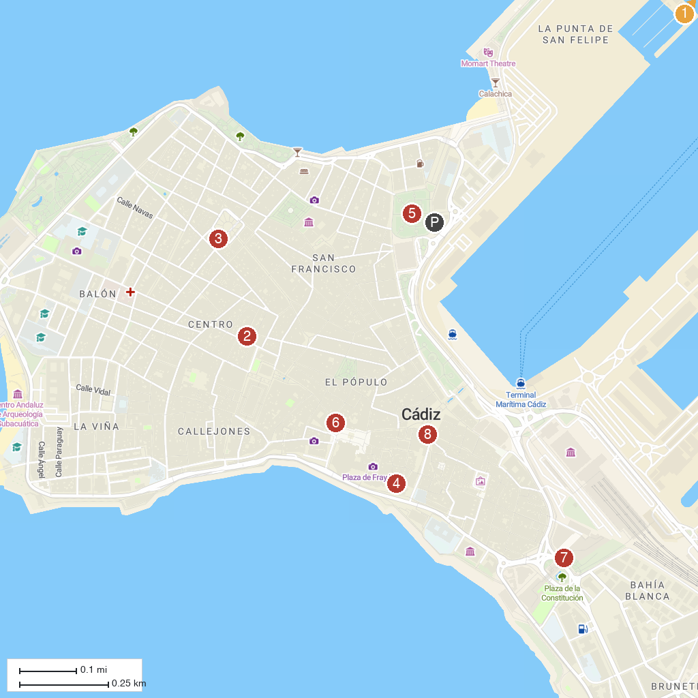
MAP KEY
1. Real Plaza de Toros | 5. The 1812 Constitution Monument
2. Torre Tavira | 6. Iglesia de Santiago Apóstol
3. Parish of St Anthony of Padua | 7. Museo del Títere
4. Teatro Romano de Cádiz | 8. Iglesia de San Juan de Dios
P. Cruise port / terminal
Map © MapTiler © OpenStreetMap contributors · cruiseports.org

