Armacao dos Buzios, Brazil
The 'Saint-Tropez of Brazil'
🏖️ Beaches · 🛍️ Boutique Shopping · 🍽️ Gourmet Dining · 🇧🇷 Brazilian Culture
✍️ MY DAY IN PORT (FILL IN)
Ship / Date
In port | arrive ______ · all aboard ______
Booked excursion
Notes / meeting point
GETTING ASHORE
- Currency: Brazilian Real (BRL)
- Language: Portuguese
- Climate: Tropical/Subtropical
- Vibe: Upscale Bohemian
GETTING AROUND
- 🚕 Taxi: R$20–30 per trip — Taxis available from the pier with fixed rates at taxi ranks. Useful for reaching beaches further around the peninsula;
- 📱 Rideshare: ✅ Uber
- 🚌 Hop-on hop-off: ✅
TOP THINGS TO DO
- Beach Hopping by Buggy — Rent a buggy and explore the peninsula's highlights: Geribá for surf, João Fernandes for calm snorkeling, and Ferradura's…
- Rua das Pedras Walk — Stroll the cobblestone heart of Búzios, lined with boutiques, galleries, and cafés.
- Sailing Trip to the Islands — Charter a traditional schooner and cruise the peninsula, stopping for snorkeling in crystal-clear Atlantic waters at secluded…
- Porto da Barra Visit — Head to this waterfront complex in Manguinhos for fresh seafood, sunset cocktails, and views over the calm bay.
BEST WALKS
- The Bohemian Heart: Rua das Pedras & surroundings — Start at the pier, walk to Rua das Pedras, and explore the boutiques and cafes.
- The Coastal Path: Orla Bardot to Armação — Follow the oceanfront promenade past the fishermen's pier and colorful boats for a scenic coastal…
- Beachside Wander: Praia da Ferradura — A relaxing walk around the crescent-shaped bay of Ferradura, known for its calm waters and peaceful…
WEATHER · DAYLIGHT · MONEY
Month | High °F | Low °F | Rainy days
May | 78 | 68 | 10
Jul | 76 | 66 | 6
Sep | 78 | 69 | 8
Daylight: May 6:13AM–5:14PM · Jul 6:27AM–5:19PM · Sep 5:44AM–5:41PM
cruiseports.org/buzios · Confirm terminal & all-aboard time with your ship

Armacao dos Buzios, Brazil — Port Map
Red = walkable sights · Amber = excursions farther out · P = cruise terminal
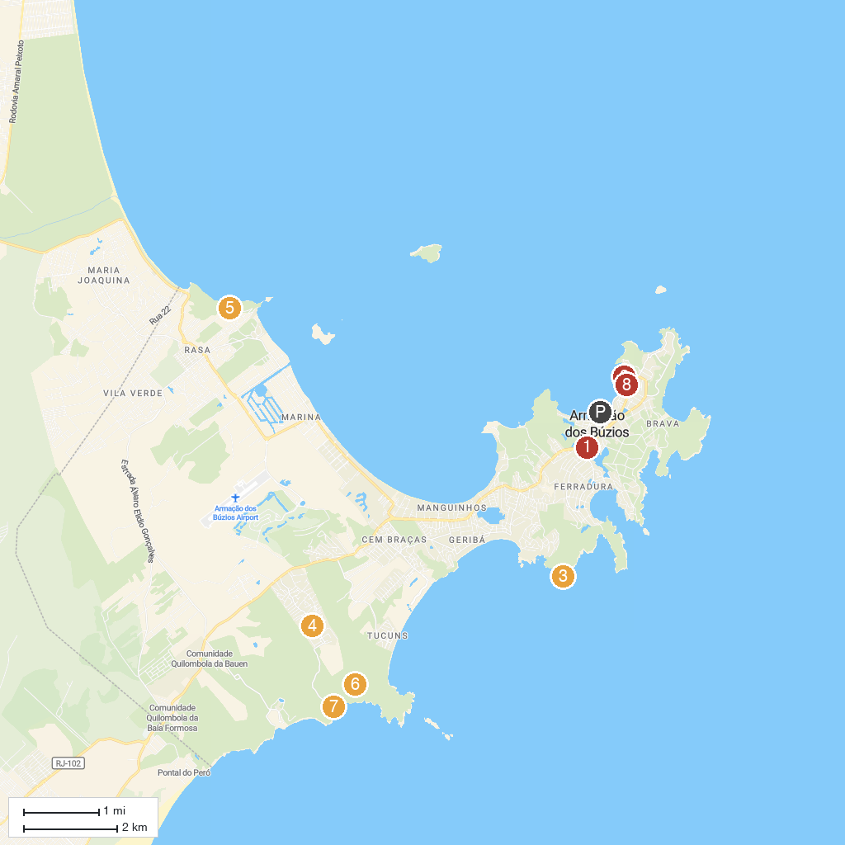
MAP KEY
1. Radical Parque | 5. Mangrove Stones
2. Church of Sant'Anna | 6. Lookout Mountain of Emerências
3. Enseada das Poças | 7. Praia de José Gonçalves
4. Buzios Eco Trails | 8. Orla Bardot
P. Cruise port / terminal
Map © MapTiler © OpenStreetMap contributors · cruiseports.org

