Busselton, Western Australia, Australia
A tender port anchored off the world's longest timber-piled jetty — Busselton punches well above its size as a gateway to Geographe Bay, limestone caves, and the acclaimed Margaret River wine region just an hour's drive away.
⚓ Tender port (anchor in Geographe Bay) · 🕒 Typical call: 7–9 hrs · 💵 Australian Dollar (AUD) · 🗣️ English
✍️ MY DAY IN PORT (FILL IN)
Ship / Date
In port | arrive ______ · all aboard ______
Booked excursion
Notes / meeting point
GETTING ASHORE
- Docking: Tender — ships anchor in Geographe Bay; tenders land at Busselton Jetty base
- Walk to Centre: ~5 min on foot from the jetty entrance to Queen Street shops
- Best For: Margaret River wine tours, the Busselton Jetty Underwater Observatory, whale watching (Jun–Dec)
- Don't Miss: Descending 8 m below sea level in the Busselton Jetty Underwater Observatory
GETTING AROUND
- 🚕 Taxi: AUD 10–15 — South West Taxis serves Busselton. Short ride to the town center costs roughly AUD 10–15; rates start at ~AUD 2.17/km. A
- 📱 Rideshare: ✅ Uber
- 🚌 Hop-on hop-off: ✅
TOP THINGS TO DO
- Busselton Jetty & Underwater Observatory — Walk or ride the solar-powered jetty train 1.8 km out to the Underwater Observatory, where you descend 8 m below sea level to see…
- Margaret River Wine & Gourmet Day — Guided coach or small-group tour to the world-famous Margaret River region (~1 hr away), visiting 3–5 cellar doors including…
- Ngilgi Cave Tour — Venture into this limestone showpiece in the Leeuwin-Naturaliste National Park — dramatic stalactites, helictites, shawls, and…
- Whale Watching on Geographe Bay — From June through early December, humpback and Southern Right whales migrate through Geographe Bay.
- Cape Naturaliste Lighthouse & Coastal Walk — Drive to the northern tip of the Leeuwin-Naturaliste ridge for sweeping views of the Indian Ocean and Geographe Bay from this…
BEST WALKS
- Busselton Jetty Walk: 3.6 km return • ~45–60 min • Easy/Flat — Walk the full length of the Southern Hemisphere's longest timber-piled jetty and back.
- Foreshore & Town Centre Stroll: ~2 km loop • 30 min • Easy — From the jetty base, stroll east along the Busselton Foreshore path past Norfolk pines to the town…
WEATHER · DAYLIGHT · MONEY
Month | High °F | Low °F | Rainy days
May | 66 | 54 | 9
Jul | 61 | 51 | 14
Sep | 63 | 50 | 9
Daylight: May 7:03AM–5:26PM · Jul 7:21AM–5:28PM · Sep 6:18AM–6:10PM
cruiseports.org/busselton-wa · Confirm terminal & all-aboard time with your ship

Busselton, Western Australia, Australia — Port Map
Red = walkable sights · Amber = excursions farther out · P = cruise terminal
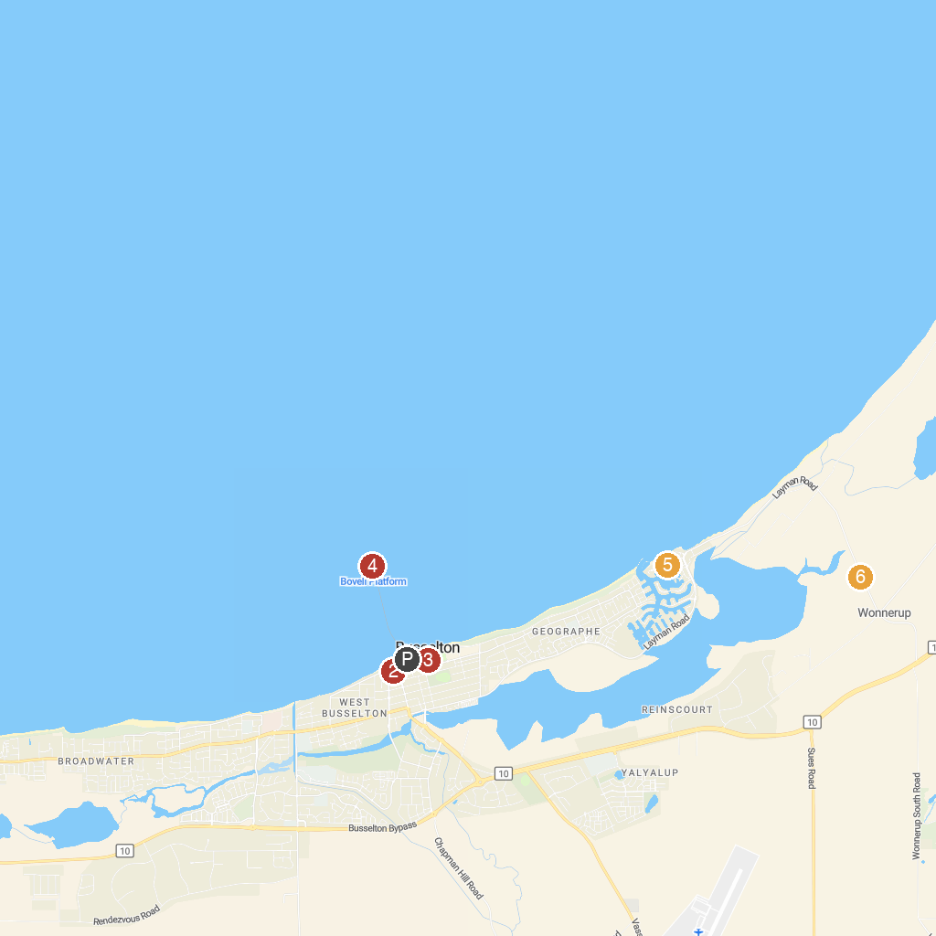
MAP KEY
1. Busselton Jetty | 4. Busselton Underwater Observatory
2. Signal Park | 5. All Sea Charters Busselton
3. Barnard Park | 6. Possum Spotlighting Trail
P. Cruise port / terminal
Map © MapTiler © OpenStreetMap contributors · cruiseports.org

