Busan, South Korea
South Korea's second city packs coastal temples, a legendary fish market, neon-lit beaches, and colourful hillside villages into a port day that rewards the independent explorer.
⚓ Docked (pier) · 🕒 Typical call: 8-10 hrs · 💴 South Korean Won (KRW) · 🗣️ Korean (English limited outside tourist zones)
✍️ MY DAY IN PORT (FILL IN)
Ship / Date
In port | arrive ______ · all aboard ______
Booked excursion
Notes / meeting point
GETTING ASHORE
- Docking: BPIT or Yeongdo pier — no tendering
- Walk to center: ~10–15 min walk via pedestrian deck or free shuttle to Nampo / Busan Station
- Best For: City explorers, foodies, temple lovers, beach days
- Don't Miss: Haedong Yonggungsa seaside temple & Jagalchi fish market
GETTING AROUND
- 🚕 Taxi: KRW 8,500–40,000 (~$6–$30 USD) — Plentiful at the terminal. Nampo-dong is ~5–10 min (KRW 8,500–16,000); Haeundae Beach is ~25–35 min (KRW 25,000–40,000).
- 📱 Rideshare: ✅ Uber, Kakao T
- 🚌 Hop-on hop-off: ✅
TOP THINGS TO DO
- Haedong Yonggungsa Temple — One of Korea's only seaside Buddhist temples, founded 1376, perched on dramatic coastal cliffs north of the city.
- Jagalchi Fish Market — Korea's largest seafood market bustles with live tanks, dried fish stalls, and the famed 'Jagalchi Ajumma' women vendors.
- Gamcheon Culture Village — A maze of pastel-painted homes cascading down a hillside — dubbed the 'Machu Picchu of Busan.' Explore street art alleys, tiny…
- Taejongdae Cliffs & Lighthouse — Rocky coastal cliffs on the southern tip of Yeongdo Island, with forested walking trails, a small lighthouse, and panoramic views…
- Haeundae Beach — Busan's most famous beach — a wide sandy arc flanked by high-rise hotels.
BEST WALKS
- Nampo Waterfront to BIFF Square: 2 km · 30 min · Easy — From BPIT walk the harbour promenade past the Busan Modern History Museum to Nampo-dong's…
- Yongdusan Park & Busan Tower: 1 km · 20 min · Easy — Escalators whisk you up to Yongdusan Park from Nampo street level.
WEATHER · DAYLIGHT · MONEY
Month | High °F | Low °F | Rainy days
May | 70 | 57 | 8
Jul | 81 | 73 | 15
Sep | 77 | 67 | 12
Daylight: May 5:20AM–7:20PM · Jul 5:21AM–7:38PM · Sep 6:06AM–6:30PM
cruiseports.org/busan · Confirm terminal & all-aboard time with your ship

Busan, South Korea — Port Map
Red = walkable sights · Amber = excursions farther out · P = cruise terminal
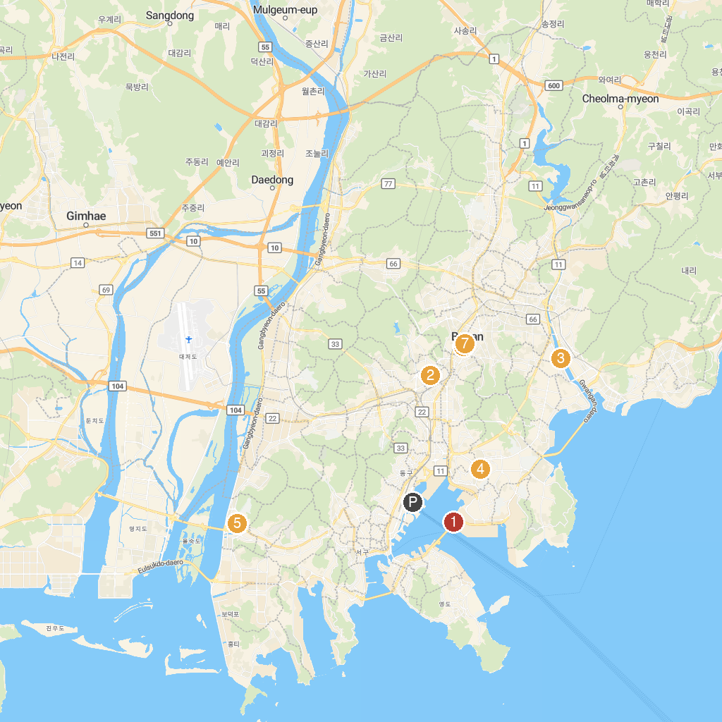
MAP KEY
1. 감만시민부두 | 5. 우룡산공원
2. Busan Citizens Park | 6. 에덴공원
3. 좌수영교 | 7. 잔디광장
4. 오산공원 | 8. 녹음광장
P. Cruise port / terminal
Map © MapTiler © OpenStreetMap contributors · cruiseports.org

