Burnside, Louisiana, USA
A sleepy Mississippi River bend hiding one of the South's grandest antebellum showpieces — Houmas House — and the live-oak-lined River Road plantation corridor that put Louisiana sugar on the map.
⚓ Docked (river dock/wharf) · 🕒 Typical call: 6–8 hrs · 💵 US Dollar (USD) · 🗣️ English / Louisiana French · 🌿 River Road plantation country
✍️ MY DAY IN PORT (FILL IN)
Ship / Date
In port | arrive ______ · all aboard ______
Booked excursion
Notes / meeting point
GETTING ASHORE
- Docking: Docked at private river wharf; ships moor directly on the Mississippi bank
- Walk to center: Burnside has no town center — Houmas House is ~0.5 mi from the dock; a car or shuttle is needed for anything else
- Best For: Plantation history, Southern gardens, Creole food, Mississippi River scenery
- Don't Miss: Houmas House guided mansion tour and gardens — the '"Crown Jewel of the River Road"'
GETTING AROUND
- 🚕 Taxi: Meter / negotiated — Taxis serving the Baton Rouge–Gonzales corridor can be pre-arranged to pick up at the wharf. Ask your cruise line concie
TOP THINGS TO DO
- Houmas House Guided Mansion Tour — The "Sugar Palace" of the River Road.
- Great River Road Museum — On the Houmas House grounds, this newer museum tells the story of life along the Mississippi — commerce, culture, folklore, and…
- Lunch at Latil's Landing or The Carriage House — Houmas House's award-winning restaurants serve upscale Creole and Louisiana fare.
- River Road Plantation Drive — For independent travelers with a rental car, the River Road stretches in both directions from Burnside, connecting Laura…
- Mississippi River Levee Walk — A short, flat walk along the river levee adjacent to the dock offers expansive views of one of the world's great rivers — barge…
BEST WALKS
- Houmas House Gardens & Grounds Loop: 1–1.5 mi · Easy · ~45 min — From the shuttle drop-off at Houmas House, walk the formal garden paths, past ponds and live oaks…
- Riverside Levee Stroll: 0.5 mi · Flat · 20 min — From the ship dock, walk the top of the Mississippi River levee north toward the plantation.
WEATHER · DAYLIGHT · MONEY
Month | High °F | Low °F | Rainy days
May | 76 | 57 | 12
Jul | 86 | 70 | 13
Sep | 81 | 63 | 8
Daylight: May 6:30AM–8:39PM · Jul 6:31AM–8:57PM · Sep 7:21AM–7:45PM
cruiseports.org/burnside-la · Confirm terminal & all-aboard time with your ship

Burnside, Louisiana, USA — Port Map
Red = walkable sights · Amber = excursions farther out · P = cruise terminal
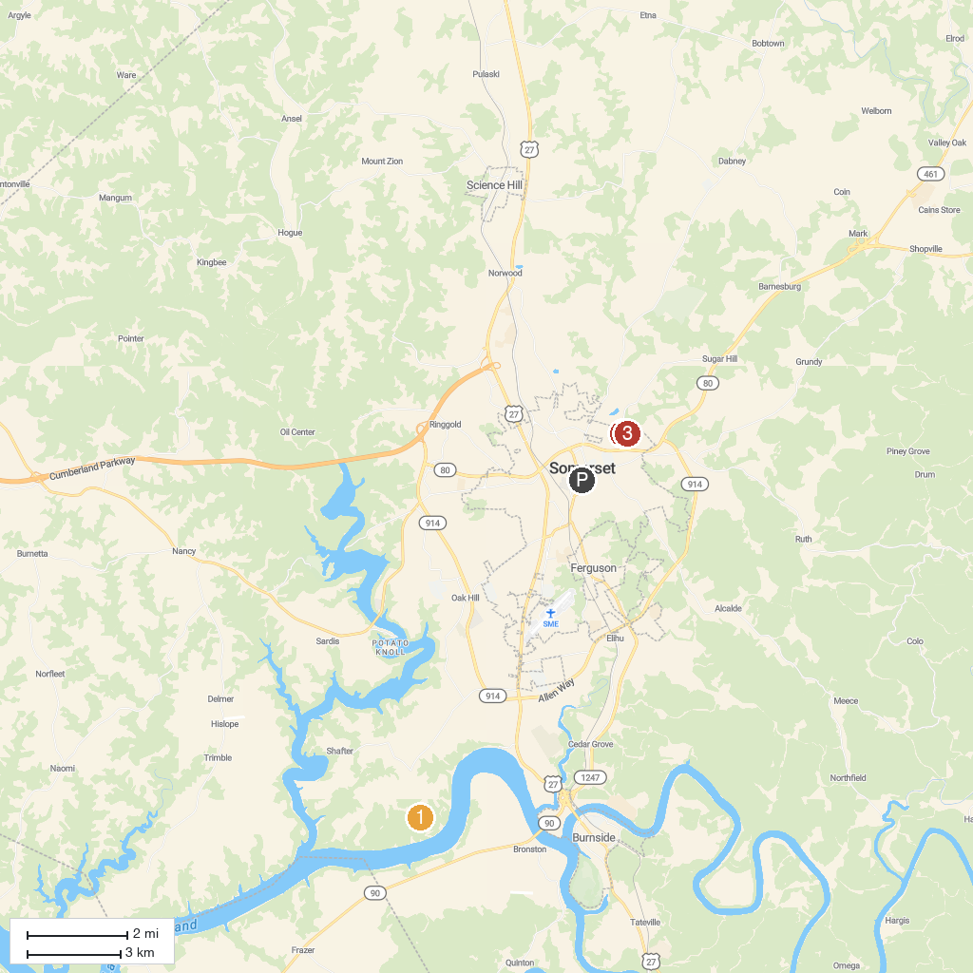
MAP KEY
1. Pulaski County Park | 5. Eagle Scout Trail Head
2. Liberty Nature Center | 6. SomerSplash Waterpark
3. Somerset Parks & Recreation | 7. Zollicoffer Park
4. SomerSport Park
P. Cruise port / terminal
Map © MapTiler © OpenStreetMap contributors · cruiseports.org

