Burnie, Tasmania, Australia
Tasmania's northwest gateway balances working-port grit with rolling farmland, native wildlife, and a surprisingly vibrant arts scene — all within easy reach of the pier.
⚓ Docked (deep-water berth) · 🕒 Typical call: 7-9 hrs · 💵 Australian Dollar (AUD) · 🗣️ English
✍️ MY DAY IN PORT (FILL IN)
Ship / Date
In port | arrive ______ · all aboard ______
Booked excursion
Notes / meeting point
GETTING ASHORE
- Docking: Ships berth at Port of Burnie — Tasmania's largest deep-water cargo port, ~2 km from city center
- Walk to center: Free shuttle bus to Burnie Discovery Hub; ~25-min walk along foreshore alternatively
- Best For: Wildlife encounters, Tasmanian whisky tastings, day trips to Cradle Mountain
- Don't Miss: Wings Wildlife Park for Tasmanian devils, Hellyers Road Distillery, Makers' Workshop
GETTING AROUND
- 🚕 Taxi: AUD 18–25 (city center) — Taxis are available but limited in Burnie; pre-booking is strongly recommended. A typical port-to-city ride is around AU
- 📱 Rideshare: ✅ Uber
- 🚌 Hop-on hop-off: ✅ Burnie Attractions Bus (eGuide)
TOP THINGS TO DO
- Wings Wildlife Park — Tasmania's largest native wildlife collection sits on rolling farmland at Gunns Plains, about 45 minutes' drive from the port.
- Cradle Mountain Day Trip — Drive south to Cradle Mountain-Lake St Clair National Park for Dove Lake and ancient rainforest walks.
- Hellyers Road Distillery — Australia's largest boutique single malt whisky distillery offers guided tours of the production floor plus generous tastings of…
- Makers' Workshop & Burnie Regional Museum — The Makers' Workshop celebrates Burnie's transition from paper-mill town to creative hub — watch artisans make paper by hand and…
- Stanley & The Nut — The historic fishing village of Stanley anchors around a dramatic volcanic plug called The Nut.
BEST WALKS
- Foreshore to Discovery Hub & West Beach: 2.5 km one-way · Flat & paved · 30 min — From the shuttle drop at the Burnie Discovery Hub, walk west along the foreshore promenade past the…
- City Center Wander: 1-2 km loop · Easy · 45 min — From the shuttle drop, explore Burnie's compact CBD — Makers' Workshop, Burnie Regional Museum, the…
WEATHER · DAYLIGHT · MONEY
Month | High °F | Low °F | Rainy days
May | 57 | 47 | 12
Jul | 52 | 44 | 16
Sep | 56 | 44 | 12
Daylight: May 7:17AM–5:07PM · Jul 7:37AM–5:07PM · Sep 6:18AM–6:05PM
cruiseports.org/burnie · Confirm terminal & all-aboard time with your ship

Burnie, Tasmania, Australia — Port Map
Red = walkable sights · Amber = excursions farther out · P = cruise terminal
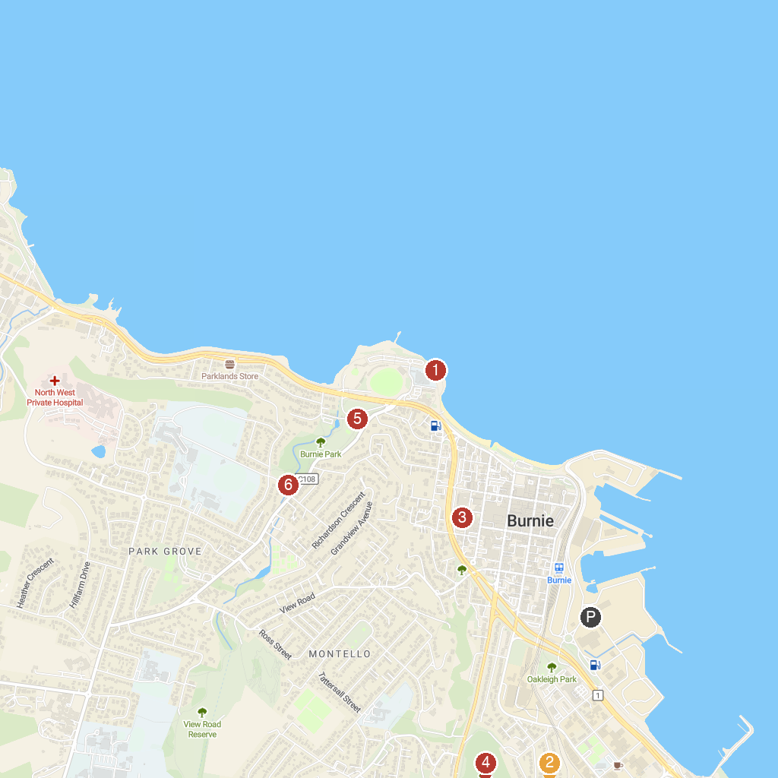
MAP KEY
1. Little Penguin Observation Centre | 4. Upper Burnie Lookout
2. Emu Valley Rhododendron Garden | 5. Burnie Park
3. Burnie Regional Museum | 6. Oldaker Falls
P. Cruise port / terminal
Map © MapTiler © OpenStreetMap contributors · cruiseports.org

