Burlington, Iowa, USA
Perched on the bluffs above the Mississippi, Burlington is best known for Snake Alley — one of the crookedest streets in the world — and a compact historic downtown steps from the dock.
⚓ Docked — downtown riverfront · 🕒 Typical call: 6-8 hrs · 💵 US Dollar (USD) · 🗣️ English
✍️ MY DAY IN PORT (FILL IN)
Ship / Date
In port | arrive ______ · all aboard ______
Booked excursion
Notes / meeting point
GETTING ASHORE
- Docking: Alongside at Port of Burlington, 400 N Front St — right on the downtown riverfront
- Walk to center: 5 min walk to Heritage Hill and Snake Alley; flat along the river, then a steep climb
- Best For: American history, quirky landmarks, scenic riverfront walks
- Don't Miss: Snake Alley — five half-curves over 275 ft; voted crookedest street in the world by Ripley's
GETTING AROUND
- 🚕 Taxi: $8–15 — Local taxis (A2Z Taxi 319-752-6866, Yellow Cab 319-752-6625) serve the area. Fares within town are generally modest give
- 📱 Rideshare: ✅ Uber, Lyft
TOP THINGS TO DO
- Snake Alley & Heritage Hill Walk — Stroll up from the riverfront to Burlington's most photographed attraction — a cobblestone street with five half-curves and a 21%…
- Garrett-Phelps House Museum — An elegant 1851 Victorian mansion with nine furnished rooms showcasing antiques dating back to 1774 — one of Iowa's finest house…
- Des Moines County Heritage Center — Burlington's main history museum, covering the county's settlement, industrial, and cultural heritage through engaging exhibits…
- Starr's Cave Park & Preserve — A 184-acre preserve just minutes from downtown with hiking trails, Flint Creek views, and caves including Devil's Kitchen and…
- Geode State Park — Named for Iowa's state rock, this park 20 minutes from town offers a lake for kayaking and fishing, plus hiking trails through…
BEST WALKS
- Riverfront to Snake Alley Loop: 1.5 miles | 45-60 min | Moderate — Walk north along the riverfront from the dock, turn inland up the bluff stairway on Columbia…
- Mosquito Park Overlook: 0.5 miles | 20 min | Easy — A short walk or quick drive to Mosquito Park on the bluffs above the river for sweeping panoramic…
WEATHER · DAYLIGHT · MONEY
Month | High °F | Low °F | Rainy days
May | 65 | 47 | 10
Jul | 80 | 63 | 12
Sep | 72 | 57 | 10
Daylight: May 5:54AM–8:37PM · Jul 5:53AM–8:57PM · Sep 6:59AM–7:28PM
cruiseports.org/burlington-ia · Confirm terminal & all-aboard time with your ship

Burlington, Iowa, USA — Port Map
Red = walkable sights · Amber = excursions farther out · P = cruise terminal
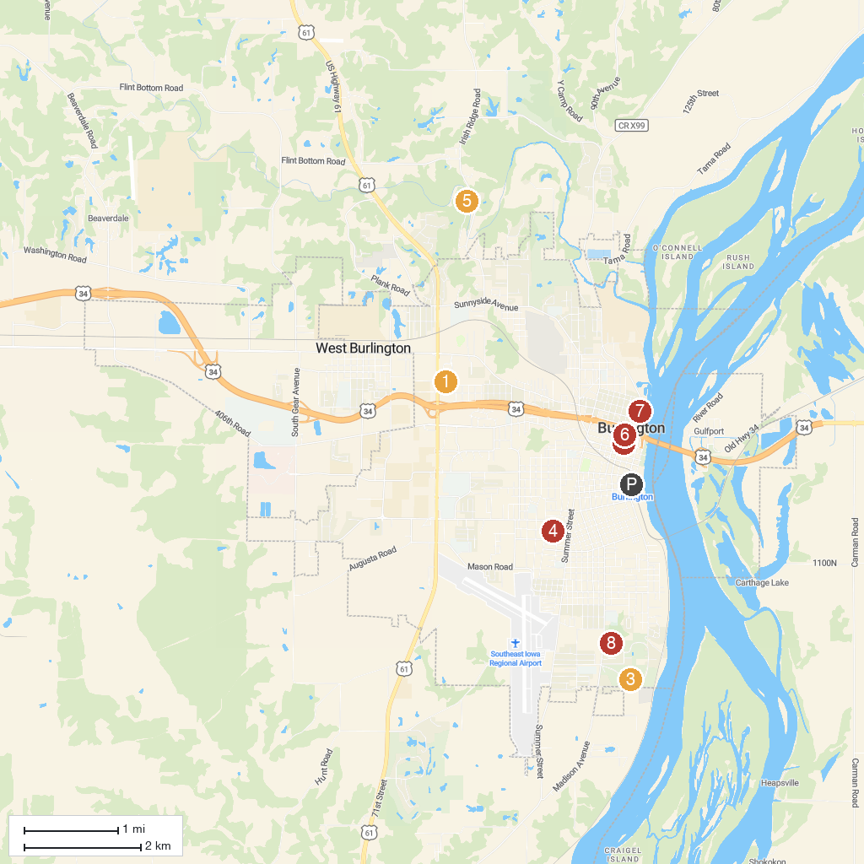
MAP KEY
1. Fun City | 5. Starr's Cave Nature Center
2. Des Moines County Heritage Center Museum | 6. North Hill Park
3. Crapo Park | 7. Mosquito Park
4. Perkins Park | 8. Dankwardt Memorial Park
P. Cruise port / terminal
Map © MapTiler © OpenStreetMap contributors · cruiseports.org

