Buenaventura, Valle del Cauca, Colombia
Colombia's principal Pacific port opened to cruises only in 2023. The rewards — pristine Pacific beaches, humpback whales, and dense mangrove swamps — all lie a speedboat ride away from the pier.
⚓ Anchor/Tender port · 🕒 Typical call: 8-10 hrs · 💵 Colombian Peso (COP) · 🗣️ Spanish
✍️ MY DAY IN PORT (FILL IN)
Ship / Date
In port | arrive ______ · all aboard ______
Booked excursion
Notes / meeting point
GETTING ASHORE
- Docking: Anchor & tender; no dedicated cruise terminal
- Best For: Pacific beaches, whale watching (Jul–Oct), mangroves
- Don't Miss: Speedboat to Juanchaco & Ladrilleros beaches
- Safety Note: Stay on guided tours — city centre is not safe for independent walking
GETTING AROUND
- 🚕 Taxi: 8,000–15,000 COP (~$2–4 USD) — Local taxis are the most common transport option. Always negotiate the fare before getting in and pay in cash.
- 📱 Rideshare: ✅ Uber
TOP THINGS TO DO
- Juanchaco & Ladrilleros Beaches — A one-hour speedboat ride delivers you to wild Pacific beaches backed by jungle.
- Humpback Whale Watching — From July to October (peak Aug–Sep), humpback whales migrate along the Colombian Pacific coast.
- Mangrove Swamp Boat Tour — Glide through Buenaventura's intricate mangrove channels with a local guide.
- San Cipriano Nature Reserve — Reached via a memorable ride on a hand-powered rail cart (the famous 'brujita'), San Cipriano features crystal-clear rivers…
- Afro-Colombian Culture & Seafood — The Tourist Pier area offers a gentle introduction to the region's Afro-Colombian heritage — folklore music, marimba de chonta…
BEST WALKS
- Muelle Turístico Promenade: 0.3 km · Easy · Stay on the pier — A short walk along the floating Tourist Pier offers bay views, craft vendors, and a seafood kiosk…
WEATHER · DAYLIGHT · MONEY
Month | High °F | Low °F | Rainy days
May | 81 | 73 | 31
Jul | 80 | 73 | 31
Sep | 80 | 72 | 30
Daylight: May 5:56AM–6:12PM · Jul 6:04AM–6:23PM · Sep 5:59AM–6:06PM
cruiseports.org/buenaventura-colombia · Confirm terminal & all-aboard time with your ship

Buenaventura, Valle del Cauca, Colombia — Port Map
Red = walkable sights · Amber = excursions farther out · P = cruise terminal
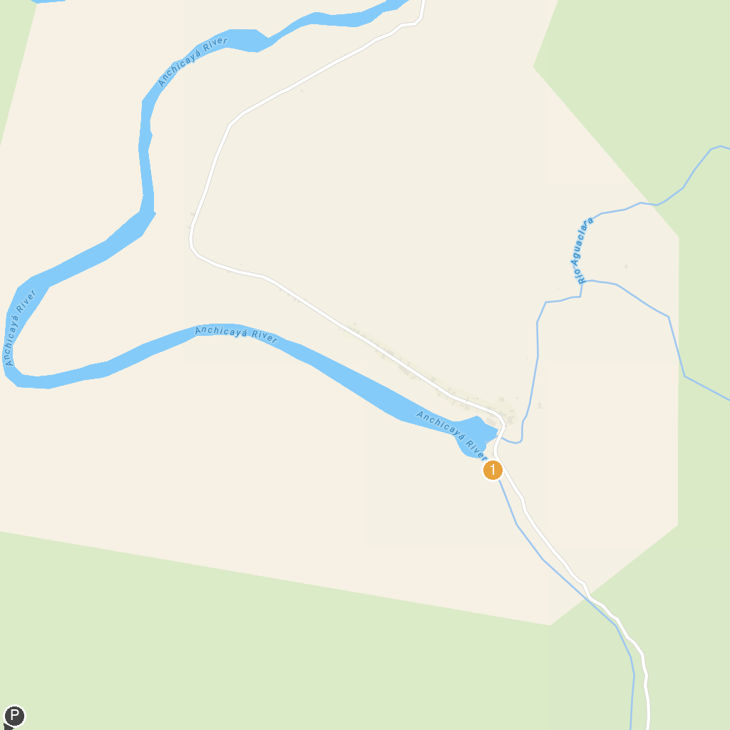
MAP KEY
1. Balneario de Aguaclarita | 3. Cascada La Ventiadora
2. Balneario de Zabaletas
P. Cruise port / terminal
Map © MapTiler © OpenStreetMap contributors · cruiseports.org

