Budapest, Central Hungary, Hungary
The Pearl of the Danube delivers palace-crowned hills, neo-Gothic Parliament spires, and steaming thermal baths — all within easy walking distance of your ship's berth.
⚓ Docked (Danube quayside piers) · 🕒 Typical call: full day or overnight · 💵 Hungarian Forint (HUF) · 🗣️ Hungarian (English widely spoken in tourist areas)
✍️ MY DAY IN PORT (FILL IN)
Ship / Date
In port | arrive ______ · all aboard ______
Booked excursion
Notes / meeting point
GETTING ASHORE
- Docking: Multiple quayside piers on the Pest bank of the Danube; ships typically dock at Akadémia, MAHART International, or Vigadó piers near the city center
- Walk to Center: Most piers are within 5–15 min walk of the Chain Bridge and Váci Street shopping area
- Best For: Architecture, history, thermal baths, river panoramas, Central European cuisine
- Don't Miss: Fisherman's Bastion at sunrise and a sunset view of the floodlit Parliament from the Danube
GETTING AROUND
- 🚕 Taxi: ~€5–€15 — Metered yellow cabs are widely available and affordable for short hops in the city. Look for yellow license plates; conf
- 📱 Rideshare: ✅ Uber, Bolt
- 🚌 Hop-on hop-off: ✅
TOP THINGS TO DO
- Buda Castle & Castle District — UNESCO World Heritage hilltop quarter with Buda Castle, Fisherman's Bastion, Matthias Church, and sweeping views over the Danube…
- Hungarian Parliament Building — One of Europe's largest and most ornate parliament buildings, viewable in full glory from the river.
- Széchenyi Thermal Baths — Budapest's most famous thermal complex in City Park, with large outdoor and indoor pools fed by natural hot springs.
- Jewish Quarter & Dohány Street Synagogue — The Great Synagogue on Dohány Street is the largest in Europe and anchor of Budapest's historic Jewish district.
- Great Market Hall & Hungarian Food — The ornate 1897 Neo-Gothic market hall on Fővám Square stocks fresh paprika, sausages, lángos, and Tokaj wine.
BEST WALKS
- Pest Embankment to Chain Bridge & St. Stephen's Basilica: 2.5 km · ~1 hr · Easy — Stroll north along the riverside promenade past the MAHART piers, up to the Széchenyi Chain Bridge…
- Castle Hill Loop: 3 km · ~2 hrs · Moderate — Cross the Chain Bridge, ride the funicular to the top, explore Fisherman's Bastion, Matthias…
- Andrássy Avenue to Heroes' Square: ~1.5 km one-way · ~30 min · Easy — From the Opera House on Andrássy Avenue, walk the grand UNESCO-listed boulevard past Art Nouveau…
WEATHER · DAYLIGHT · MONEY
Month | High °F | Low °F | Rainy days
May | 69 | 52 | 13
Jul | 83 | 64 | 10
Sep | 72 | 56 | 8
Daylight: May 5:07AM–8:14PM · Jul 5:02AM–8:36PM · Sep 6:21AM–6:55PM
cruiseports.org/budapest · Confirm terminal & all-aboard time with your ship

Budapest, Central Hungary, Hungary — Port Map
Red = walkable sights · Amber = excursions farther out · P = cruise terminal
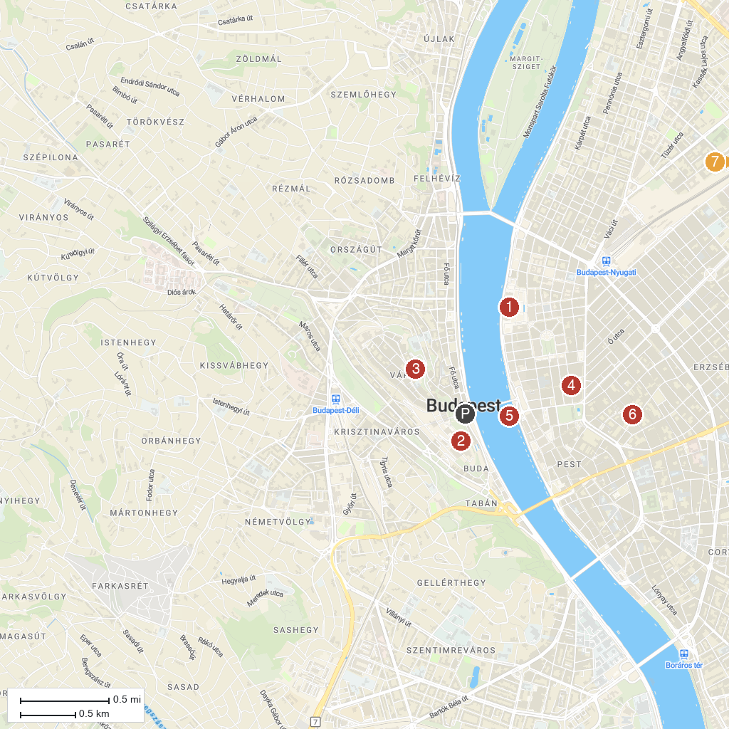
MAP KEY
1. Országház | 5. Széchenyi Lánchíd
2. Budavári Palota | 6. Dohány utcai Zsinagóga
3. Halászbástya | 7. Széchenyi gyógyfürdő
4. Szent István-bazilika
P. Cruise port / terminal
Map © MapTiler © OpenStreetMap contributors · cruiseports.org

