Bucharest, Muntenia, Romania
Romania's grand capital blends communist-era monuments with Ottoman lanes and Art Nouveau boulevards. River cruise passengers arrive via Giurgiu, an hour south — the transfer is worth every minute.
⚓ Docked at Giurgiu (river pier) · 🕒 Typical call: 8-10 hrs · 💵 Romanian Leu (RON) · 🗣️ Romanian (English widely spoken)
✍️ MY DAY IN PORT (FILL IN)
Ship / Date
In port | arrive ______ · all aboard ______
Booked excursion
Notes / meeting point
GETTING ASHORE
- Docking: River ships berth at Giurgiu, ~60 km (40 mi) south of Bucharest. Coach transfer ~1 hr each way.
- Walk to center: Not walkable from pier — coach or private car required into the city.
- Best For: Communist-era architecture, Romanian history, lively Old Town, café culture.
- Don't Miss: Palace of Parliament (book ahead), Stavropoleos Monastery, Calea Victoriei.
GETTING AROUND
- 🚕 Taxi: $40–$55 — Standard taxi from Giurgiu port to Bucharest city center. Negotiate or confirm the fare before departing — metered cabs
- 📱 Rideshare: ✅ Uber, Bolt
- 🚌 Hop-on hop-off: ✅
TOP THINGS TO DO
- Palace of Parliament Tour — The world's second-largest administrative building — 1,100 rooms, 12 floors, and an astonishing weight of marble.
- Old Town (Lipscani) Walk — Cobblestone streets hide Ottoman-era inns, Curtea Veche (Vlad the Impaler's court ruins), Stavropoleos Monastery, and the ornate…
- Calea Victoriei & Romanian Athenaeum — Stroll Bucharest's oldest boulevard past the National Art Museum (former Royal Palace), Revolution Square, and the domed Romanian…
- National Museum of Romanian History — Houses the Romanian Crown Jewels and a cast of Trajan's Column, tracing Romanian history from Dacian times to the present day.
- Cișmigiu Gardens — Bucharest's oldest public park, established in 1847 around a central lake.
BEST WALKS
- Old Town to Calea Victoriei Loop: 3-4 km · 1.5-2 hrs · Easy — Start at Unirii Square, explore Lipscani's cobblestone lanes (Curtea Veche, Stavropoleos Monastery…
- Palace of Parliament to Cișmigiu Gardens: 1.5 km · 30-45 min · Easy — After your Parliament tour, walk the wide Izvor Park promenade northwest to Cișmigiu Gardens for a…
WEATHER · DAYLIGHT · MONEY
Month | High °F | Low °F | Rainy days
May | 72 | 53 | 11
Jul | 84 | 66 | 9
Sep | 77 | 58 | 4
Daylight: May 5:48AM–8:36PM · Jul 5:45AM–8:57PM · Sep 6:54AM–7:25PM
cruiseports.org/bucharest · Confirm terminal & all-aboard time with your ship

Bucharest, Muntenia, Romania — Port Map
Red = walkable sights · Amber = excursions farther out · P = cruise terminal
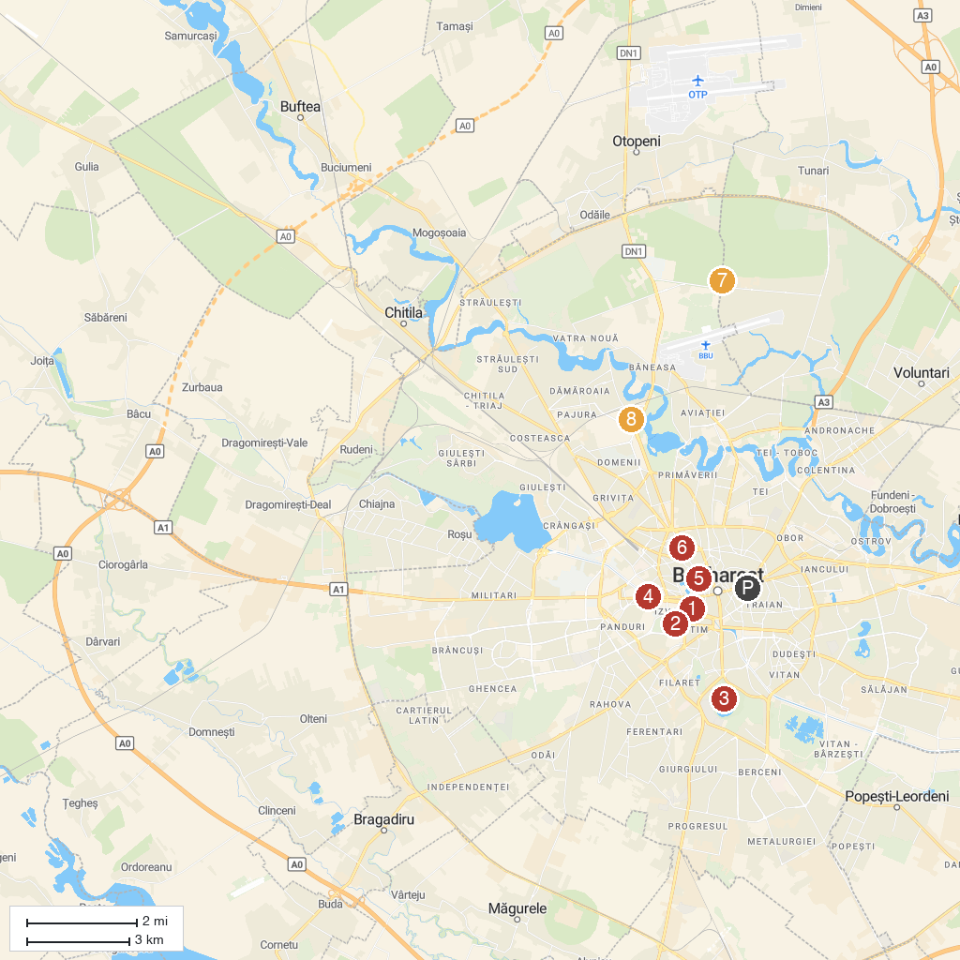
MAP KEY
1. Michael the Voivode Church | 5. National Museum of Art
2. Palace of Parliament | 6. Palace Casino
3. Tineretului Park | 7. Zoo Bucharest
4. The Monument of Medical Heroes | 8. The House of the Free Press
P. Cruise port / terminal
Map © MapTiler © OpenStreetMap contributors · cruiseports.org

