Brussels, Belgium
Belgium's grand capital rewards cruisers with a UNESCO World Heritage main square, Baroque guild halls dripping in gold, and streets thick with the smell of waffles and chocolate. River ships berth at the Brussels Cruise Terminal on the Brussels-Scheldt Maritime Canal, a short ride from the historic centre.
⚓ Docked at Brussels Cruise Terminal · 🕒 Typical call: full day or overnight · 💶 Euro (€) · 🗣️ French, Dutch (English widely spoken)
✍️ MY DAY IN PORT (FILL IN)
Ship / Date
In port | arrive ______ · all aboard ______
Booked excursion
Notes / meeting point
GETTING ASHORE
- Docking: Brussels Cruise Terminal on the Brussels-Scheldt Maritime Canal, in the city's northwest. No tender — direct berth.
- Transfer to centre: ~15-20 min by taxi, tram, or metro to the Grand Place area
- Best For: History, food culture, architecture, EU politics buffs, chocolate & beer lovers
- Don't Miss: Grand Place at golden hour — arguably Europe's finest city square
GETTING AROUND
- 🚕 Taxi: €10–€20 to city center — Licensed taxis are available near the terminal. The meter rate is €1.80/km within the Brussels Capital Region.
- 📱 Rideshare: ✅ Uber, Bolt
- 🚌 Hop-on hop-off: ✅ Tootbus
TOP THINGS TO DO
- Grand Place & Old Town Walking Tour — Brussels' showpiece square is a UNESCO World Heritage Site ringed by ornate 17th-century guild halls and the soaring Gothic Town…
- Belgian Chocolate & Beer Tasting — Belgium produces some of the world's finest chocolate and hundreds of artisan beers.
- Atomium & Mini-Europe — The Atomium — a 102-metre steel atom built for the 1958 World's Fair — remains Brussels' most striking landmark.
- EU Quarter & Parlamentarium — Brussels is the de-facto capital of the European Union.
- Royal Museums of Fine Arts — Belgium's premier art collection spans Old Masters to modern Surrealism, including the world's largest Magritte Museum.
BEST WALKS
- Grand Place to the Atomium: ~3 km city walk + metro | 1.5 hrs — Start at the Grand Place for the guild halls, then detour to Manneken Pis a block south.
- Mont des Arts Panorama Loop: ~1.5 km | 45 min — From the Grand Place walk up to Mont des Arts garden for panoramic views of the city skyline.
WEATHER · DAYLIGHT · MONEY
Month | High °F | Low °F | Rainy days
May | 65 | 48 | 11
Jul | 74 | 58 | 11
Sep | 68 | 54 | 11
Daylight: May 5:53AM–9:25PM · Jul 5:46AM–9:49PM · Sep 7:18AM–7:56PM
cruiseports.org/brussels · Confirm terminal & all-aboard time with your ship

Brussels, Belgium — Port Map
Red = walkable sights · Amber = excursions farther out · P = cruise terminal
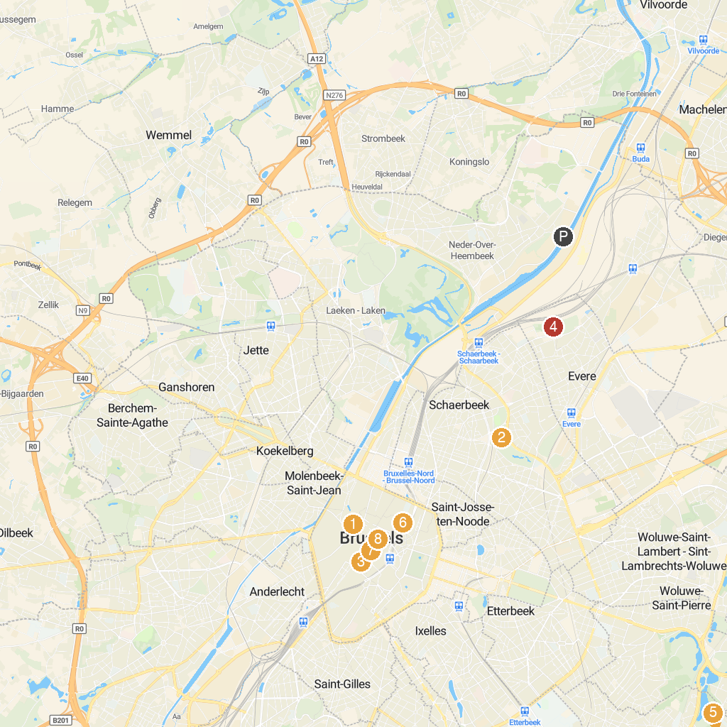
MAP KEY
1. Saint Catherine Catholic Church | 5. Château de la Solitude
2. Josaphat Park | 6. Comics Art Museum | Brussels
3. Manneken Pis | 7. Grand Place
4. Moeraske | 8. Jeanneke Pis
P. Cruise port / terminal
Map © MapTiler © OpenStreetMap contributors · cruiseports.org

