Bruinisse, Zeeland, Netherlands
A compact Zeeland fishing village where mussel boats share the harbor with visiting ships, backed by Europe's largest saltwater lake and the engineering marvels of the Delta Works.
⚓ Docked at marina quay · 🕒 Typical call: 5–7 hrs · 💶 Currency: Euro (€) · 🗣️ Language: Dutch
✍️ MY DAY IN PORT (FILL IN)
Ship / Date
In port | arrive ______ · all aboard ______
Booked excursion
Notes / meeting point
GETTING ASHORE
- Docking: Small ships dock alongside Jachthaven Bruinisse marina; no large cruise terminal
- Walk to center: 2–5 min on foot from the marina to the harbor front and village center
- Best For: Mussels, cycling the Delta, water sports on the Grevelingenmeer, Zeeland heritage
- Don't Miss: Fresh mussels at a harborside restaurant and the Brusea Fishing Museum
GETTING AROUND
- 🚕 Taxi: €10–€20 — Local taxis serve Bruinisse with a base fare of roughly €5; short village rides typically run €10–€20. Book via phone or
- 📱 Rideshare: ✅ Uber
TOP THINGS TO DO
- Brusea Fishing Museum — Explore the history of mussel farming and harbor life in Bruinisse at this local heritage museum, which includes a restored…
- Grevelingenmeer Water Sports — The Grevelingenmeer is Western Europe's largest saltwater lake and a haven for sailing, windsurfing, kitesurfing, diving, and…
- Watersnoodmuseum — Flood Museum — A short drive from Bruinisse, this striking museum chronicles the catastrophic 1953 North Sea flood that devastated Zeeland and…
- Cycle the Brouwersdam & Delta Works — Rent a bike and ride to the Brouwersdam, the massive Delta Works dam separating the Grevelingenmeer from the North Sea, with…
- Mussel Tasting at the Harbor — Bruinisse is the self-proclaimed mussel capital of the Netherlands.
BEST WALKS
- Harbor & Mussel Boulevard Loop: 1.5 km · 20–30 min · Easy — Walk from the marina quay along the Havendijk past the working mussel boats, past the Mussel…
- Grevelingenmeer Shoreline Walk: 3–4 km · 45–60 min · Easy — Follow the lakeside path south from the marina along the Grevelingenmeer shoreline.
WEATHER · DAYLIGHT · MONEY
Month | High °F | Low °F | Rainy days
May | 63 | 49 | 12
Jul | 72 | 59 | 13
Sep | 68 | 56 | 11
Daylight: May 5:51AM–9:29PM · Jul 5:43AM–9:54PM · Sep 7:18AM–7:57PM
cruiseports.org/bruinisse · Confirm terminal & all-aboard time with your ship

Bruinisse, Zeeland, Netherlands — Port Map
Red = walkable sights · Amber = excursions farther out · P = cruise terminal
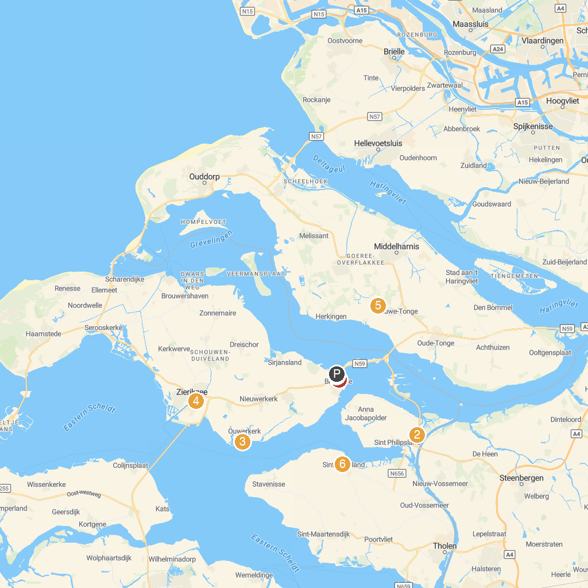
MAP KEY
1. Brusea museum | 5. Zierikzee
2. Slikken van de Heen | 6. Faunapark Flakkee
3. National Monument Flood 1953 | 7. Streekmuseum "The Meestoof '
4. Zuidhavenpoort, Old Port, Zierikzee, Netherlands | 8. Zeehondensafari
P. Cruise port / terminal
Map © MapTiler © OpenStreetMap contributors · cruiseports.org

