Brønnøysund, Nordland, Norway
A compact Norwegian coastal town that punches above its size — home to a mountain with a hole through it, a UNESCO island group teeming with eider ducks, and a quay monument celebrating its claim as 'the town in the centre of Norway'.
⚓ Docked (town pier) · 🕒 Typical call: 6–8 hrs · 💵 Norwegian Krone (NOK) · 🗣️ Norwegian (English widely spoken)
✍️ MY DAY IN PORT (FILL IN)
Ship / Date
In port | arrive ______ · all aboard ______
Booked excursion
Notes / meeting point
GETTING ASHORE
- Docking: Small/mid ships dock at Midthavna pier in the town centre; larger ships use Nordhavna (Gårdsøya), ~1 km north
- Walk to centre: Steps from the pier — the town is compact and flat along the harbour
- Best For: Torghatten hike, UNESCO Vega Islands, Norwegian coastal culture
- Don't Miss: Walking through Torghatten's 160-metre natural tunnel with panoramic archipelago views
GETTING AROUND
- 🚕 Taxi: 200–300 NOK one-way (~$20–30 USD) — Taxis wait at the harbor and are the best option for reaching Torghatten mountain (~15-min drive). Metered fares; no app
- 📱 Rideshare: ❌ not available
TOP THINGS TO DO
- Torghatten — Hike Through the Mountain — A 160-metre natural tunnel pierces Torghatten hill, formed by ice-age erosion.
- Vega Archipelago — UNESCO World Heritage — Over 6,500 islands, reefs and skerries make up this UNESCO site, celebrated for 1,500 years of islanders harvesting eiderdown by…
- Norwegian Aquaculture Centre (Norsk Havbrukssenter) — An interactive museum north of town that demystifies Norway's salmon-farming industry with underwater cameras, live fish feeding…
- Hildurs Urterarium — Herb Farm & Garden — A 250-year-old family farm just outside town with 400 herb varieties, 100 rose types, and 1,000 cacti species.
- Brønnøysund Town Walk & Brønnøy Church — Stroll Havnegata along the marina, spot the Centre-of-Norway monument on the quay, and visit Brønnøy Church — a Neo-Gothic stone…
BEST WALKS
- Harbour Stroll & Centre of Norway: 1–2 km · 30–40 min · flat — Walk Havnegata from the cruise pier past the visitors' marina to the Centre-of-Norway monument…
- Skarsåsen WWII Fortress Viewpoint: 2–3 km · ~1 hr · gentle incline — A short walk up to the Skarsåsen coastal artillery fortress from WWII.
WEATHER · DAYLIGHT · MONEY
Month | High °F | Low °F | Rainy days
May | 51 | 41 | 17
Jul | 63 | 53 | 16
Sep | 56 | 48 | 18
Daylight: Sep 6:32AM–7:37PM
cruiseports.org/bronnoysund · Confirm terminal & all-aboard time with your ship

Brønnøysund, Nordland, Norway — Port Map
Red = walkable sights · Amber = excursions farther out · P = cruise terminal
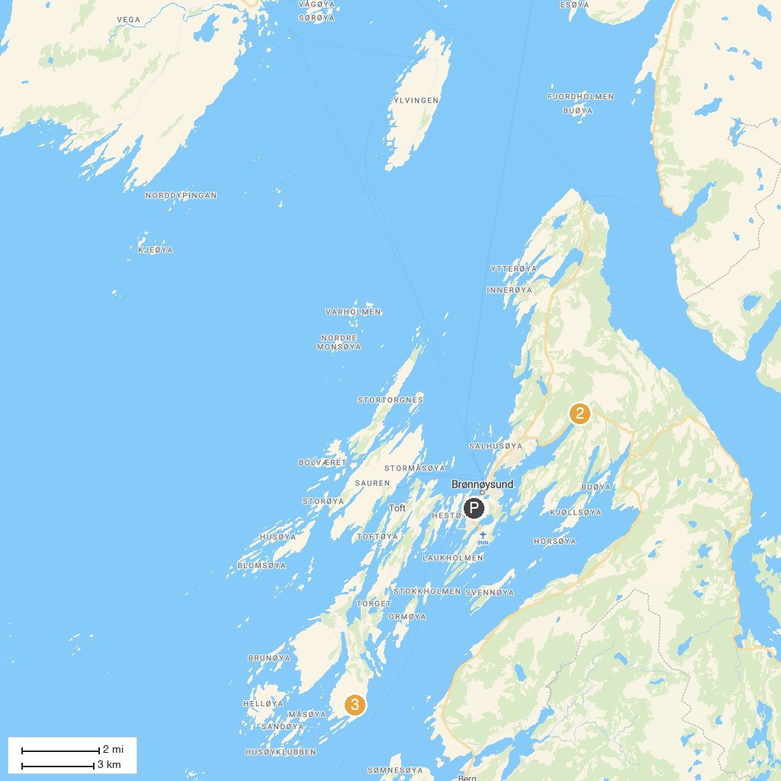
MAP KEY
1. Brønnøy Church | 3. Torghatten - Nasjonale turistveger
2. Trælvikosen
P. Cruise port / terminal
Map © MapTiler © OpenStreetMap contributors · cruiseports.org

