Bremerton, Washington, USA
A revitalized Navy town on Puget Sound, Bremerton punches above its size — destroyer museums, bonsai gardens, and a 30-minute fast ferry to downtown Seattle all within easy reach.
⚓ Docked (downtown marina) · 🕒 Typical call: 6-8 hrs · 💵 US Dollar · 🗣️ English
✍️ MY DAY IN PORT (FILL IN)
Ship / Date
In port | arrive ______ · all aboard ______
Booked excursion
Notes / meeting point
GETTING ASHORE
- Docking: Alongside at Bremerton Marina / downtown boardwalk — no tender required
- Walk to center: Steps — USS Turner Joy and Puget Sound Navy Museum are on the boardwalk
- Best For: Naval history buffs, Seattle day-trippers, waterfront strolls
- Don't Miss: Walk aboard USS Turner Joy, then fast-ferry to Seattle's Pike Place Market
GETTING AROUND
- 🚕 Taxi: $7–12 (city center) — Local taxis serve the harborside area. Short hops within downtown run $7–12; confirm metered rates with the driver befor
- 📱 Rideshare: ✅ Uber, Lyft
TOP THINGS TO DO
- USS Turner Joy Naval Destroyer Museum — Step aboard this Vietnam-era destroyer docked on the Bremerton Boardwalk.
- Puget Sound Navy Museum — Free museum next to the ferry terminal covering Puget Sound Naval Shipyard history, nuclear aircraft carriers, and submarine…
- Seattle Day Trip by Fast Ferry — The Kitsap Transit fast ferry reaches downtown Seattle in ~30 minutes.
- Elandan Gardens — World-renowned bonsai collection set on a hillside above Sinclair Inlet, featuring trees hundreds of years old and sweeping water…
- Downtown Arts District & Manette — Stroll downtown's galleries, independent shops, breweries, and cafes, then cross the Manette Bridge to the Manette neighborhood…
BEST WALKS
- Boardwalk Naval Trail: 1.5 miles · Flat · 30-45 min — Walk the full Bremerton Boardwalk from the marina past Harborside Fountain Park, the Puget Sound…
- Manette Bridge Loop: 2 miles · Flat · 45-60 min — From the boardwalk, walk east through downtown, cross the Manette Bridge over Port Washington…
WEATHER · DAYLIGHT · MONEY
Month | High °F | Low °F | Rainy days
May | 64 | 48 | 10
Jul | 75 | 57 | 4
Sep | 68 | 54 | 11
Daylight: May 5:33AM–8:41PM · Jul 5:29AM–9:03PM · Sep 6:48AM–7:21PM
cruiseports.org/bremerton-wa · Confirm terminal & all-aboard time with your ship

Bremerton, Washington, USA — Port Map
Red = walkable sights · Amber = excursions farther out · P = cruise terminal
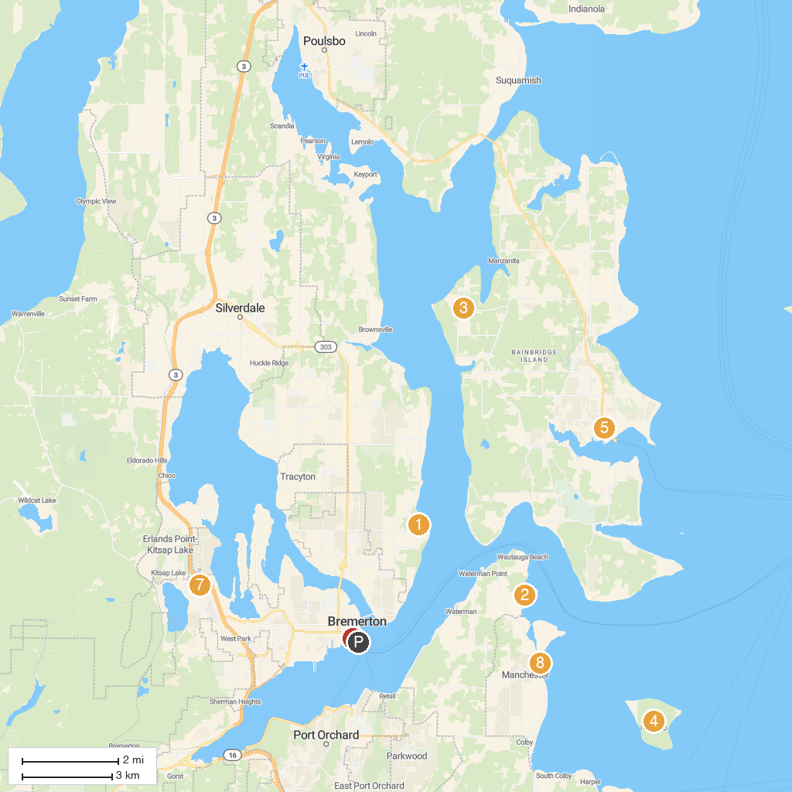
MAP KEY
1. Illahee State Park | 5. Kids Discovery Museum
2. Manchester State Park | 6. Puget Sound Navy Museum
3. Battle Point Park | 7. N.A.D. Park
4. Blake Island Marine State Park | 8. Pomeroy Park Boat Ramp
P. Cruise port / terminal
Map © MapTiler © OpenStreetMap contributors · cruiseports.org

