Bremerhaven, Bremen, Germany
Germany's deep-water cruise gateway packs an impressive punch: three world-class museums are a short walk from the pier, and the medieval city of Bremen is just 45 minutes by train.
⚓ Docked (Columbus Cruise Center) · 🕒 Typical call: 8–10 hrs · 💶 Euro (€) · 🗣️ German (English widely spoken)
✍️ MY DAY IN PORT (FILL IN)
Ship / Date
In port | arrive ______ · all aboard ______
Booked excursion
Notes / meeting point
GETTING ASHORE
- Docking: Pier berth at Columbus Cruise Center Bremerhaven (CCCB); no tendering required
- Walk to center: ~10 min walk (or 5-min taxi) to the Havenwelten museum district
- Best For: Maritime history, emigration stories, day trip to Bremen
- Don't Miss: German Emigration Center — one of Europe's best museums
GETTING AROUND
- 🚕 Taxi: €12–€15 — Taxis are available at the cruise terminal. The city center is about 5 km away — roughly a 10-minute ride. Base fare €5,
TOP THINGS TO DO
- German Emigration Center (Deutsches Auswandererhaus) — Follow the personal stories of seven million emigrants who left Europe for the New World through Bremerhaven between 1830 and 1974.
- Klimahaus 8° Ost — Climate House — Walk the 8th meridian east through a series of immersive climate zones — from the Sahara to Antarctica — with realistic…
- German Maritime Museum (Deutsches Schifffahrtsmuseum) — Germany's largest maritime museum spans centuries of seafaring history.
- Day Trip to Bremen — The medieval Hanseatic city of Bremen is just 45 minutes by train.
- Schaufenster Fischereihafen — Fish Harbor — Bremerhaven's restored old fishing harbor is the place to eat fresh Fischbrötchen (fish sandwiches), smoked salmon, and local…
BEST WALKS
- Havenwelten Museum Loop: 2.5 km · ~35 min walk · Flat — From the cruise terminal, walk north along the Weser Dyke promenade to the Klimahaus, German…
- Fish Harbor Stroll: 3 km · ~40 min walk · Flat — Head west from the terminal past the Havenwelten to the Schaufenster Fischereihafen for lunch at…
WEATHER · DAYLIGHT · MONEY
Month | High °F | Low °F | Rainy days
May | 62 | 48 | 13
Jul | 71 | 59 | 16
Sep | 66 | 54 | 12
Daylight: May 5:25AM–9:20PM · Jul 5:16AM–9:46PM · Sep 6:59AM–7:40PM
cruiseports.org/bremerhaven · Confirm terminal & all-aboard time with your ship

Bremerhaven, Bremen, Germany — Port Map
Red = walkable sights · Amber = excursions farther out · P = cruise terminal
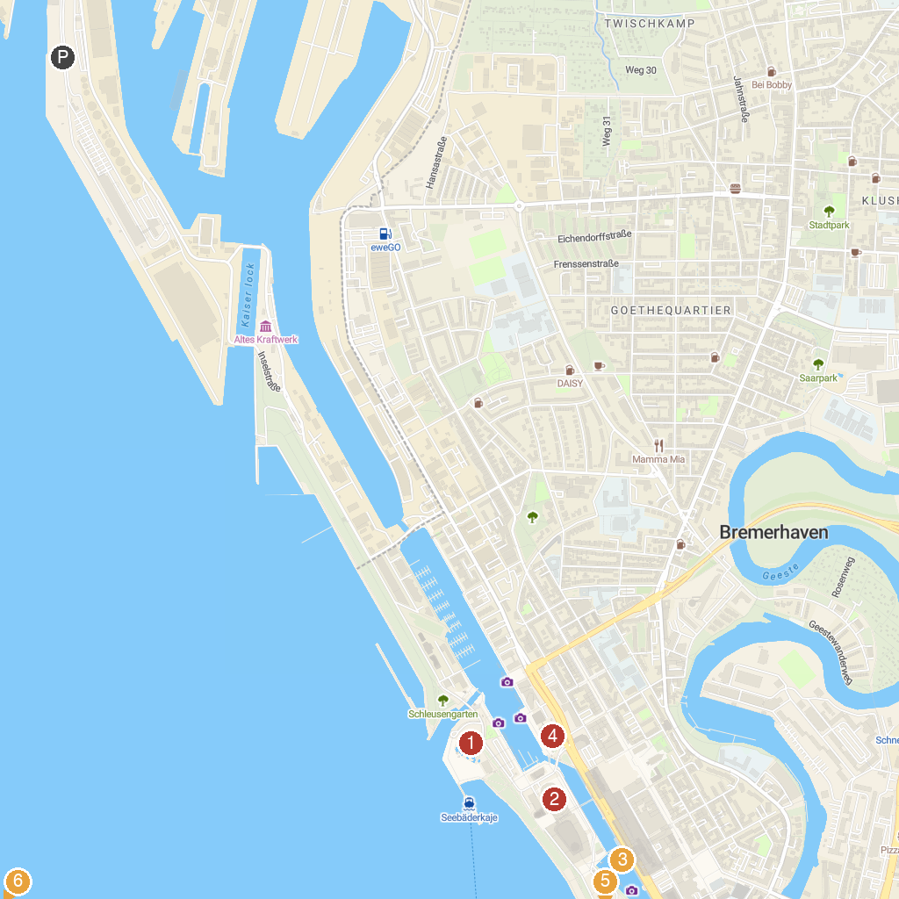
MAP KEY
1. Großsteingrab Bülzenbett | 5. German Emigration Center
2. Bremerhaven Zoo | 6. German Maritime Museum
3. Klimahaus Bremerhaven 8 ° Ost | 7. Museum Nordenham
4. U-Boot Wilhelm Bauer
P. Cruise port / terminal
Map © MapTiler © OpenStreetMap contributors · cruiseports.org

