Bremen, Bremen, Germany
River-cruise ships moor right in the heart of this compact Hanseatic city on the Weser — where Brothers Grimm fairy tales meet a UNESCO-listed market square and world-famous beer, all within walking distance of the quay.
⚓ Docked (central Bremen, Weser riverside) · 🕒 Typical call: overnight / 8-12 hrs · 💶 Euro (EUR) · 🗣️ German (English widely understood)
✍️ MY DAY IN PORT (FILL IN)
Ship / Date
In port | arrive ______ · all aboard ______
Booked excursion
Notes / meeting point
GETTING ASHORE
- Docking: Central Bremen, Weser riverside quay — pier mooring, no tender
- City center: Walkable — Marktplatz is ~10-15 min on foot from the quay
- Best For: History, architecture, fairy-tale culture, beer tasting
- Don't Miss: Marktplatz UNESCO ensemble, Schnoorviertel alleys, Beck's Brewery
GETTING AROUND
- 🚕 Taxi: €80–100 one way — Taxis and pre-booked private transfers run the 60 km from Bremerhaven port to Bremen. Cost-effective when split among 3–
- 📱 Rideshare: ✅ Uber, Bolt
- 🚌 Hop-on hop-off: ✅
TOP THINGS TO DO
- UNESCO Market Square & Rathaus — Bremen's Marktplatz is a UNESCO World Heritage site anchored by the ornate Weser Renaissance Town Hall (Rathaus) and the…
- Schnoorviertel — Bremen's Medieval Quarter — The Schnoor is Bremen's oldest neighbourhood: a dense web of 15th–16th century half-timbered houses, tiny artisan shops, and…
- Böttcherstraße & Paula Modersohn-Becker Museum — A 110-metre expressionist street built in the 1920s by coffee merchant Ludwig Roselius, featuring gold mosaics, craft workshops…
- Beck's Brewery Tour — Bremen is the home of Beck's beer, one of Germany's most exported brews.
- German Emigration Center, Bremerhaven — For a coastal day trip, this award-winning museum in Bremerhaven (~45-55 min by train from Bremen Hauptbahnhof) tells the story…
BEST WALKS
- Old Town Highlights Loop: 3 km · 60-90 min · Easy — Walk from Bremen Hauptbahnhof west along Sögestraße to Marktplatz, taking in the Rathaus and Roland…
- Böttcherstraße & Kunsthalle: 1.5 km · 30-45 min · Easy — From Marktplatz, dip into Böttcherstraße to see the expressionist facades and gold portal.
WEATHER · DAYLIGHT · MONEY
Month | High °F | Low °F | Rainy days
May | 64 | 48 | 12
Jul | 73 | 58 | 12
Sep | 67 | 53 | 11
Daylight: May 5:26AM–9:16PM · Jul 5:17AM–9:43PM · Sep 6:59AM–7:39PM
cruiseports.org/bremen · Confirm terminal & all-aboard time with your ship

Bremen, Bremen, Germany — Port Map
Red = walkable sights · Amber = excursions farther out · P = cruise terminal
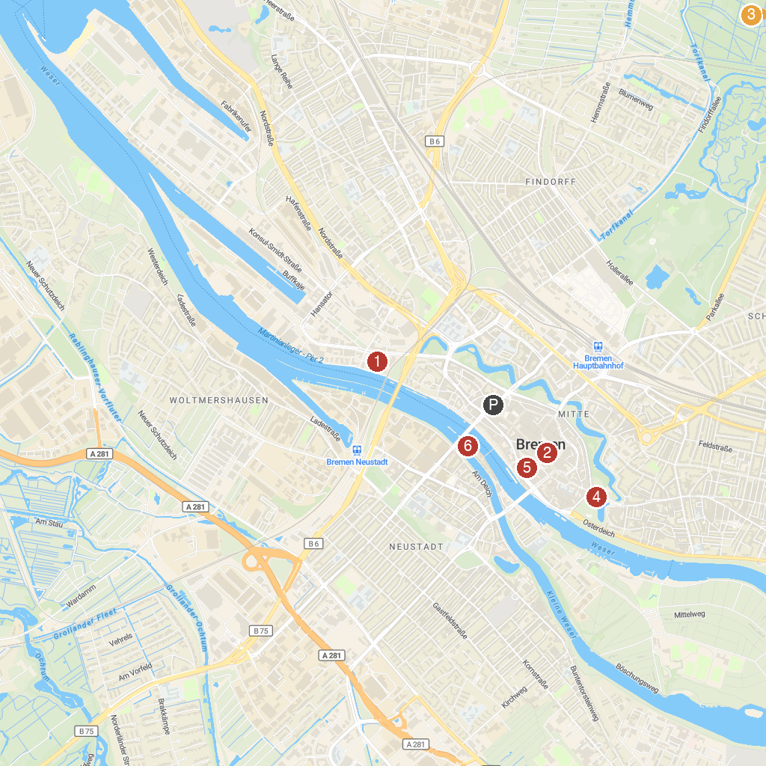
MAP KEY
1. Weser Tower | 4. Kunsthalle Bremen
2. Bremen Town Hall | 5. Böttcherstraße
3. Universum Bremen | 6. Weserburg | Museum of Modern Art
P. Cruise port / terminal
Map © MapTiler © OpenStreetMap contributors · cruiseports.org

