Breisach am Rhein, Baden-Württemberg, Germany
Perched at the German-French border on the Rhine, Breisach punches well above its size — a hilltop Romanesque-Gothic Minster, acclaimed Baden wines, and day-trip access to Colmar, Neuf-Brisach, and the Black Forest all within one shore day.
⚓ Docked (Rhine embankment) · 🕒 Typical call: 8–12 hrs · 💶 Euro (€) · 🗣️ German (French steps away)
✍️ MY DAY IN PORT (FILL IN)
Ship / Date
In port | arrive ______ · all aboard ______
Booked excursion
Notes / meeting point
GETTING ASHORE
- Docking: Ships berth alongside the Rhine embankment; town center and Minster hill are a 5–10 min walk.
- Walk to center: 5 min flat to Marktplatz; 10–15 min uphill to St. Stephen's Minster on Münsterberg.
- Best For: Wine lovers, culture day-trippers to Colmar or the Black Forest, and history buffs.
- Don't Miss: Views from St. Stephen's Minster, a tasting at Badischer Winzerkeller, and a stroll through Colmar's Petite Venise.
GETTING AROUND
- 🚕 Taxi: €10–€20 within town — Taxi Schätzle is a local provider serving Breisach and surroundings. Fares follow Breisgau-Hochschwarzwald district tari
- 📱 Rideshare: ❌ not available
TOP THINGS TO DO
- Colmar Day Trip — Alsace's Fairy-Tale Capital — Thirty minutes by bus across the Rhine, Colmar's Petite Venise canal quarter, half-timbered Grand Rue, and the Unterlinden Museum…
- Black Forest Excursion — Cuckoo Clocks & Forest Views — Cruise-line buses run to Hofgut Sternen in the Höllental valley, where artisans demonstrate cuckoo-clock making, Black Forest ham…
- Neuf-Brisach — UNESCO Star Fortress — A roughly 5 km walk or short taxi ride across the Rhine bridge brings you to Vauban's perfectly preserved star-shaped fortress…
- Baden Wine Tasting at Badischer Winzerkeller — One of Europe's largest wine co-operatives sits right in Breisach and offers cellar tours and tastings of Baden Pinot Noir…
- Breisach Old Town & St. Stephen's Minster — Climb Münsterberg hill to the 13th-century Romanesque-Gothic Minster for sweeping 360° views over the Rhine, the Vosges…
BEST WALKS
- Old Town & Minster Hill Loop: 2.5 km · 1–2 hrs · Some steep cobblestones — From the Rhine embankment, walk up Rheinstraße past the Rhine Gate (Rheintor) to the Marktplatz…
- Rhine Bridge Walk to France: 6 km return · 1.5 hrs · Flat — Head south along the Rhine embankment path to the Rheinbrücke, cross into France (no passport…
WEATHER · DAYLIGHT · MONEY
Month | High °F | Low °F | Rainy days
May | 67 | 49 | 13
Jul | 80 | 61 | 12
Sep | 72 | 54 | 9
Daylight: May 5:51AM–9:01PM · Jul 5:46AM–9:24PM · Sep 7:07AM–7:41PM
cruiseports.org/breisach-am-rhein · Confirm terminal & all-aboard time with your ship

Breisach am Rhein, Baden-Württemberg, Germany — Port Map
Red = walkable sights · Amber = excursions farther out · P = cruise terminal
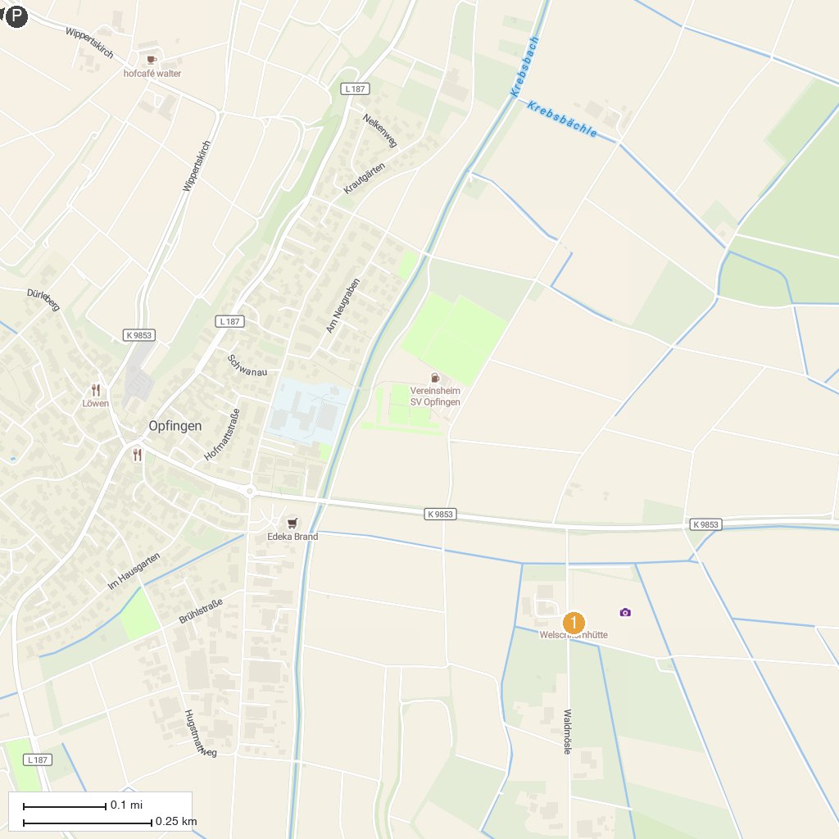
MAP KEY
1. Maislabyrinth | 3. Freiburger Rieselfeld
2. Samengarten Eichstetten am Kaiserstuhl | 4. Duft- und Kräutergarten
P. Cruise port / terminal
Map © MapTiler © OpenStreetMap contributors · cruiseports.org

