Braubach, Rhineland-Palatinate, Germany
A compact medieval town crowned by Marksburg — the only undestroyed hilltop castle on the Middle Rhine. Half-timbered lanes, Rhine promenades, and Riesling await just steps from the dock.
⚓ Docked (riverside quay) · 🕒 Typical call: 5–8 hrs · 💶 Euro (€) · 🗣️ German
✍️ MY DAY IN PORT (FILL IN)
Ship / Date
In port | arrive ______ · all aboard ______
Booked excursion
Notes / meeting point
GETTING ASHORE
- Docking: Riverside quay; ships dock directly on the Rhine, town center 2-min walk
- Walk to Marksburg: 30–40 min uphill hike or shuttle bus (~10 min) from the quay
- Best For: Castle history, Rhine Valley scenery, medieval architecture
- Don't Miss: Guided tour inside Marksburg Castle — the only major Rhine castle never destroyed
GETTING AROUND
- 🚕 Taxi: €6–10 each way — Funktaxi-Braubach (the only taxi operator in town) can take you up to Marksburg Castle in about 3–5 minutes. Book at the
- 📱 Rideshare: ❌ not available
TOP THINGS TO DO
- Marksburg Castle Guided Tour — The only major hilltop castle on the Middle Rhine never to be destroyed, Marksburg offers an exceptionally authentic medieval…
- Braubach Old Town Walk — Stroll narrow lanes past well-preserved 16th–17th-century half-timbered houses to Marktplatz.
- Rheinsteig Trail Walk — Braubach is a trailhead for the Rheinsteig, a scenic long-distance hiking path above the Rhine gorge.
- Riesling Wine Tasting — The Middle Rhine Valley is Riesling country.
BEST WALKS
- Riverside Promenade to Marktplatz: 0.3 km · 5 min · Flat — A quick stroll from the cruise dock along the Rhine promenade straight into Braubach's charming…
- Old Town Loop: Schloss Philippsburg & St. Remigius: 1.5 km · 25 min · Easy — From Marktplatz, wind through the historic lanes past the 16th-century Schloss Philippsburg and its…
- Hike to Marksburg Castle: 2 km · 35–40 min · Steep — Follow the forest trail uphill from the Braubach quay area to Marksburg Castle.
WEATHER · DAYLIGHT · MONEY
Month | High °F | Low °F | Rainy days
May | 66 | 49 | 12
Jul | 77 | 60 | 11
Sep | 70 | 54 | 9
Daylight: May 5:42AM–9:09PM · Jul 5:36AM–9:33PM · Sep 7:05AM–7:42PM
cruiseports.org/braubach · Confirm terminal & all-aboard time with your ship

Braubach, Rhineland-Palatinate, Germany — Port Map
Red = walkable sights · Amber = excursions farther out · P = cruise terminal
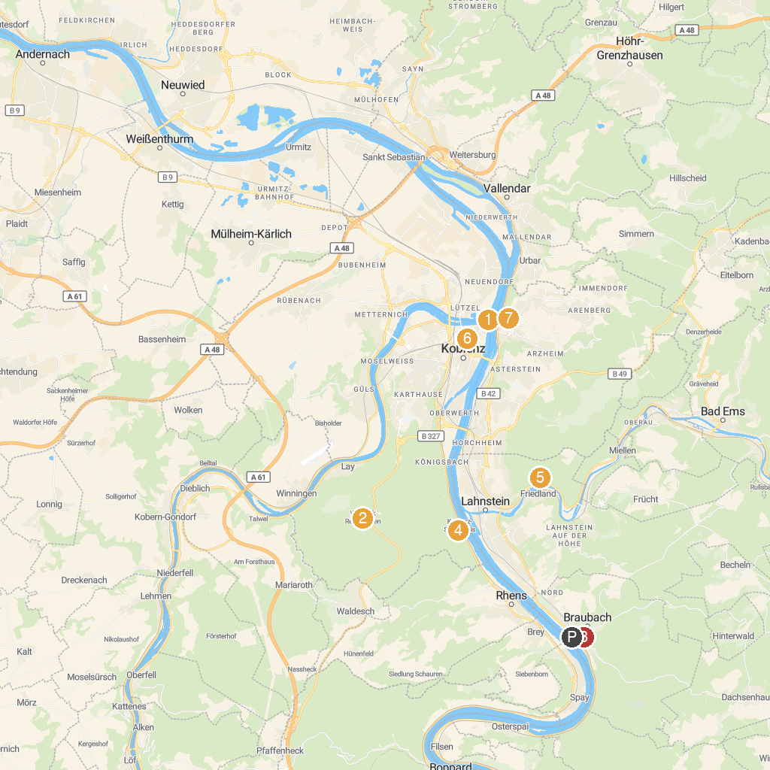
MAP KEY
1. Deutsches Eck | 5. Ruppertsklamm
2. Remstecken | 6. Rheinfels Castle
3. Marksburg | 7. Mittelrheinmuseum Koblenz
4. Stolzenfels Castle | 8. Ehrenbreitstein Fortress
P. Cruise port / terminal
Map © MapTiler © OpenStreetMap contributors · cruiseports.org

