Brandýs nad Labem-Stará Boleslav, Central Bohemia, Czech Republic
Two towns split by the Elbe northeast of Prague — one a Habsburg Renaissance retreat, the other the spot where Bohemia's patron saint met his end in 935 AD. History runs deep in every cobblestone here.
⚓ Docked (river pier) · 🕒 Typical call: 6–8 hrs · 💵 Czech Koruna (CZK) · 🗣️ Czech
✍️ MY DAY IN PORT (FILL IN)
Ship / Date
In port | arrive ______ · all aboard ______
Booked excursion
Notes / meeting point
GETTING ASHORE
- Docking: River mooring on the Elbe; an emerging, limited river-cruise stop with most access via Mělník or by road
- Walk to center: ~10 min walk to Brandýs town square; Stará Boleslav a short walk across the bridge
- Best For: History lovers, pilgrims, Habsburg architecture, day-trippers from Prague
- Don't Miss: Basilica of St. Wenceslas in Stará Boleslav — Bohemia's oldest pilgrimage church
GETTING AROUND
- 🚕 Taxi: 150–300 CZK (~€6–12) — Local taxis cover short hops within town quickly. Pre-booked transfers to Prague airport or city center are also availab
- 📱 Rideshare: ✅ Bolt
TOP THINGS TO DO
- Brandýs nad Labem Castle — This Gothic castle was transformed into a magnificent Renaissance chateau in the mid-16th century, famous for its…
- Stará Boleslav Pilgrimage Quarter — Stará Boleslav is the most important pilgrimage site in Bohemia, marking the spot where Duke Wenceslas was murdered by his…
- Jewish Cemetery & Synagogue — One of the oldest Jewish cemeteries in Bohemia, with burials documented from after 1568, alongside a historic synagogue on Na…
- Day Trip to Prague — Some river itineraries position Brandýs as a Prague-area stop — the capital is roughly 22 km southwest.
- Proboštská Lakes — A cluster of recreational lakes on the outskirts of town, popular for swimming and windsurfing in summer and hosting open-air…
BEST WALKS
- Brandýs to Stará Boleslav Pilgrimage Walk: 3.5 km · ~50 min · flat riverside path + bridge — From the river pier, follow the Elbe bank into Brandýs nad Labem and pass through Masarykovo Square…
- Brandýs Castle & Old Town Stroll: 1.5 km · ~25 min · flat town streets — A short loop from the bridge into the Brandýs old town, past the Renaissance castle facade and the…
WEATHER · DAYLIGHT · MONEY
Month | High °F | Low °F | Rainy days
May | 67 | 49 | 11
Jul | 79 | 60 | 12
Sep | 70 | 53 | 9
Daylight: May 5:14AM–8:41PM · Jul 5:08AM–9:05PM · Sep 6:37AM–7:14PM
cruiseports.org/brandys-nad-labem-stara-boleslav · Confirm terminal & all-aboard time with your ship

Brandýs nad Labem-Stará Boleslav, Central Bohemia, Czech Republic — Port Map
Red = walkable sights · Amber = excursions farther out · P = cruise terminal
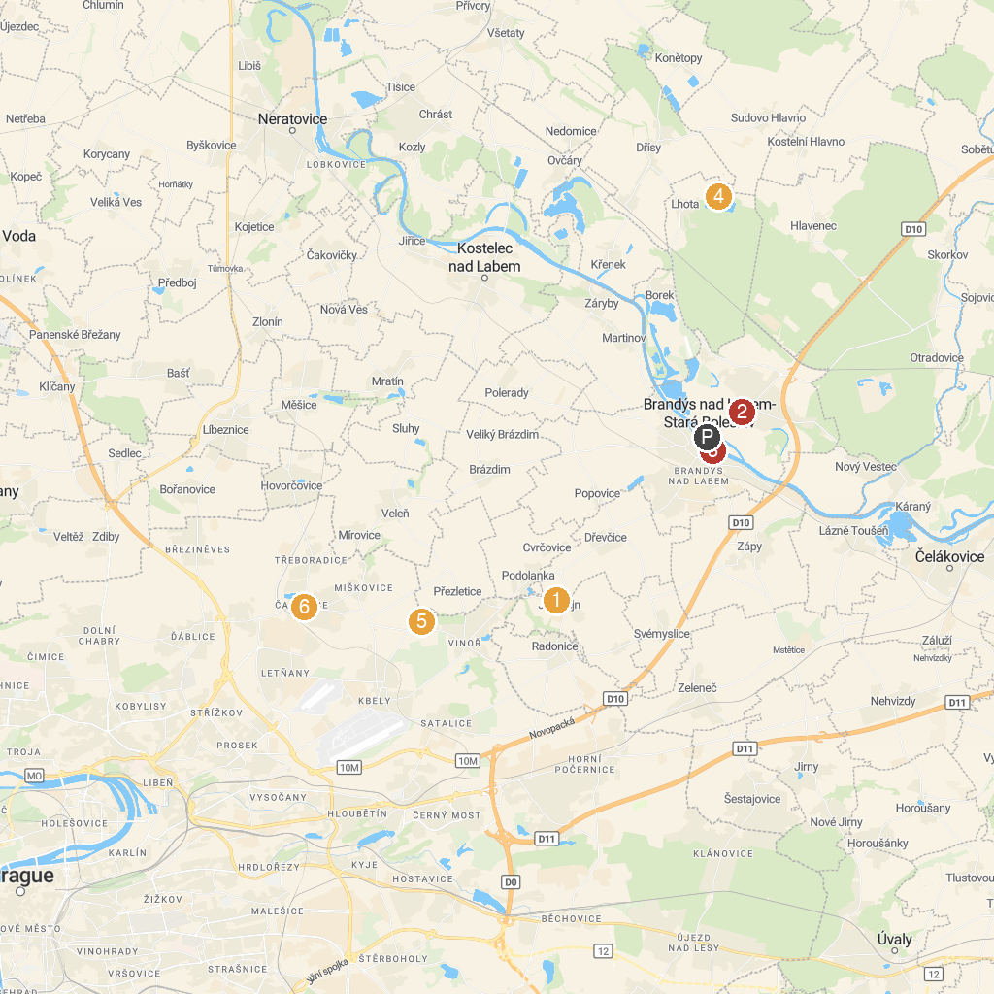
MAP KEY
1. Aquacentrum Letňany Lagoon | 5. Lake Lhota
2. Jenštejn | 6. The castle area Ctěnice
3. Basilica of the Blessed Virgin Mary | 7. Čakovice castle
4. Zámek Brandýs nad Labem | 8. Pragovka Art District
P. Cruise port / terminal
Map © MapTiler © OpenStreetMap contributors · cruiseports.org

