Bozcaada, Çanakkale, Turkey
A tiny Aegean island that has been making wine since antiquity, guarded by an Ottoman castle, and barely touched by mass tourism — Bozcaada (ancient Tenedos) rewards cruisers who step off the tender into its cobblestone lanes.
⚓ Tender / small-ship dock · 🕒 Typical call: 6-8 hrs · 💵 Turkish Lira (TRY) · 🗣️ Turkish · 🍷 Wine island
✍️ MY DAY IN PORT (FILL IN)
Ship / Date
In port | arrive ______ · all aboard ______
Booked excursion
Notes / meeting point
GETTING ASHORE
- Docking: Tender for large ships; small/luxury ships dock at the main pier in town
- Walk to center: Immediate — pier and tender dock are in the heart of Bozcaada Town
- Best For: Wine tasting, Aegean old-town atmosphere, beaches, Bozcaada Castle
- Don't Miss: Bozcaada Castle and a winery visit (Corvus or Amadeus are top picks)
GETTING AROUND
- 🚕 Taxi: Metered (short rides ~₺50–150 est.) — Taxis wait at the harbor and can take you to beaches, vineyards, or anywhere on the island. Convenient but can be in dem
TOP THINGS TO DO
- Bozcaada Castle — The island's most striking landmark, this well-preserved fortress dominates the harbor entrance.
- Winery Visit & Tasting — Bozcaada has produced wine since antiquity.
- Ayazma Beach — The island's most popular beach — white sand, turquoise Aegean water, sunbed hire, and a cafe.
- Old Town Walk — Greek & Ottoman Quarters — Bozcaada's compact old town layers Greek Orthodox houses and a clock tower alongside Ottoman mosques and timber-framed…
- Troy & Gallipoli from the Mainland — A roughly 35-minute ferry from Bozcaada to Geyikli port connects to guided day excursions to ancient Troy (less than an hour's…
BEST WALKS
- Harbor to Castle to Old Town Loop: 1.5 km · 45 min · Easy — Walk straight from the pier to Bozcaada Castle, explore the ramparts, then loop through the old…
- Town to Çayır Bay Beach: 1.8 km · 25 min walk · Easy — Çayır Bay on the north shore is within walking distance of town — a clean sandy beach popular with…
WEATHER · DAYLIGHT · MONEY
Month | High °F | Low °F | Rainy days
May | 74 | 60 | 6
Jul | 89 | 72 | 1
Sep | 82 | 67 | 3
Daylight: May 6:01AM–8:23PM · Jul 6:00AM–8:42PM · Sep 6:57AM–7:24PM
cruiseports.org/bozcaada-island · Confirm terminal & all-aboard time with your ship

Bozcaada, Çanakkale, Turkey — Port Map
Red = walkable sights · Amber = excursions farther out · P = cruise terminal
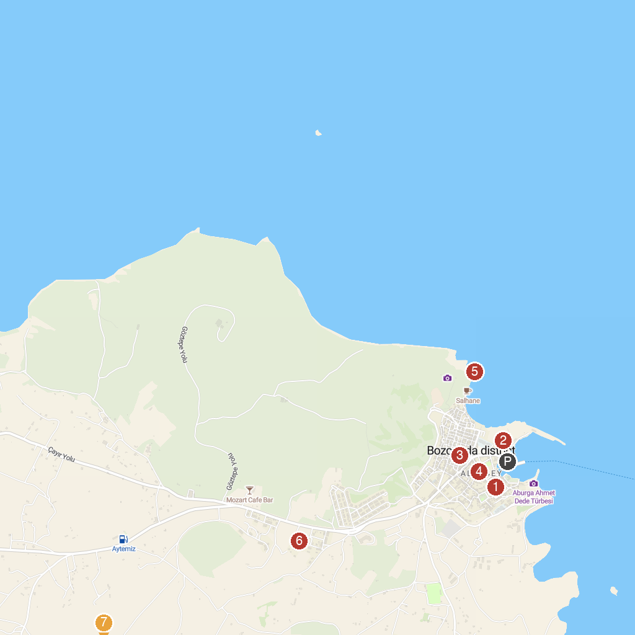
MAP KEY
1. Accommodations Bozcaada | 5. Bozcaada Yel Değirmenleri
2. Bozcaada Castle | 6. Ada Güzeli Konaklama Bozcaada
3. Bozcaada Yerel Tarih Araştırma Merkez Müzesi | 7. Ayana Koyu
4. Alaybey Cami
P. Cruise port / terminal
Map © MapTiler © OpenStreetMap contributors · cruiseports.org

