Bourg-sur-Gironde, Nouvelle-Aquitaine, France
Perched on the Dordogne just above its confluence with the Garonne, Bourg-sur-Gironde packs two millennia of history into a single limestone hillside — citadel ruins, troglodyte caves, and Côtes de Bourg vineyards all within a short walk of the pontoon.
⚓ Docked (river pontoon) · 🕒 Typical call: 6–8 hrs · 💶 Euro (€) · 🗣️ French
✍️ MY DAY IN PORT (FILL IN)
Ship / Date
In port | arrive ______ · all aboard ______
Booked excursion
Notes / meeting point
GETTING ASHORE
- Docking: Quai Jean Bart pontoon, ~300 m from town center
- Walk to centre: 5 min on foot from pontoon to ville basse
- Best For: Medieval history, Bordeaux wine, estuary scenery
- Don't Miss: Citadel panorama and Musée des Calèches
GETTING AROUND
- 🚕 Taxi: €30–€70 to Saint-André-de-Cubzac (~13 km) — Local taxis are available in the Gironde area. For the short distance into Bourg center a taxi is rarely needed; useful
- 📱 Rideshare: ✅ Uber
TOP THINGS TO DO
- Citadel & Musée des Calèches — Explore the ruined citadel on its rocky promontory above the estuary.
- Estuary Cruise — Carrelets & Cliffs — Board a small local boat (e.g., Clapotine) for a guided trip onto the Dordogne and Gironde estuary.
- Côtes de Bourg Wine Tasting — Bourg is the capital of the Côtes de Bourg appellation.
- Blaye Citadel Day Trip — A 20-minute drive across the estuary (ferry from Blaye or road via Bordeaux), the Blaye Citadel is a UNESCO World Heritage Vauban…
- Route de la Corniche Fleurie — The scenic cliff road between Bourg and Villeneuve winds past troglodyte dwellings, traditional carrelets, and limestone outcrops…
BEST WALKS
- Ville Basse to Citadel Loop: 2 km · 45–60 min · Easy/Moderate — From the pontoon, walk through the lower town past the covered washhouse, through Porte…
- Corniche Fleurie Walk: 3 km one-way · 1 hr · Easy — Head south-west out of town along the cliff road toward Villeneuve for views of carrelets and…
WEATHER · DAYLIGHT · MONEY
Month | High °F | Low °F | Rainy days
May | 69 | 53 | 11
Jul | 80 | 63 | 7
Sep | 76 | 59 | 8
Daylight: May 6:33AM–9:24PM · Jul 6:30AM–9:45PM · Sep 7:41AM–8:12PM
cruiseports.org/bourg-sur-gironde · Confirm terminal & all-aboard time with your ship

Bourg-sur-Gironde, Nouvelle-Aquitaine, France — Port Map
Red = walkable sights · Amber = excursions farther out · P = cruise terminal
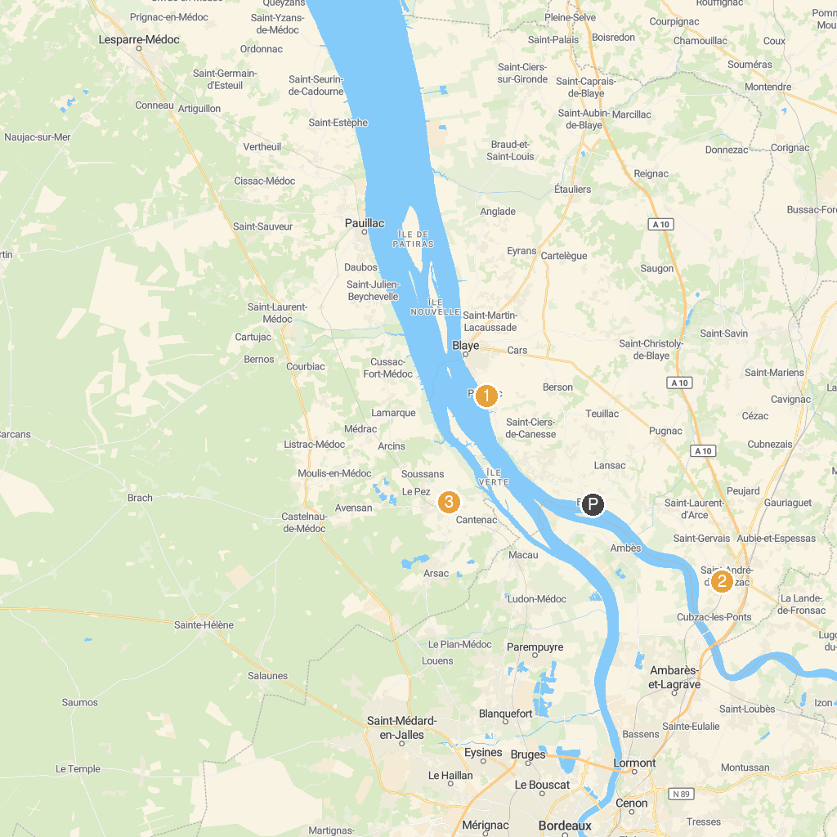
MAP KEY
1. Villa Gallo Romaine de Plassac | 3. Château Marquis de Terme Tourisme
2. Église catholique Saint-André-du-Nom-de-Dieu à Saint-André-de-Cubzac | 4. Tourist Office of Blaye
P. Cruise port / terminal
Map © MapTiler © OpenStreetMap contributors · cruiseports.org

