Bougival, Île-de-France, France
Monet and Renoir painted these very riverbanks. Bougival's sleepy Seine-side quays and Impressionist trail make for a peaceful half-day off the barge — with Versailles just 20 minutes away.
⚓ River barge — docked along Seine quay · 🕒 Typical call: 4–6 hrs · 💶 Euro (EUR) · 🗣️ French
✍️ MY DAY IN PORT (FILL IN)
Ship / Date
In port | arrive ______ · all aboard ______
Booked excursion
Notes / meeting point
GETTING ASHORE
- Docking: River barge ties up along the Seine embankment; you step straight off onto the quay
- Walk to center: Town center is immediately ashore; Impressionist trail starts within a few steps
- Best For: Art history lovers, cyclists, day-trippers to Versailles or Malmaison
- Don't Miss: The 2 km Chemin des Impressionnistes on Île de la Chaussée with enamel painting reproductions at their exact original locations
GETTING AROUND
- 🚕 Taxi: €28–€40 — Taxis and Uber/Bolt are readily available for the ~30-minute ride to central Paris. Uber estimated ~€31; metered taxis m
- 📱 Rideshare: ✅ Uber, Bolt
TOP THINGS TO DO
- Chemin des Impressionnistes — Walk the 2 km trail along the Île de la Chaussée where enamel plaques reproduce Impressionist paintings — Monet, Renoir, Sisley…
- Château de Malmaison — About 4 km east in Rueil-Malmaison, this elegant château was Empress Joséphine's beloved home and now a museum preserving…
- Palace of Versailles — The Sun King's palace is only about 8 km away — a 15-minute drive.
- Ivan Turgenev Museum — The Russian novelist Ivan Turgenev spent his final years in this chalet-dacha in Bougival.
- Parc de la Jonchère — A hillside park frequented by Impressionist painters for its views over the Seine valley.
BEST WALKS
- Chemin des Impressionnistes — Île de la Chaussée: 2 km · Flat · 45–60 min — Cross the footbridge from the quay onto the Île de la Chaussée and follow the enamel plaques…
- Quayside Stroll & Town Center: 1 km · Flat · 20–30 min — Walk the Seine embankment from the dock into Bougival's town center.
WEATHER · DAYLIGHT · MONEY
Month | High °F | Low °F | Rainy days
May | 66 | 49 | 13
Jul | 77 | 60 | 9
Sep | 71 | 55 | 8
Daylight: May 6:09AM–9:26PM · Jul 6:04AM–9:49PM · Sep 7:28AM–8:03PM
cruiseports.org/bougival · Confirm terminal & all-aboard time with your ship

Bougival, Île-de-France, France — Port Map
Red = walkable sights · Amber = excursions farther out · P = cruise terminal
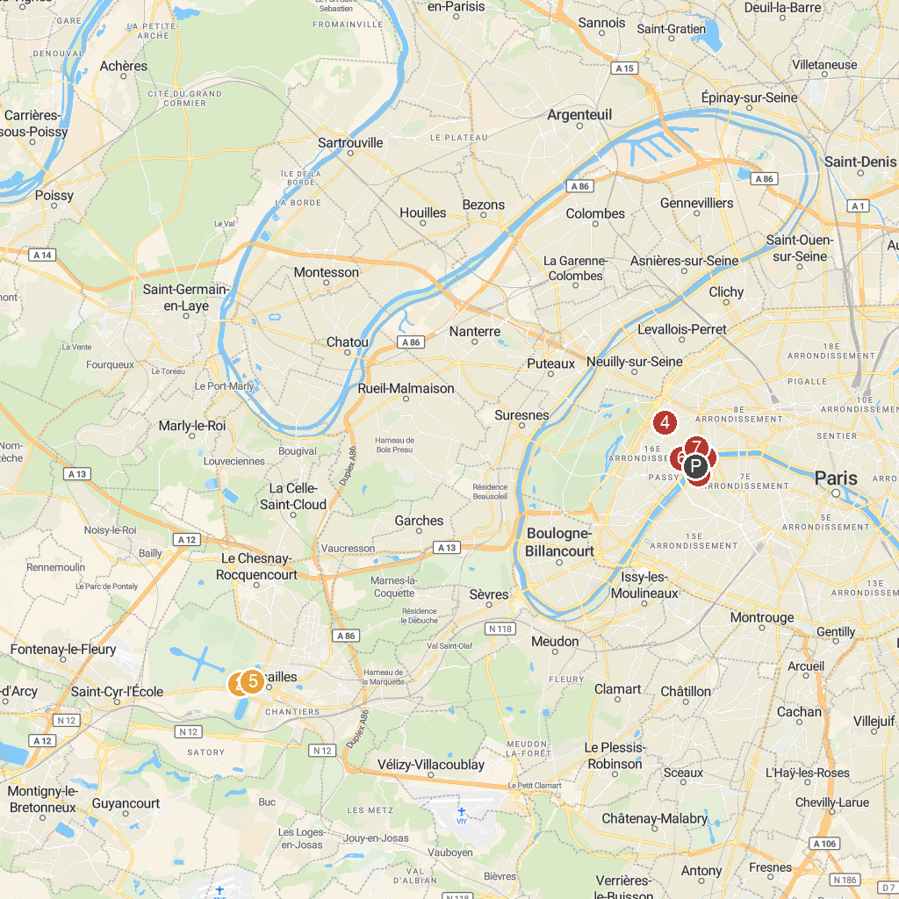
MAP KEY
1. Passerelle Debilly | 5. Palace of Versailles
2. Bacchus Pool | 6. Palais de Chaillot
3. Eiffel Tower | 7. Pavillon Vendôme
4. Ennery Museum | 8. Musée national des arts asiatiques - Guimet
P. Cruise port / terminal
Map © MapTiler © OpenStreetMap contributors · cruiseports.org

