Bouchemaine, Loire Valley, France
Where the Maine meets the Loire, this quiet Anjou village is a gateway to medieval fortresses, world-class tapestries, and the famed Loire à Vélo cycling route — all within easy reach of your ship.
⚓ River pontoon (moored) · 🕒 Typical call: 6–8 hrs · 💶 Euro · 🗣️ French
✍️ MY DAY IN PORT (FILL IN)
Ship / Date
In port | arrive ______ · all aboard ______
Booked excursion
Notes / meeting point
GETTING ASHORE
- Docking: River pontoon / halte fluviale on the Loire
- Walk to center: La Pointe village ~5 min; Angers by shuttle/taxi ~20 min
- Best For: Château d'Angers, Loire cycling, river boat trips
- Don't Miss: The 14th-century Apocalypse Tapestry at Château d'Angers
GETTING AROUND
- 🚕 Taxi: €20–€33 — Taxis run to Angers city center in about 12–14 minutes (~9 km). Pre-booking may secure better rates around €23.
- 📱 Rideshare: ✅ Uber
TOP THINGS TO DO
- Château d'Angers & the Apocalypse Tapestry — The massive 13th-century fortress about 9 km away houses the world's largest surviving medieval tapestry — roughly 100 metres of…
- Loire à Vélo Riverside Ride — Hop on the famous Loire à Vélo trail directly from the port.
- La Pointe — the Boatmen's Quarter — Walk the narrow lanes of this artisan neighbourhood at the confluence of the Maine and Loire.
- Anjou Wine & Château de Brissac — The Brissac area, 11 km south-east, is the gateway to Anjou's rosé and Coteaux du Layon appellations.
- Traditional Loire Boat Trip — Operators La Batellerie de la Loire and Instants de Loire offer guided trips on flat-bottomed traditional boats (toues cabanées)…
BEST WALKS
- La Pointe Confluence Trail: 2 km · 30–45 min · Easy — Follow the interpretive nature trail from the halte fluviale pontoon through La Pointe to the exact…
- Belvédère de la Piverdière Panorama Walk: 4 km round trip · 1–1.5 hrs · Easy — A gentle uphill path leads to a 7-hectare park with a viewpoint over the Maine, the Basses Vallées…
WEATHER · DAYLIGHT · MONEY
Month | High °F | Low °F | Rainy days
May | 67 | 51 | 10
Jul | 79 | 61 | 7
Sep | 73 | 56 | 8
Daylight: May 6:25AM–9:32PM · Jul 6:21AM–9:54PM · Sep 7:40AM–8:14PM
cruiseports.org/bouchemaine · Confirm terminal & all-aboard time with your ship

Bouchemaine, Loire Valley, France — Port Map
Red = walkable sights · Amber = excursions farther out · P = cruise terminal
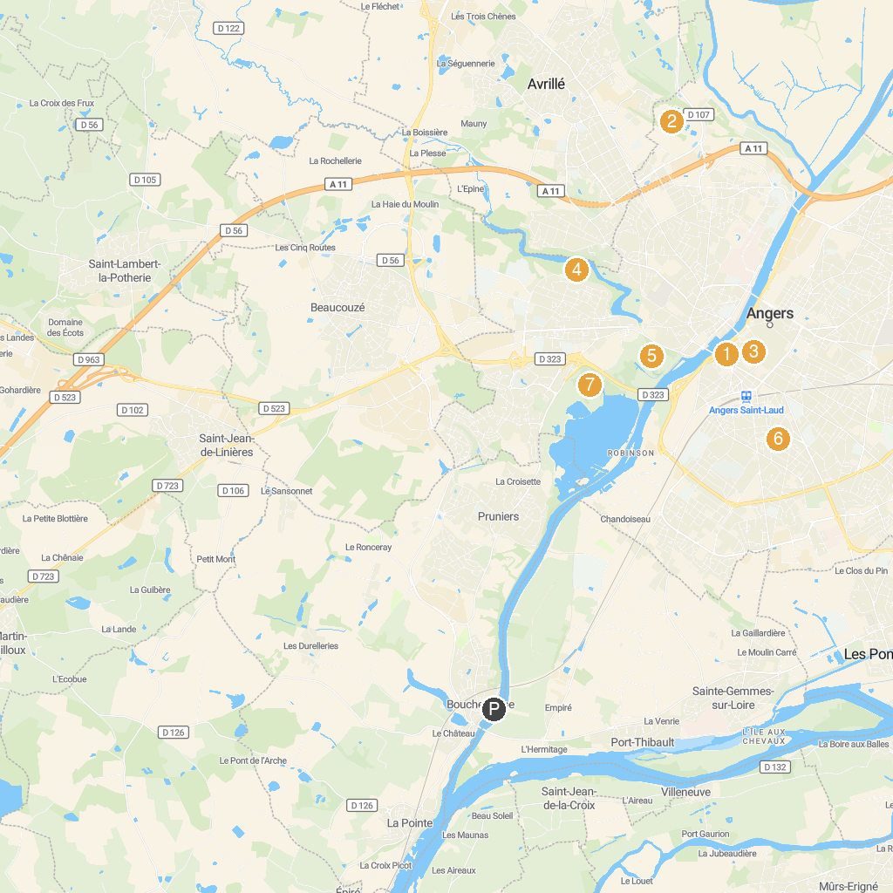
MAP KEY
1. Château de Brissac | 5. Saint Nicolas park
2. Château d'Angers | 6. Balzac Park
3. Terra Botanica | 7. Parc du Pin (Rue du Pin)
4. Cathédrale Saint-Maurice d'Angers | 8. Jardin biologique
P. Cruise port / terminal
Map © MapTiler © OpenStreetMap contributors · cruiseports.org

