Boston, Massachusetts
The Hub of the Universe
Freedom Trail · Academic Hub · Colonial History · Seaport District
✍️ MY DAY IN PORT (FILL IN)
Ship / Date
In port | arrive ______ · all aboard ______
Booked excursion
Notes / meeting point
GETTING ASHORE
- Founded: 1630
- Nickname: The Hub
- Key Landmark: Bunker Hill Monument
- Famous University: Harvard University
GETTING AROUND
- 🚕 Taxi: $20–$55 — Metered taxis are available at the terminal. Fare to Boston Common or downtown is roughly $20–$30; to Logan Airport runs
- 📱 Rideshare: ✅ Uber, Lyft
- 🚌 Hop-on hop-off: ✅ Old Town Trolley Tours / Boston Sightseeing
TOP THINGS TO DO
- The Freedom Trail — Follow the red-brick path through downtown Boston, visiting sites like the Old North Church, Faneuil Hall, and the Boston Common.
- Harvard & MIT Tour — Explore the prestigious campuses of Harvard and MIT in Cambridge, visiting Massachusetts Hall and the famous Infinite Corridor.
- Public Garden & Beacon Hill — Stroll through the historic, gas-lit streets of Beacon Hill and relax in the beautifully landscaped Boston Public Garden.
- Whale Watch Cruise — Set sail from the harbor to spot humpback whales and dolphins in the Atlantic waters off the coast of Massachusetts.
BEST WALKS
- North End Italian Walk: Food & Culture — Walk from the pier to the North End, exploring the narrow cobblestone streets and enjoying a…
- Seaport Waterfront Stroll: Scenic — Walk along the Harborwalk, exploring the modern architecture of the Seaport District and the…
- Back Bay Shopping Walk: Shopping — Walk down Newbury Street for high-end boutiques and the historic brownstones of the Back Bay…
WEATHER · DAYLIGHT · MONEY
Month | High °F | Low °F | Rainy days
May | 67 | 49 | 11
Jul | 83 | 66 | 11
Sep | 74 | 59 | 9
Daylight: May 5:22AM–7:59PM · Jul 5:21AM–8:18PM · Sep 6:24AM–6:53PM
cruiseports.org/boston · Confirm terminal & all-aboard time with your ship

Boston, Massachusetts — Port Map
Red = walkable sights · Amber = excursions farther out · P = cruise terminal
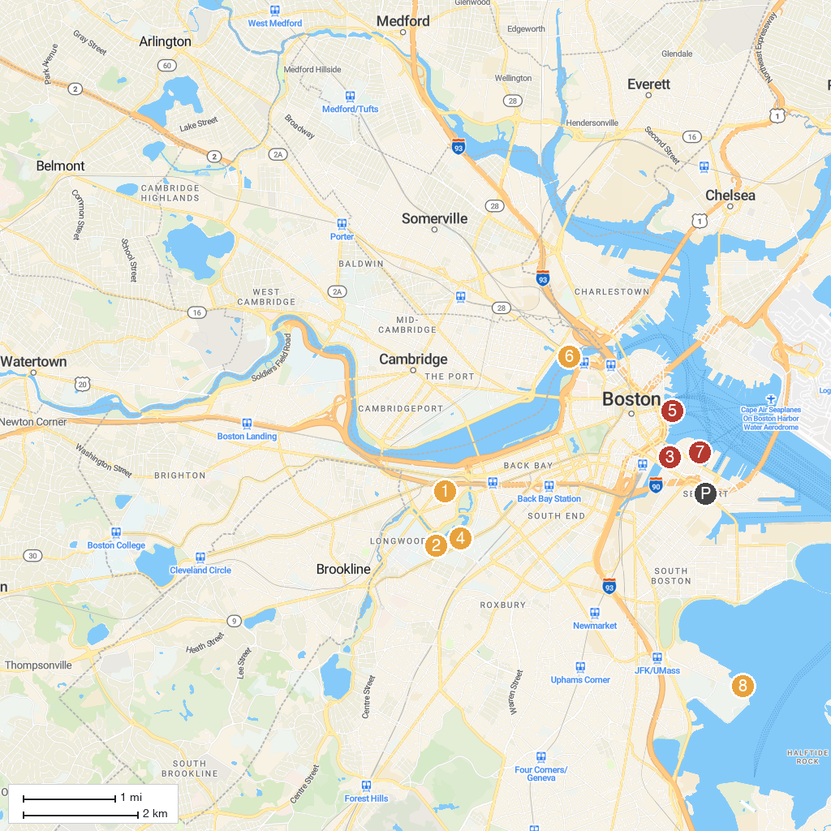
MAP KEY
1. Fenway Park | 5. New England Aquarium
2. Isabella Stewart Gardner Museum | 6. Museum of Science
3. Boston Children's Museum | 7. Institute of Contemporary Art
4. Museum of Fine Arts, Boston | 8. John F. Kennedy Presidential Library and Museum
P. Cruise port / terminal
Map © MapTiler © OpenStreetMap contributors · cruiseports.org

