Rønne, Bornholm, Denmark
Denmark's 'sunshine island' in the Baltic — medieval round churches, smokehouse herring, granite cliffs, and craft studios, all on a green isle made for slow exploring.
⚓ Docked (Rønne harbour) · 🕒 Typical call: 8–10 hrs · 💵 Danish Krone (DKK) · 🗣️ Danish · English in tourism
✍️ MY DAY IN PORT (FILL IN)
Ship / Date
In port | arrive ______ · all aboard ______
Booked excursion
Notes / meeting point
GETTING ASHORE
- Docking: Rønne harbour
- Walk to town: 5–10 min
- Best For: Nature · Crafts · Food
- Don't Miss: Round churches
GETTING AROUND
- 🚕 Taxi: 60–100 DKK (~$9–15 USD) — Taxis are available at the port. Base fare is ~45 DKK plus ~14 DKK/km. The short run to town center runs roughly 60–100
- 📱 Rideshare: ✅ Uber
TOP THINGS TO DO
- Round Churches Tour — Bornholm's four whitewashed medieval round churches — fortress-like and utterly unique, with Østerlars the largest and most…
- Hammershus Castle Ruins — Northern Europe's largest medieval fortress ruin, sprawling atop granite cliffs on the wild north coast with sweeping Baltic…
- Smokehouses & Art Towns — Taste the famous smoked Bornholm herring ('sol over Gudhjem'), then browse the glass, ceramic, and craft studios of pretty…
- Bornholm by Bike — Rent a bike and roll the flat, scenic cycle paths between fishing villages, smokehouses, and granite coast — the island's…
BEST WALKS
- Rønne old town stroll: ~2 km · 1–1.5 hrs · easy — Wander the cobbled lanes of crooked, pastel half-timbered houses around Storegade and Laksegade…
- Rønne harbour & coast: ~2 km · 1 hr · easy — Along the working fishing harbour and out toward the coast, with the lighthouse and Baltic views…
- Kastellet & town walls: ~1.5 km · 1 hr · easy — The small round Rønne citadel (Kastellet) and the green ramparts at the southern edge of the old…
WEATHER · DAYLIGHT · MONEY
Month | High °F | Low °F | Rainy days
May | 56 | 47 | 7
Jul | 67 | 60 | 13
Sep | 63 | 57 | 11
Daylight: May 4:53AM–9:03PM · Jul 4:42AM–9:31PM · Sep 6:34AM–7:17PM
cruiseports.org/bornholm · Confirm terminal & all-aboard time with your ship

Rønne, Bornholm, Denmark — Port Map
Red = walkable sights · Amber = excursions farther out · P = cruise terminal
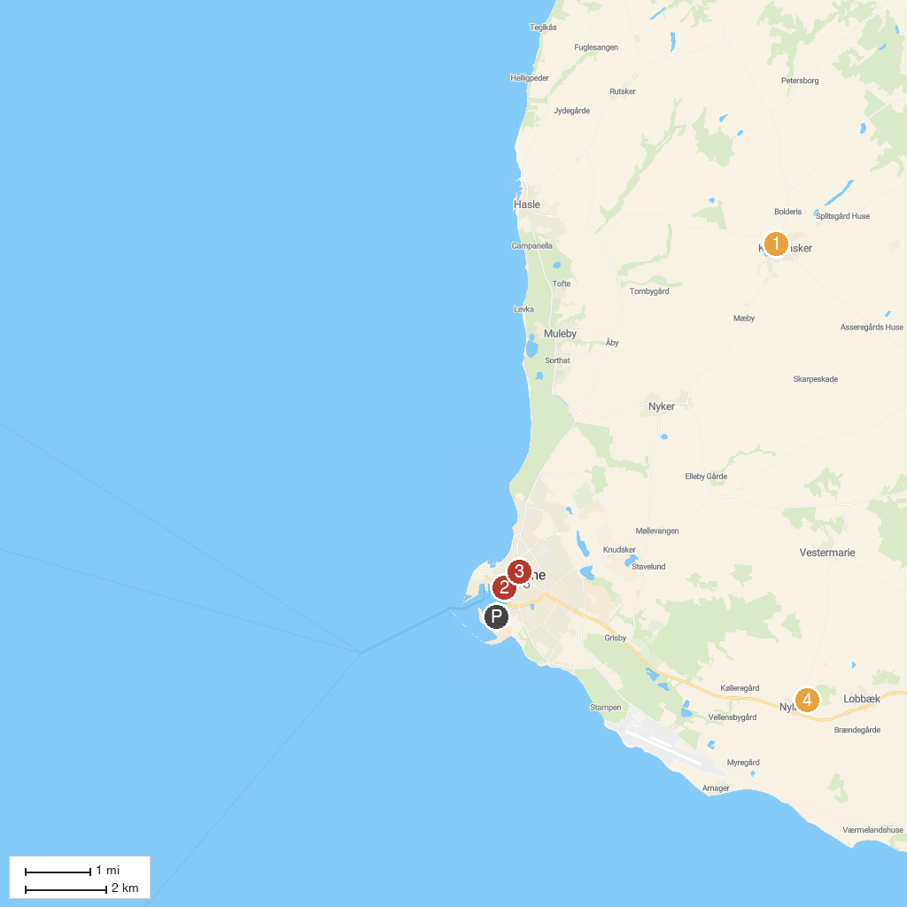
MAP KEY
1. St. Clement's Church | 5. Jon's Chapel
2. Lilleborg | 6. St Nicholas Church
3. Gamleborg | 7. Bornholms Museum - Bornholms kulturhistoriske samlinger
4. NaturBornholm | 8. Nylars Church
P. Cruise port / terminal
Map © MapTiler © OpenStreetMap contributors · cruiseports.org

