Borgholm, Öland, Sweden
A tender port with outsized rewards — Sweden's most spectacular castle ruin crowns a hilltop above a compact harbour town, while the island of Öland stretches south through a UNESCO World Heritage landscape of wildflower meadows and windmills.
⚓ Tender port · 🕒 Typical call: 7-9 hrs · 💵 Swedish Krona (SEK) · 🗣️ Swedish (English widely spoken)
✍️ MY DAY IN PORT (FILL IN)
Ship / Date
In port | arrive ______ · all aboard ______
Booked excursion
Notes / meeting point
GETTING ASHORE
- Docking: Tender to Borgholm guest harbour — town centre is a 5-minute walk
- Walk to centre: 5 min flat walk; Borgholm Castle 15 min uphill
- Best For: History, cycling, royal sites, UNESCO landscapes
- Don't Miss: Borgholm Castle ruins and Solliden Palace gardens
GETTING AROUND
- 🚕 Taxi: 100–300 SEK (~$11–32 USD) — Local taxis are available at the tender drop-off point. Useful for reaching Borgholm Castle (~2 km) or Solliden Palace (
- 📱 Rideshare: ❌ not available
TOP THINGS TO DO
- Borgholm Castle Ruins — Dating to the 12th century and rebuilt multiple times, Borgholm Castle is one of Scandinavia's most dramatic ruins.
- Solliden Palace Gardens — The Swedish Royal Family's summer residence lies just south of the castle.
- Stora Alvaret UNESCO Landscape — The flat limestone alvar plain that runs the length of southern Öland is a UNESCO World Heritage site, famous for rare orchids…
- Eketorp's Castle — A fully reconstructed ring-fort from the Iron Age and medieval period in southern Öland.
- Trollskogen & Northern Öland — The "Enchanted Forest" nature reserve in northern Öland features ancient gnarled pines and twisted oaks draped in ivy — a…
BEST WALKS
- Harbour → Castle → Solliden Loop: 4 km round-trip | 1.5–2 hrs | Moderate (uphill to castle) — Walk north along the waterfront into town, browse the main street, then climb the hill to Borgholm…
- Princess Estelle's Walk — Castle Forest to Solliden: 2.5 km one-way | ~45 min | Easy forest path — A marked woodland trail through the castle forest, named after the Crown Princess, linking the…
WEATHER · DAYLIGHT · MONEY
Month | High °F | Low °F | Rainy days
May | 58 | 46 | 8
Jul | 71 | 59 | 9
Sep | 63 | 54 | 9
Daylight: May 4:35AM–9:04PM · Jul 4:22AM–9:34PM · Sep 6:24AM–7:11PM
cruiseports.org/borgholm · Confirm terminal & all-aboard time with your ship

Borgholm, Öland, Sweden — Port Map
Red = walkable sights · Amber = excursions farther out · P = cruise terminal
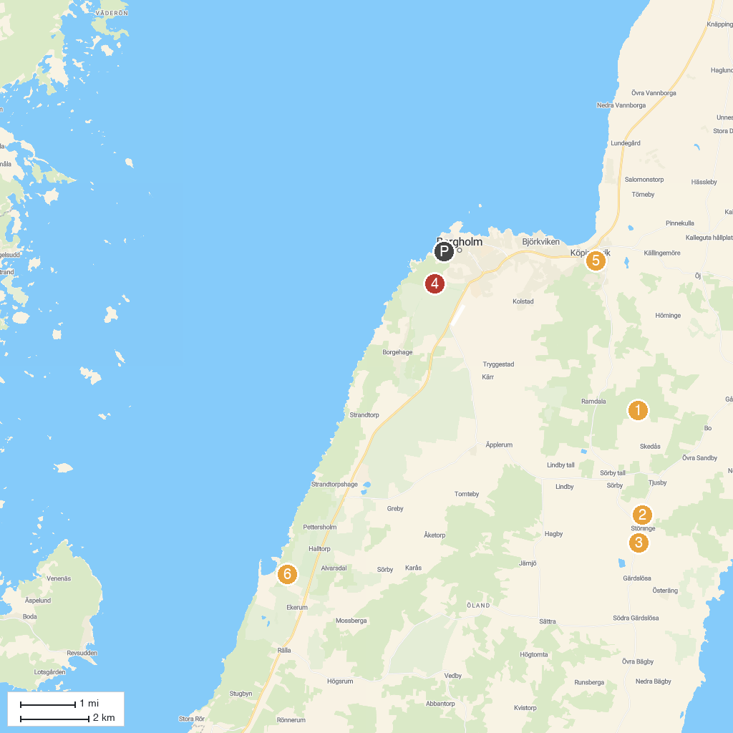
MAP KEY
1. Skedemosse Museum | 5. Borgholm Castle
2. Störlinge Windmills | 6. Ismantorp Fortress
3. Störlinge Agro & Motor Museum | 7. Tingsflisan
4. Kapelludden Tala Beach | 8. Halltorps Hage
P. Cruise port / terminal
Map © MapTiler © OpenStreetMap contributors · cruiseports.org

