Boracay Island, Aklan, Philippines
Four kilometres of powder-white sand, crystal-clear turquoise water, and a reef teeming with marine life — Boracay earns its reputation as one of Asia's finest beach destinations.
⚓ Tender port · 🕒 Typical call: 7-9 hrs · 💵 Currency: Philippine Peso (PHP) · 🗣️ Filipino & English spoken
✍️ MY DAY IN PORT (FILL IN)
Ship / Date
In port | arrive ______ · all aboard ______
Booked excursion
Notes / meeting point
GETTING ASHORE
- Docking: Tender — ships anchor offshore; tenders to Caticlan Jetty, then bangka boat to Cagban Port on Boracay (30–40 min total)
- Walk to Beach: 10–15 min e-trike ride from Cagban Port to White Beach Station 2/D'Mall
- Best For: Beach days, island hopping, water sports, sunset sailing
- Don't Miss: Sunset paraw sail along White Beach, island hopping to Crystal Cove
GETTING AROUND
- 📱 Rideshare: ✅ Boracay Xpress
- 🚌 Hop-on hop-off: ✅
TOP THINGS TO DO
- White Beach Day — Walk or e-trike along the 4-km White Beach from Station 3's quiet south end to the luxurious Station 1.
- Island Hopping Tour — A classic Boracay boat tour typically visits Crystal Cove Island (sea caves, snorkelling, cliff views), Puka Beach on the…
- Sunset Paraw Sailing — A paraw is the traditional Filipino double-outrigger sailboat.
- Helmet Diving — No scuba certification needed — helmet diving lets you walk on the seabed at 4–5 metres depth while breathing normally through an…
- Puka Beach & North Island — Puka Beach (Yapak Beach) on Boracay's northern tip is wilder and less developed than White Beach.
BEST WALKS
- White Beach End-to-End: 4 km one-way · Easy · 45–60 min — Start at the southern end of White Beach (Station 3, quiet and budget) — a short e-trike from…
- D'Mall to Willy's Rock: 1 km · Easy · 15 min — Short beach stroll from the main shopping hub at D'Mall north to Willy's Rock, a coral-encrusted…
WEATHER · DAYLIGHT · MONEY
Month | High °F | Low °F | Rainy days
May | 86 | 79 | 22
Jul | 83 | 78 | 28
Sep | 83 | 78 | 26
Daylight: May 5:28AM–6:08PM · Jul 5:35AM–6:20PM · Sep 5:41AM–5:53PM
cruiseports.org/boracay-island-philippines · Confirm terminal & all-aboard time with your ship

Boracay Island, Aklan, Philippines — Port Map
Red = walkable sights · Amber = excursions farther out · P = cruise terminal
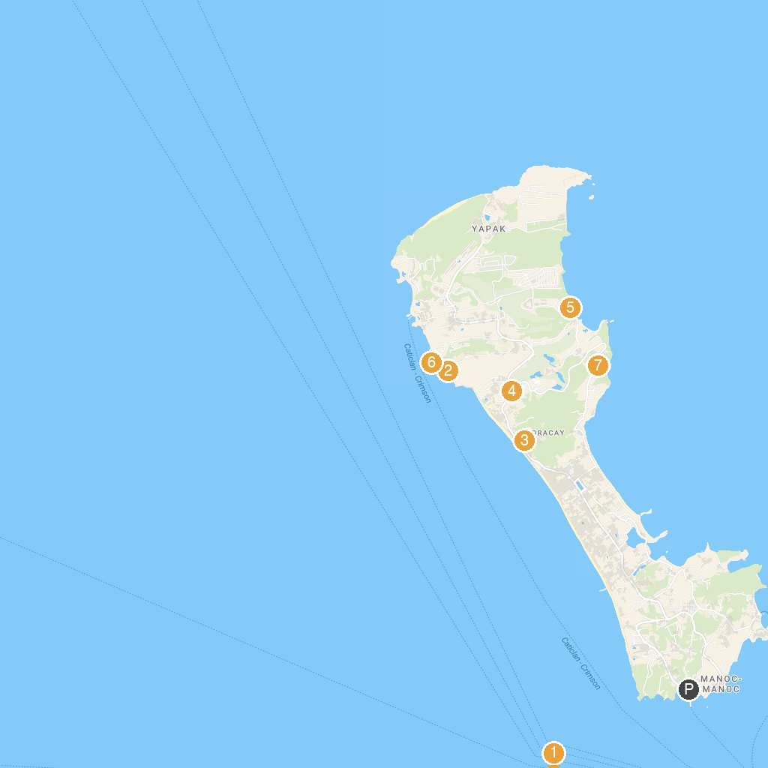
MAP KEY
1. Motag Living Museum | 5. Boracay Newcoast Cove 2 Beach
2. Diniwid Beach | 6. West Cove Ruins
3. Our Lady of the Most Holy Rosary Parish | 7. Mt. Luho View Deck
4. Museum Shine Boracay
P. Cruise port / terminal
Map © MapTiler © OpenStreetMap contributors · cruiseports.org

