Bora Bora, Society Islands, French Polynesia
Ringed by one of the world's most spectacular lagoons and crowned by the volcanic spire of Mount Otemanu, Bora Bora is French Polynesia at its most cinematic. Tender ashore to Vaitape and choose between glass-clear snorkeling, island-circling adventures, and WWII relics hiding in the jungle.
⚓ Tender port — anchor in Pofai Bay · 🕒 Typical call: 7–9 hrs · 💵 CFP Franc (XPF); USD widely accepted · 🗣️ French & Tahitian; English common in tourist areas
✍️ MY DAY IN PORT (FILL IN)
Ship / Date
In port | arrive ______ · all aboard ______
Booked excursion
Notes / meeting point
GETTING ASHORE
- Docking: Tender to Quai de Vaitape (5–10 min ride)
- Walk to center: Vaitape village is at the pier; Matira Beach is ~8 km south
- Best For: Lagoon snorkeling, stingray encounters, 4x4 island tours
- Don't Miss: Lagoon snorkel with stingrays and sharks, WWII U.S. naval cannons
GETTING AROUND
- 🚕 Taxi: ~1,500–2,500 CFP (~$14–24 USD) per trip — Unmetered taxis available at Vaitape wharf. Always agree on the fare before boarding — a ride to Matira Beach is typical
- 📱 Rideshare: ❌ not available
TOP THINGS TO DO
- Lagoon Snorkel with Stingrays & Reef Sharks — The signature Bora Bora experience: wade and snorkel in a shallow sandbar with friendly stingrays, then snorkel a coral garden…
- 4x4 Circle Island Safari — Rattle through the jungle in an open 4x4, stopping at WWII U.S.
- Matira Beach Afternoon — Bora Bora's only public beach stretches 1.5 km of powdery white sand with calm, shallow turquoise water.
- Jet Ski Lagoon Tour — Zip across the lagoon on your own jet ski, looping the island and taking in unobstructed views of Mount Otemanu from the water.
- Bloody Mary's Lunch Stop — One of French Polynesia's most famous restaurants, Bloody Mary's has a sand floor, a thatched roof, and a celebrity wall of past…
BEST WALKS
- Vaitape Village Wander: 1–2 km · Flat · 30–45 min — From the tender dock, explore Vaitape's main street: local supermarkets, souvenir shops, a church…
- Matira Beach Shore Walk: ~3 km round-trip · Flat · 1–1.5 hrs — Take a taxi to the north end of Matira Beach and walk south along the shore.
- Vaitape Village Stroll: ~1 km · 30 min · easy — From the tender quay, walk along the waterfront past local shops, the covered market, and the Bank…
WEATHER · DAYLIGHT · MONEY
Month | High °F | Low °F | Rainy days
May | 82 | 79 | 20
Jul | 79 | 77 | 16
Sep | 79 | 76 | 14
Daylight: May 6:23AM–5:43PM · Jul 6:36AM–5:50PM · Sep 6:02AM–6:02PM
cruiseports.org/bora-bora-island · Confirm terminal & all-aboard time with your ship

Bora Bora, Society Islands, French Polynesia — Port Map
Red = walkable sights · Amber = excursions farther out · P = cruise terminal
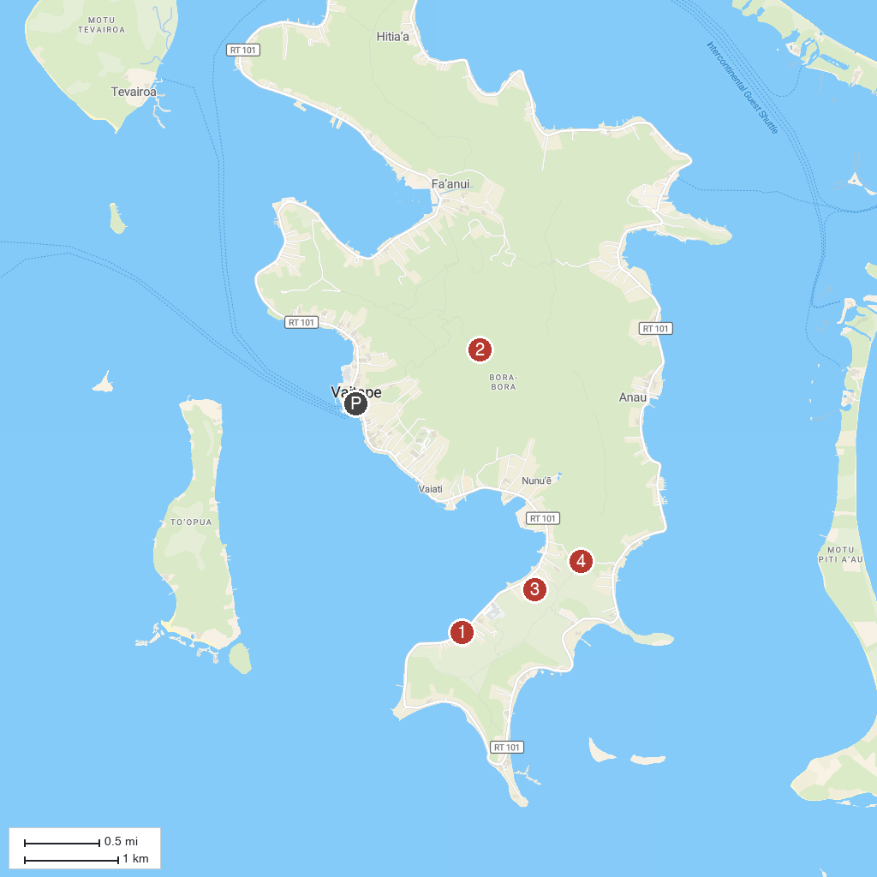
MAP KEY
1. Bora Bora Romantic Tour | 3. Bora Bora Adventures ATV / QUADS Tours
2. Mt. Pa’ia Summit | 4. ʻĀmanahune
P. Cruise port / terminal
Map © MapTiler © OpenStreetMap contributors · cruiseports.org

