Boothbay Harbor, Maine, USA
A quintessential Maine fishing village turned summer destination — cedar-shingled shops, lobster shacks, and the smell of salt air from the moment you step ashore. Boothbay Harbor is compact, walkable, and tailor-made for a cruise day.
⚓ Docked (small ships) / Tender (larger vessels) · 🕒 Typical call: 7-12 hrs · 💵 USD · 🗣️ English · 🦞 Seafood paradise
✍️ MY DAY IN PORT (FILL IN)
Ship / Date
In port | arrive ______ · all aboard ______
Booked excursion
Notes / meeting point
GETTING ASHORE
- Docking: Small cruise ships dock at Town Dock (Public Landing); larger/expedition vessels anchor and tender to the inner harbor
- Walk to center: 1–3 min from Town Dock to downtown shops and restaurants
- Best For: Puffin & whale-watch cruises, Coastal Maine Botanical Gardens, fresh lobster rolls
- Don't Miss: A boat tour with Cap'n Fish's or Balmy Days Cruises — the Eastern Egg Rock puffin trip is a highlight
GETTING AROUND
- 🚕 Taxi: Flat rate (varies) — Bo Bo's Coastal Cabs offers flat-rate fares by reservation (9 AM–9 PM); cash or local check only, no credit cards. Wicke
- 📱 Rideshare: ✅ Uber
TOP THINGS TO DO
- Puffin Cruise to Eastern Egg Rock — Cap'n Fish's Cruises runs the signature Audubon-narrated excursion: a round trip to Eastern Egg Rock, where Atlantic puffins nest…
- Coastal Maine Botanical Gardens — New England's largest botanical garden (about 295 acres) with ornamental gardens, woodland trails, a children's garden, and…
- Whale Watching Cruise — Cap'n Fish's Cruises and others run 3–4 hour whale-watch trips into the Gulf of Maine.
- Cabbage Island Clambake — A boat takes you to Cabbage Island for a traditional Downeast clambake — steamed clams, lobster, corn, and chowder cooked in…
- Boothbay Railway Village — A living history museum with vintage narrow-gauge steam trains, 60+ antique autos, and 28 historic buildings relocated from…
BEST WALKS
- Harbor Loop & Footbridge: 1.5 miles · Easy · 45-60 min — Start at Public Landing, walk east along Commercial Street past Pier 8 (Balmy Days), cross the…
- McKown Hill Viewpoint: 1 mile round-trip · Easy · 30 min — A short uphill walk from downtown to the top of McKown Hill rewards you with a panoramic view of…
WEATHER · DAYLIGHT · MONEY
Month | High °F | Low °F | Rainy days
May | 61 | 46 | 9
Jul | 77 | 64 | 10
Sep | 70 | 57 | 9
Daylight: May 5:12AM–7:57PM · Jul 5:10AM–8:17PM · Sep 6:18AM–6:48PM
cruiseports.org/boothbay-harbor-me · Confirm terminal & all-aboard time with your ship

Boothbay Harbor, Maine, USA — Port Map
Red = walkable sights · Amber = excursions farther out · P = cruise terminal
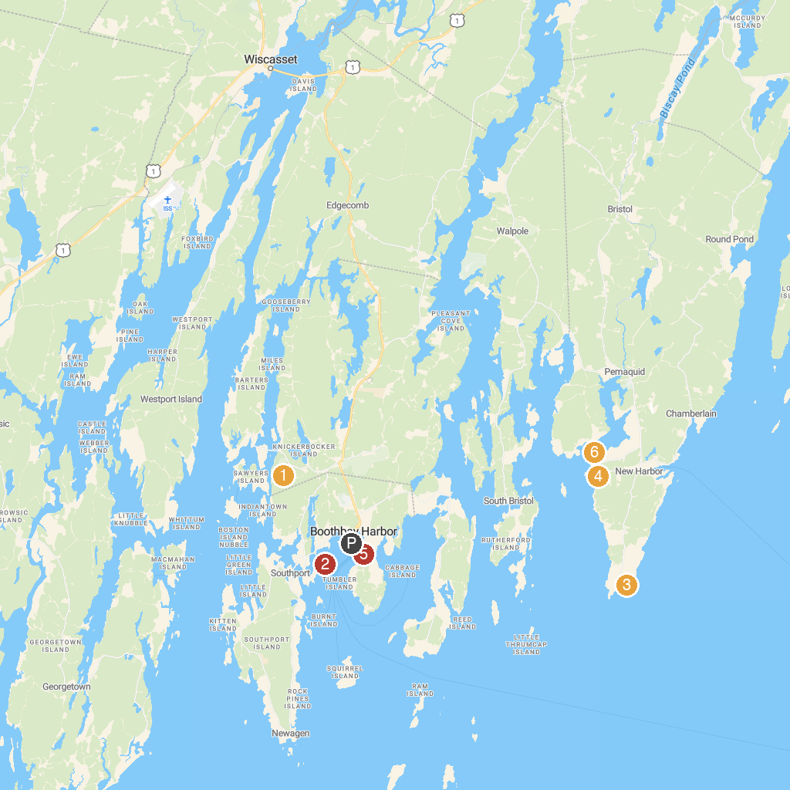
MAP KEY
1. Coastal Maine Botanical Gardens | 4. Pemaquid Beach Park
2. Maine State Aquarium | 5. Our Lady Queen of Peace Catholic Church
3. Fisherman Museum | 6. Colonial Pemaquid State Historic Site
P. Cruise port / terminal
Map © MapTiler © OpenStreetMap contributors · cruiseports.org

