Bonn, North Rhine-Westphalia, Germany
Germany's former capital along the Rhine delivers Beethoven's birthplace, a walkable old town, and the rolling Siebengebirge hills — all within easy reach of the dock.
⚓ Docked — Brassertufer quay · 🕒 Typical call: 8-10 hrs · 💵 Currency: Euro (€) · 🗣️ Language: German · 🎵 Beethoven's birthplace
✍️ MY DAY IN PORT (FILL IN)
Ship / Date
In port | arrive ______ · all aboard ______
Booked excursion
Notes / meeting point
GETTING ASHORE
- Docking: Riverside quay at Brassertufer — 10-15 min walk to Old Town
- Walk to center: ~10 min along the Rhine promenade to Münsterplatz
- Best For: History, classical music, Rhine scenery, museum lovers
- Don't Miss: Beethoven-Haus birthplace museum and the Bonn Minster
GETTING AROUND
- 🚕 Taxi: €3.60 base + ~€2.10/km — Taxis use a metered fare; a 5 km ride runs roughly €13. Given the dock's central location, most city-center rides will b
- 📱 Rideshare: ✅ Uber, Bolt
- 🚌 Hop-on hop-off: ✅
TOP THINGS TO DO
- Beethoven-Haus Museum — Tour the house where Ludwig van Beethoven was born in 1770.
- Bonn Old Town & Minster Walk — Stroll through the Altstadt to the Romanesque Bonn Minster (Münsterbasilika), the Rococo Old Town Hall on Marktplatz, and…
- Königswinter & Drachenfels Castle — Cruise downstream to Königswinter and ride the historic Drachenfels Zahnradbahn rack railway to the hilltop castle ruins…
- Museum Mile — Haus der Geschichte — Germany's House of History of the Federal Republic documents post-WWII German life through to reunification with engaging…
- Rhine Panorama Cruise to Siebengebirge — Take a scenic river cruise south along the Rhine to enjoy views of the Seven Mountains (Siebengebirge), the wooded hills that…
BEST WALKS
- Old Town Heart Walk: 2.5 km · 45 min · Easy — From the Brassertufer quay, follow the Rhine promenade north to Münsterplatz, visit Bonn Minster…
- Museum Mile Stroll: 3 km one way · 1 hr · Easy — From Münsterplatz head south along the former government district (Bundesviertel) past the Langer…
WEATHER · DAYLIGHT · MONEY
Month | High °F | Low °F | Rainy days
May | 66 | 48 | 12
Jul | 76 | 59 | 12
Sep | 69 | 53 | 10
Daylight: May 5:43AM–9:13PM · Jul 5:36AM–9:38PM · Sep 7:07AM–7:45PM
cruiseports.org/bonn · Confirm terminal & all-aboard time with your ship

Bonn, North Rhine-Westphalia, Germany — Port Map
Red = walkable sights · Amber = excursions farther out · P = cruise terminal
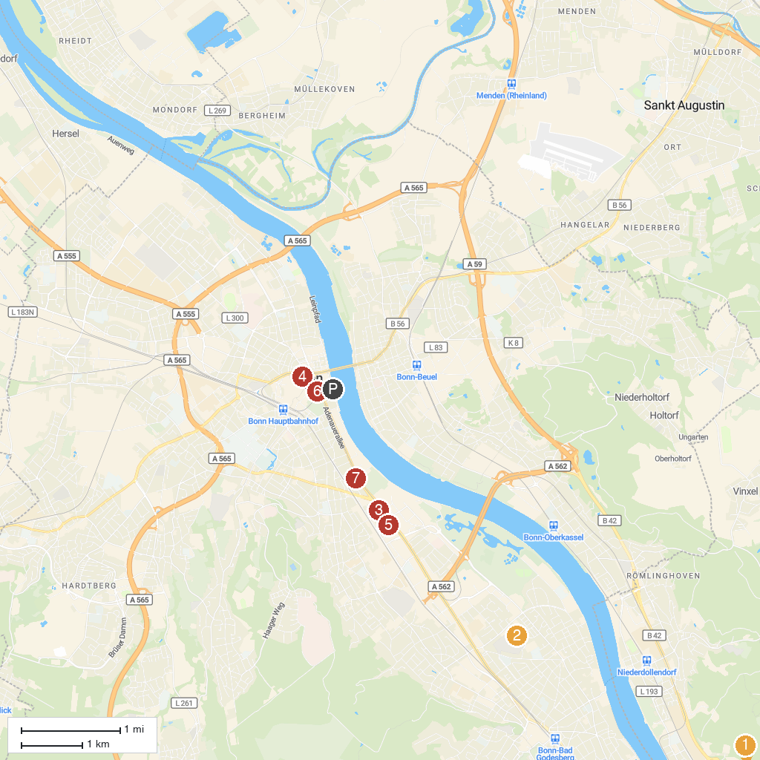
MAP KEY
1. Burg Odenhausen | 5. Beethoven-Haus Bonn
2. Schloss Drachenburg | 6. Art museum
3. German Museum Bonn | 7. StadtMuseum Bonn
4. House of the History of the Federal Republic of Germany | 8. Museum Koenig Bonn
P. Cruise port / terminal
Map © MapTiler © OpenStreetMap contributors · cruiseports.org

