Bolgar, Tatarstan, Russia
One of the oldest cities of medieval Russia, Bolgar sat at the crossroads of Eurasian civilisations. Today its vast archaeological park — a UNESCO World Heritage site — draws both history travellers and Muslim pilgrims to the place where the Volga Bolgars embraced Islam in 922 CE.
⚓ Docked (river pier) · 🕒 Typical call: 4–6 hrs · 💵 Russian Ruble (RUB) · 🗣️ Russian / Tatar
✍️ MY DAY IN PORT (FILL IN)
Ship / Date
In port | arrive ______ · all aboard ______
Booked excursion
Notes / meeting point
GETTING ASHORE
- Docking: Cruise ships dock directly at Bolgar river terminal; no tender required
- Walk to complex: Museum of Bulgarian Civilization is steps from the pier; White Mosque ~1 km
- Best For: Medieval history, Islamic heritage, UNESCO archaeology
- Don't Miss: Cathedral Mosque & Great Minaret, White Mosque, Museum of Bulgarian Civilization
GETTING AROUND
- 🚕 Taxi: Negotiate locally — Local taxis are available in Bolgar for trips beyond the museum grounds. Agree on a fare before departing; metered cabs
TOP THINGS TO DO
- Bolgar Historical & Archaeological Complex — Walk the atmospheric ruins of medieval Volga Bulgaria: the Cathedral Mosque, Great Minaret, Khan's Palace remains, Black Chamber…
- White Mosque (Ak Mosque) — Opened in 2012, this gleaming modern mosque — three domes, two minarets, granite-lined reflecting pool — is nicknamed the 'Tatar…
- Museum of Bulgarian Civilization & Koran Museum — The riverside Museum of Bulgarian Civilization covers 1,600 exhibits tracing Bolgar's medieval golden age.
- Museum of Bread — A charming open-air complex on the edge of the park with a reconstructed windmill, watermill, blacksmith's shop, and exhibits on…
BEST WALKS
- Riverfront to Ruins Loop: 3–4 km · 1.5–2.5 hrs · mostly flat grassy park — From the pier, pass through the Western Gate into the UNESCO complex.
WEATHER · DAYLIGHT · MONEY
Month | High °F | Low °F | Rainy days
May | 65 | 50 | 9
Jul | 77 | 63 | 9
Sep | 62 | 50 | 8
Daylight: May 3:36AM–7:44PM · Jul 3:25AM–8:13PM · Sep 5:16AM–6:00PM
cruiseports.org/bolgar · Confirm terminal & all-aboard time with your ship

Bolgar, Tatarstan, Russia — Port Map
Red = walkable sights · Amber = excursions farther out · P = cruise terminal
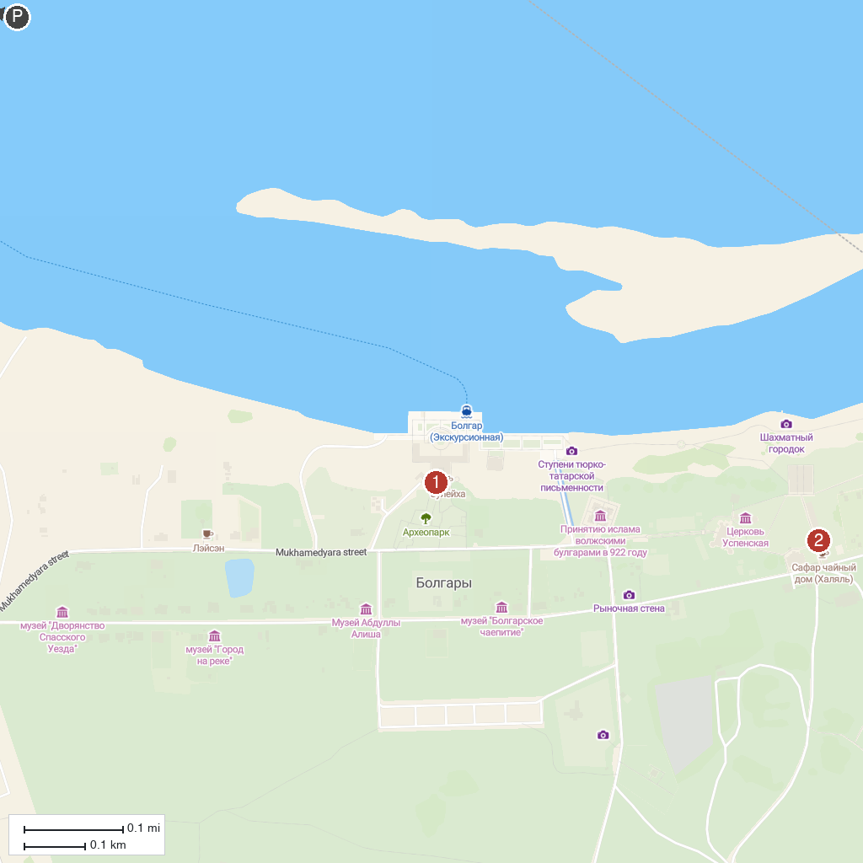
MAP KEY
1. Болгарский государственный историко-архитектурный музей-заповедник | 4. Pamyatnik 960-Kilogrammovoy Beluge Vylovlennoy V Volge
2. Музей «Дом лекаря» | 5. Smotrovaya Bashnya
3. Tetyushskiy Krayevedcheskiy Muzey
P. Cruise port / terminal
Map © MapTiler © OpenStreetMap contributors · cruiseports.org

