Bohol Island, Visayas, Philippines
A compact island punching above its weight: surreal chocolate-brown hills, the world's tiniest primate, a floating buffet on the Loboc River, and Panglao's turquoise reefs — all within striking distance of a dockside pier.
⚓ Docked (Tagbilaran City Pier) · 🕒 Typical call: 7-9 hrs · 💵 Philippine Peso (₱) · 🗣️ Filipino / English
✍️ MY DAY IN PORT (FILL IN)
Ship / Date
In port | arrive ______ · all aboard ______
Booked excursion
Notes / meeting point
GETTING ASHORE
- Docking: Ships dock at Tagbilaran City Tourist Pier (265 m berth); no tendering required for most calls
- Walk to center: Tagbilaran downtown is ~10 min walk from the pier; most attractions need a van or tour
- Best For: Nature lovers, wildlife spotters, river cruisers, beach days
- Don't Miss: Chocolate Hills viewpoint at Carmen and the Philippine Tarsier Sanctuary in Corella
GETTING AROUND
- 🚕 Taxi: PHP 300–500 — Metered taxis are available at Tagbilaran Port for the short ride to Tagbilaran City center. Agree on a fare or insist o
- 📱 Rideshare: ✅ Grab
TOP THINGS TO DO
- Chocolate Hills & Carmen Viewpoint — More than 1,200 nearly identical conical mounds stretch across central Bohol.
- Philippine Tarsier Sanctuary — The Corella sanctuary protects one of the world's smallest primates in a semi-wild forest enclosure.
- Loboc River Floating Buffet Cruise — Bamboo raft-restaurants drift along the jungle-fringed Loboc River while a local band plays and you eat a Filipino buffet.
- Panglao Island Beach Day — Alona Beach on Panglao Island offers powdery white sand, turquoise shallows, and beachfront cafés.
- Baclayon Church & Museum — One of the oldest coral-stone churches in the Philippines; the present church was completed in 1727, on a Jesuit mission site…
BEST WALKS
- Tagbilaran City Pier to Baclayon Church Walk: 4 km · ~1 hr · Flat — Head east along the coastal road from the pier past Carlos P.
- Bilar Man-Made Forest Trail: 1 km · Easy · Shaded — A dense corridor of mahogany trees planted decades ago lines the road through Bilar.
WEATHER · DAYLIGHT · MONEY
Month | High °F | Low °F | Rainy days
May | 87 | 78 | 25
Jul | 85 | 78 | 24
Sep | 85 | 78 | 25
Daylight: May 5:24AM–5:57PM · Jul 5:31AM–6:09PM · Sep 5:34AM–5:44PM
cruiseports.org/bohol-island-philippines · Confirm terminal & all-aboard time with your ship

Bohol Island, Visayas, Philippines — Port Map
Red = walkable sights · Amber = excursions farther out · P = cruise terminal
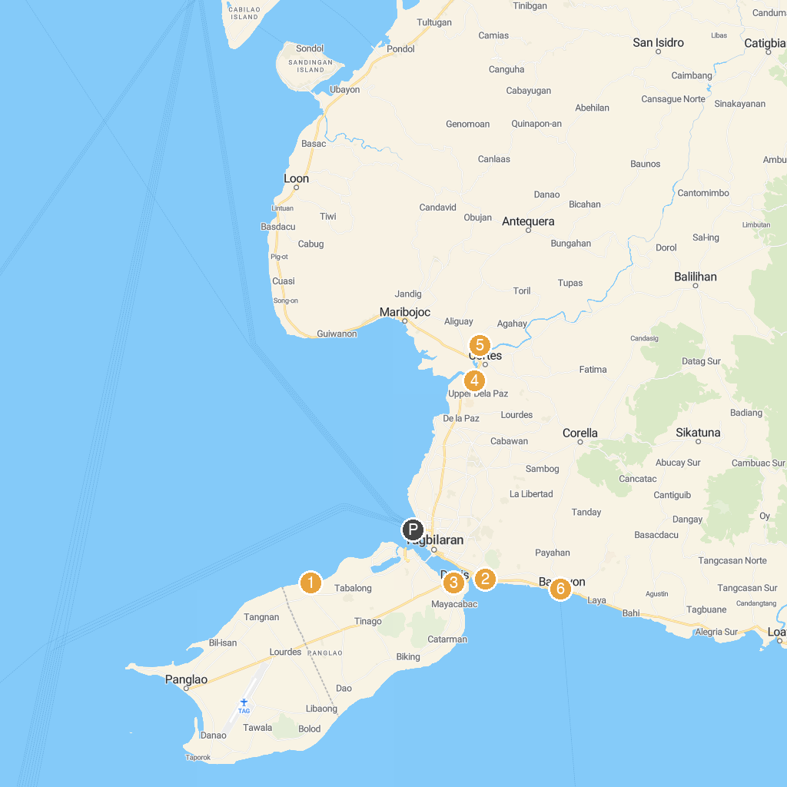
MAP KEY
1. Hinagdanan Cave | 5. Maribojoc Mangrove Firefly Watching
2. Blood Compact Shrine | 6. Baclayon Church
3. Church of Our Lady of the Assumption (Dauis Church) | 7. Panglao Watchtower
4. Abatan River Community Life Tour | 8. 塔比拉兰码头 （薄荷岛）
P. Cruise port / terminal
Map © MapTiler © OpenStreetMap contributors · cruiseports.org

