Bodrum, Aegean, Turkey
A 15th-century crusader castle watches over a glittering Aegean bay where ancient Halicarnassus once stood — one of the ancient world's greatest cities, and a ruin worth every step.
⚓ Docked (finger pier) · 🕒 Typical call: 7-10 hrs · 💵 Turkish Lira (TRY) · 🗣️ Turkish
✍️ MY DAY IN PORT (FILL IN)
Ship / Date
In port | arrive ______ · all aboard ______
Booked excursion
Notes / meeting point
GETTING ASHORE
- Docking: Finger pier, up to 2 large ships; no tendering
- Walk to center: ~1.5 km, 20 min along the waterfront promenade
- Best For: Ancient history, gulet boat trips, bazaar shopping
- Don't Miss: Museum of Underwater Archaeology inside Bodrum Castle
GETTING AROUND
- 🚕 Taxi: €10–€15 short ride / metered fares — Taxis queue outside the passenger terminal. For the short hop to the marina, castle, or bazaar, confirm the meter or agr
- 📱 Rideshare: ✅ Uber
TOP THINGS TO DO
- Bodrum Castle & Museum of Underwater Archaeology — The 15th-century Castle of St Peter, built by the Knights Hospitaller, houses one of the world's best underwater archaeology…
- Mausoleum at Halicarnassus — Ruins of the original Mausoleum — one of the Seven Wonders of the Ancient World and the tomb of King Mausolus (d.
- Bodrum Peninsula Gulet Cruise — Spend half a day on a traditional wooden gulet sailing the Bodrum Peninsula's secluded bays, including Kara Ada (Black Island)…
- Orak Island Boat Trip — Called the 'Turkish Maldives' by locals, Orak Island's turquoise water and white rocky shores make for one of the Aegean's most…
- Ephesus Full-Day Tour — A popular full-day excursion (roughly 2.5 hrs each way) to the great ruins of ancient Ephesus, including the Library of Celsus…
BEST WALKS
- Waterfront Promenade to Bodrum Castle: 1.5 km · 20 min · Easy · Flat — Walk west along the promenade from the cruise terminal past the marina to reach Bodrum Castle.
- Old Town & Mausoleum Loop: 2.5 km · 45 min · Easy · Some gentle slopes — From the castle head north into the bazaar streets, then continue to the Mausoleum at Halicarnassus…
- Bodrum Amphitheatre Viewpoint: ~3 km · 1 hr · Moderate · Uphill — The ancient Hellenistic amphitheatre on the hillside above town offers sweeping views over the bay.
WEATHER · DAYLIGHT · MONEY
Month | High °F | Low °F | Rainy days
May | 76 | 64 | 5
Jul | 90 | 76 | 0
Sep | 84 | 72 | 2
Daylight: May 6:02AM–8:11PM · Jul 6:02AM–8:29PM · Sep 6:52AM–7:17PM
cruiseports.org/bodrum · Confirm terminal & all-aboard time with your ship

Bodrum, Aegean, Turkey — Port Map
Red = walkable sights · Amber = excursions farther out · P = cruise terminal
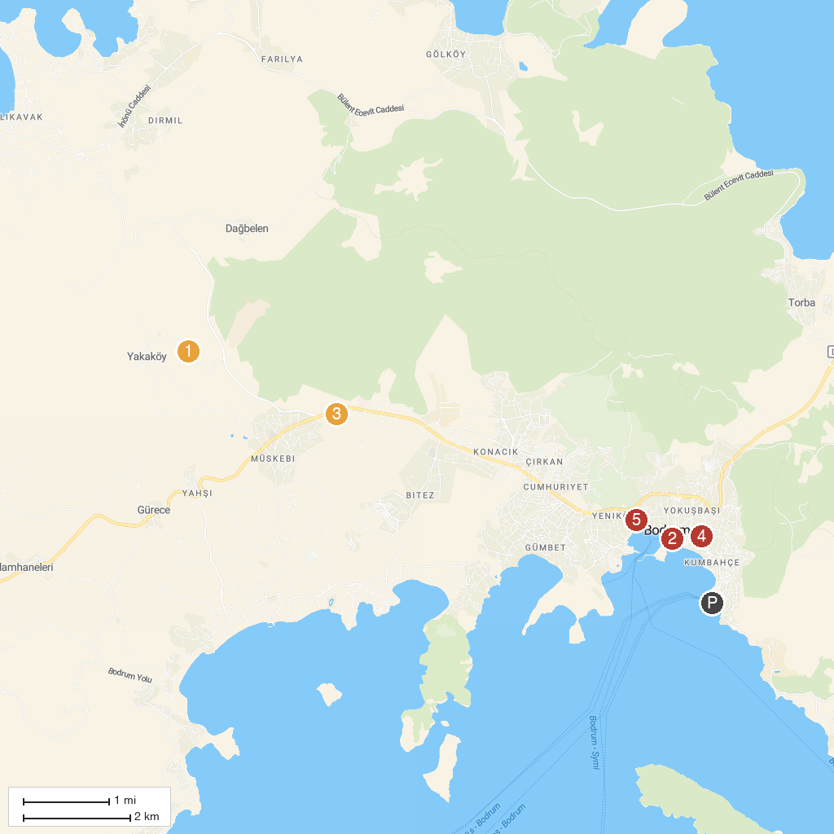
MAP KEY
1. Dibeklihan Culture and Art Village | 4. Historical (Turkish bath ) Tarihi Bardakçı Hamamı
2. Bodrum Maritime Museum | 5. Mausoleum at Halicarnassus
3. Bodrum Aquapark
P. Cruise port / terminal
Map © MapTiler © OpenStreetMap contributors · cruiseports.org

