Bodø, Nordland, Norway
Gateway to the Arctic, Bodø packs midnight sun, sea eagles, and the planet's most powerful tidal current into a compact, walkable city just north of the Arctic Circle.
⚓ Docked (deep-water quay) · 🕒 Typical call: 7-10 hrs · 💵 Norwegian Krone (NOK) · 🗣️ Norwegian / English widely spoken · ☀️ Midnight Sun: early June – mid July
✍️ MY DAY IN PORT (FILL IN)
Ship / Date
In port | arrive ______ · all aboard ______
Booked excursion
Notes / meeting point
GETTING ASHORE
- Docking: Deep-water quay, ~5 min walk to city center
- Best For: Saltstraumen maelstrom, sea eagle safaris, Arctic scenery
- Don't Miss: Saltstraumen — world's strongest tidal current, 33 km out
- Walk to Center: 5–10 minutes on foot
GETTING AROUND
- 🚕 Taxi: 100–150 NOK — Taxis queue near the port. Base fare is ~100 NOK plus ~14.5 NOK/km; the short hop to the center costs roughly 100–150 NO
- 📱 Rideshare: ✅ Uber, Bolt
TOP THINGS TO DO
- Saltstraumen Maelstrom — The world's most powerful tidal current churns through a narrow strait 33 km southeast of Bodø, generating massive whirlpools up…
- Sea Eagle Safari — The skerries and coastline around Bodø host one of the world's highest concentrations of white-tailed sea eagles.
- Kjerringøy Trading Post — A beautifully preserved 19th-century coastal trading station north of Bodø, reachable by bus and a short ferry.
- RIB Boat Fjord Safari — High-speed inflatable boats launch from the harbour for an adrenaline ride through the coastal skerries, often combined with sea…
- Norwegian Aviation Museum — One of the largest aviation museums in the Nordic countries, the Norsk Luftfartsmuseum sits a short bike ride or taxi from the…
BEST WALKS
- Harbour to Cathedral Walk: 1.5 km · 20 min · flat · easy — Stroll from the cruise quay along the harbourfront to Bodø Cathedral, a striking postwar structure…
- Keiservarden Viewpoint Hike: 5 km return · 2 hrs · moderate · panoramic — Hike or eBike the trail up to Keiservarden for a sweeping 360° view of Bodø, the surrounding…
WEATHER · DAYLIGHT · MONEY
Month | High °F | Low °F | Rainy days
May | 49 | 38 | 17
Jul | 63 | 52 | 14
Sep | 55 | 45 | 18
Daylight: Sep 6:21AM–7:31PM
cruiseports.org/bodo · Confirm terminal & all-aboard time with your ship

Bodø, Nordland, Norway — Port Map
Red = walkable sights · Amber = excursions farther out · P = cruise terminal
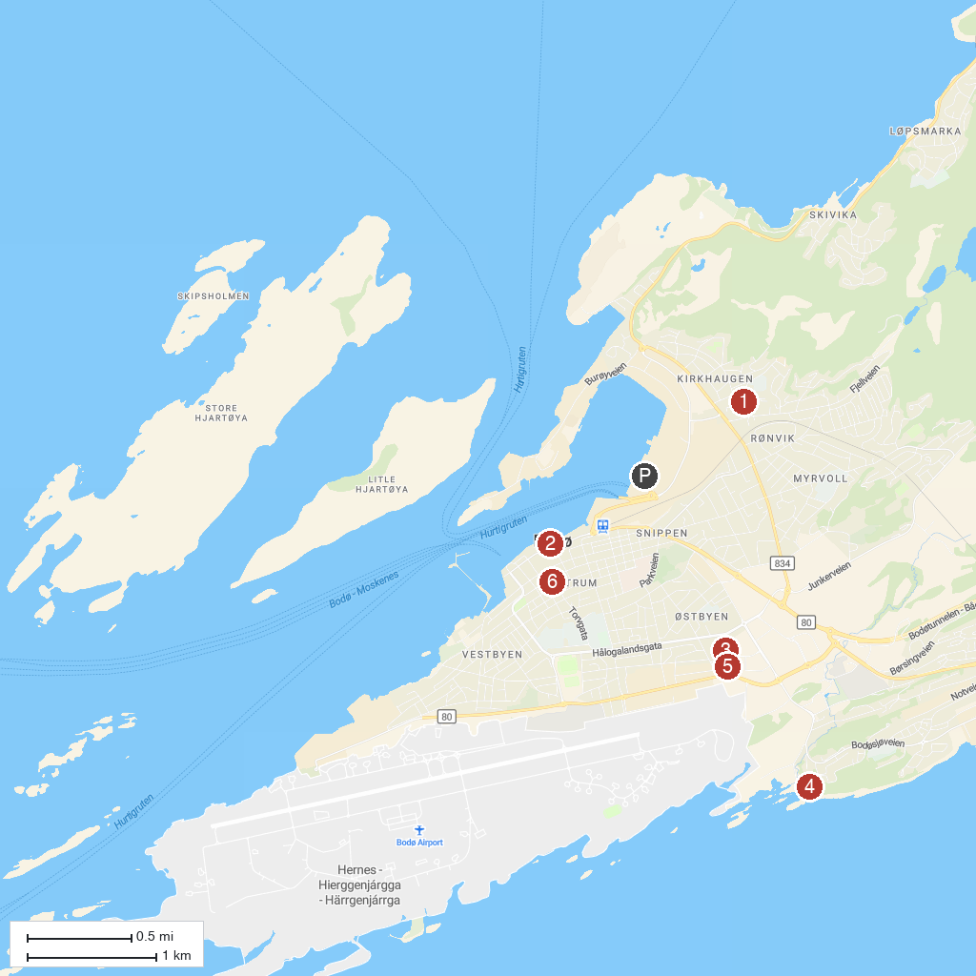
MAP KEY
1. Rønvik Church | 4. Nordlandsmuseet Bodøsjøen friluftsmuseum
2. Salmon Center Bodø | 5. Norwegian Aviation Museum
3. Nordlandsbadet | 6. Bodø Cathedral
P. Cruise port / terminal
Map © MapTiler © OpenStreetMap contributors · cruiseports.org

