Boa Vista Island, Cape Verde
Africa's windswept gem drops you onto a desert island where Saharan dunes meet turquoise Atlantic surf — and loggerhead turtles outnumber the tourists.
⚓ Tender port (no cruise pier) · 🕒 Typical call: 7-9 hrs · 💵 Cape Verdean Escudo (CVE) / Euros accepted · 🗣️ Portuguese (Kriolu widely spoken) · 🐢 Turtle nesting: July–October
✍️ MY DAY IN PORT (FILL IN)
Ship / Date
In port | arrive ______ · all aboard ______
Booked excursion
Notes / meeting point
GETTING ASHORE
- Docking: Anchor in Sal Rei Bay; tender to waterfront pier
- Walk to Center: < 2 min from tender pier to Sal Rei town
- Best For: Beaches, desert tours, snorkeling, turtle watching
- Don't Miss: Viana Desert quad tour & Cabo Santa Maria shipwreck
GETTING AROUND
- 🚕 Taxi: €10–€22 — Taxis are available at the port and can take you to Sal Rei (the main town) for around €10–€15. Prices may be quoted in
- 📱 Rideshare: ❌ not available
TOP THINGS TO DO
- Viana Desert Quad or Buggy Tour — Saharan sand carried by trade winds has built a true desert in the heart of Boa Vista.
- Santa Monica Beach Day — A roughly 18 km sweep of white sand on the island's southwest coast, consistently ranked one of Africa's finest beaches.
- Loggerhead Turtle Night Tour (Jul–Oct) — Boa Vista hosts one of the Atlantic's most important loggerhead sea-turtle nesting sites.
- Catamaran Snorkel & Swim — Sail around Sal Rei Bay past Djeu Island, snorkel over coral reefs and shipwreck debris, and swim in clear Atlantic waters.
- Sal Rei Town & Chapel Walk — Compact and walkable, Sal Rei has colonial-era architecture, a lively market, and the Igreja de Santa Isabel on the main square.
BEST WALKS
- Sal Rei Waterfront & Town Loop: 1.5 km · 25 min · Easy — From the tender pier stroll north along the waterfront past fishing boats, then into the small…
WEATHER · DAYLIGHT · MONEY
Month | High °F | Low °F | Rainy days
May | 78 | 69 | 0
Jul | 81 | 73 | 1
Sep | 85 | 77 | 8
Daylight: May 6:01AM–6:54PM · Jul 6:07AM–7:07PM · Sep 6:20AM–6:33PM
cruiseports.org/boa-vista-island · Confirm terminal & all-aboard time with your ship

Boa Vista Island, Cape Verde — Port Map
Red = walkable sights · Amber = excursions farther out · P = cruise terminal
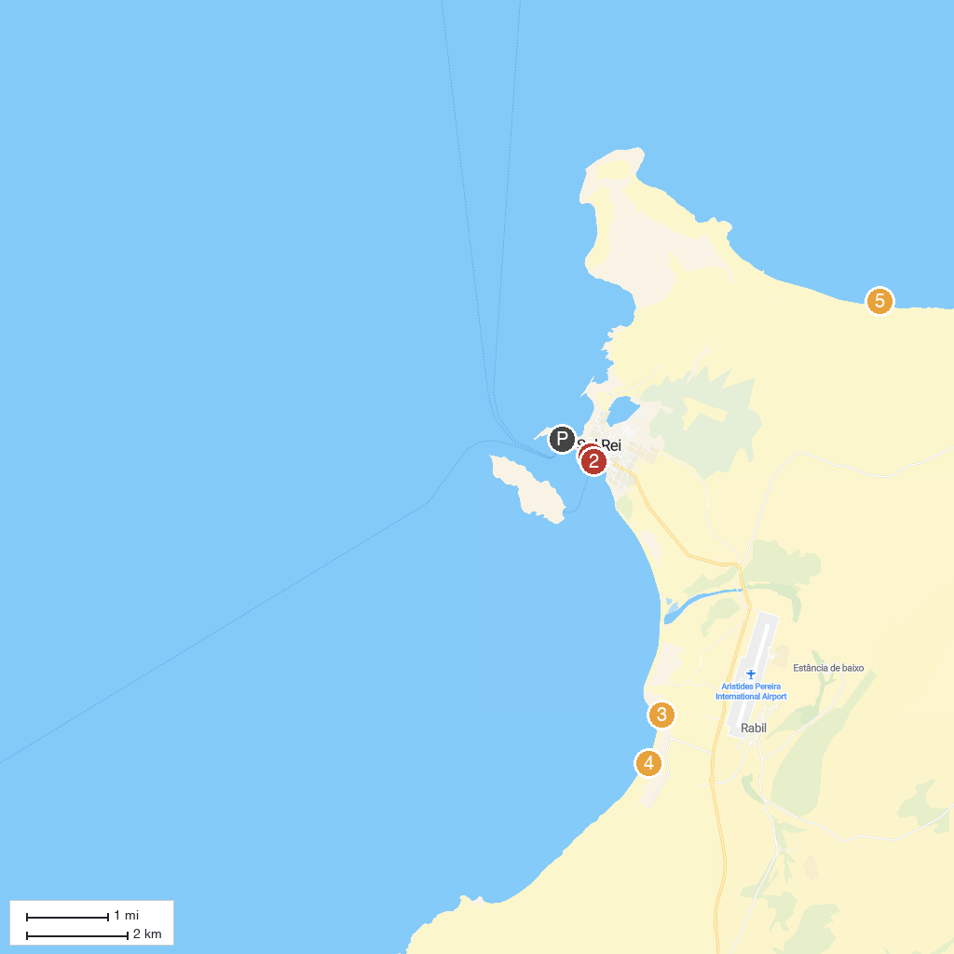
MAP KEY
1. sidy tours | 4. Praia de Chaves
2. Momo Tour Boavista Cap vert | 5. Praia da Atalanta
3. Chaminé de Chaves
P. Cruise port / terminal
Map © MapTiler © OpenStreetMap contributors · cruiseports.org

