Bluff, Southland, New Zealand
At the very bottom of New Zealand's South Island, Bluff punches well above its size — world-famous oysters, the iconic Stirling Point signpost, and ferry rides to pristine Stewart Island all start here.
⚓ Docked (commercial port) · 🕒 Typical call: 8-10 hrs · 💵 NZD (New Zealand Dollar) · 🗣️ English · 🦪 Oyster season: March–August
✍️ MY DAY IN PORT (FILL IN)
Ship / Date
In port | arrive ______ · all aboard ______
Booked excursion
Notes / meeting point
GETTING ASHORE
- Docking: Commercial port berths in Bluff Harbour; shuttle buses run to town centre (~2 km)
- Walk to centre: Town centre ~20 min walk or short shuttle from port gates
- Best For: Food lovers, nature seekers, end-of-the-earth bragging rights
- Don't Miss: Stirling Point signpost and Bluff oysters (if in season)
GETTING AROUND
- 🚕 Taxi: NZD $120–$150 — Taxis are available from the port to Invercargill city center (~22 min). Blue Star Taxis can be booked via the YourRide
- 📱 Rideshare: ✅ Uber
TOP THINGS TO DO
- Stirling Point & Bluff Hill — Walk or drive to the famous directional signpost at Stirling Point — the official end of SH1 — then continue up Bluff Hill…
- Stewart Island Ferry Day Trip — A 1-hour ferry from Bluff crosses Foveaux Strait to Rakiura National Park on Stewart Island — New Zealand's third-largest island.
- Bluff Oyster Tasting — Bluff oysters (Ostrea chilensis) are prized worldwide for their deep, briny flavour.
- Invercargill City & Transport World — Head 30 minutes north to Invercargill for Bill Richardson Transport World (300+ vehicles) and E Hayes Motorworks, home to Burt…
- The Catlins Wildlife & Coastal Drive — The rugged Catlins coast east of Bluff offers petrified forests at Curio Bay, Hector's dolphins, fur seals, and Slope Point — New…
BEST WALKS
- Stirling Point to Bluff Hill Lookout: 4 km return · 1.5 hrs · Easy–Moderate — From the town centre walk south along Foreshore Road to the iconic Stirling Point signpost, then…
- Bluff Heritage Trail Loop: ~5 km · 1.5-2 hrs · Easy (flat) — Self-guided walk linking 17 heritage markers around Bluff's compact streets, covering the town's…
WEATHER · DAYLIGHT · MONEY
Month | High °F | Low °F | Rainy days
May | 79 | 52 | 3
Jul | 96 | 71 | 2
Sep | 85 | 59 | 3
Daylight: May 6:09AM–8:20PM · Jul 6:10AM–8:37PM · Sep 7:00AM–7:25PM
cruiseports.org/bluff-invercargill-nz · Confirm terminal & all-aboard time with your ship

Bluff, Southland, New Zealand — Port Map
Red = walkable sights · Amber = excursions farther out · P = cruise terminal
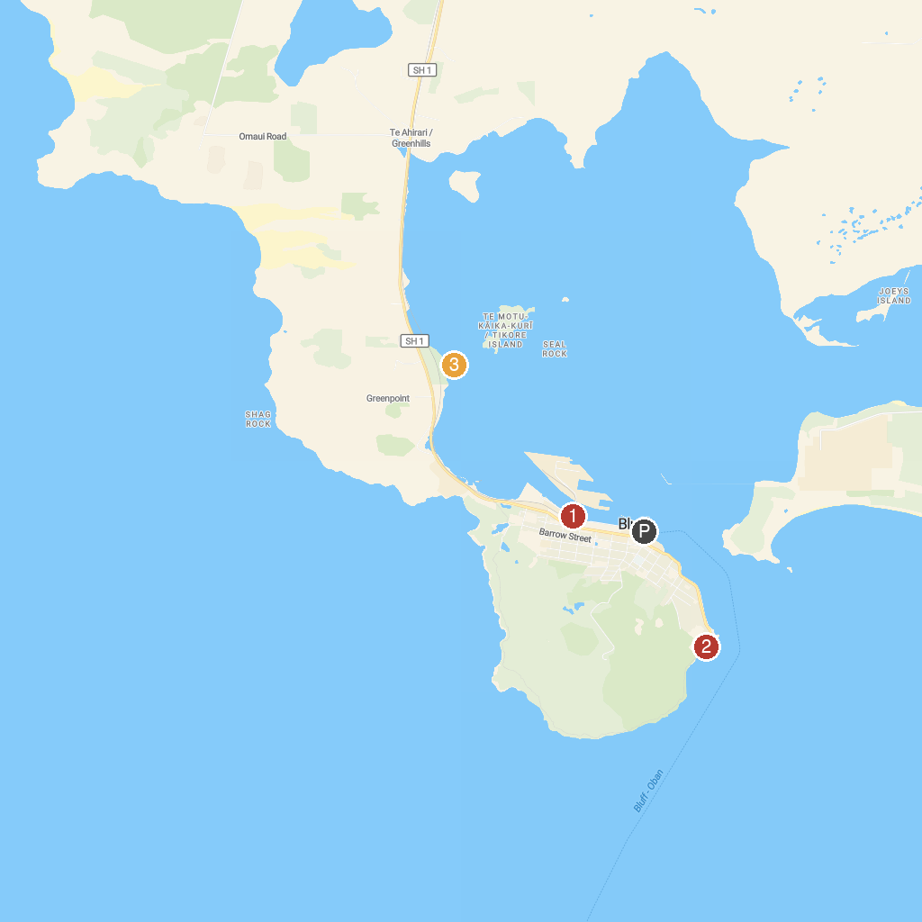
MAP KEY
1. Bluff Maritime Museum | 3. Greenpoint Ship Graveyard
2. Stirling Point
P. Cruise port / terminal
Map © MapTiler © OpenStreetMap contributors · cruiseports.org

