Block Island, Rhode Island, USA
A tiny island paradise off the Rhode Island coast, Block Island rewards its cruise visitors with dramatic clay bluffs, two historic lighthouses, pristine beaches, and miles of walking trails — all reachable by tender from Old Harbor.
⚓ Tender port (anchor off Old Harbor) · 🕒 Typical call: 6-8 hrs · 💵 USD · 🗣️ English · 🚲 Bikes & mopeds for hire
✍️ MY DAY IN PORT (FILL IN)
Ship / Date
In port | arrive ______ · all aboard ______
Booked excursion
Notes / meeting point
GETTING ASHORE
- Docking: Tender only — ships anchor and ferry passengers to Old Harbor pier
- Walk to Center: Old Harbor town is steps from the tender dock
- Best For: Beaches, lighthouse hiking, cycling, nature trails
- Don't Miss: Mohegan Bluffs & Southeast Lighthouse — 200-ft clay cliffs with ocean views
GETTING AROUND
- 🚕 Taxi: Zone-based fares; short trips ~$10–$20 — Over 30 licensed taxis operate on a zone-based system (no meters). Stands are located at Old Harbor ferry dock and New H
- 📱 Rideshare: ❌ not available
TOP THINGS TO DO
- Mohegan Bluffs & Southeast Lighthouse — Hike or bike to the dramatic 200-ft clay bluffs on the island's southeast coast.
- Clay Head Trail & The Maze — A 190-acre preserve on the northeast tip with bluff-top trails, a sandy beach, and an intriguing network of unmarked paths called…
- Bike or Moped the Whole Island — Rent a bike or moped at Old Harbor and loop the roughly 19-mile perimeter road, stopping at lighthouses, bluffs, and beaches.
- North Lighthouse & Sandy Point — The 1867 granite North Light sits at Sandy Point in the Block Island National Wildlife Refuge.
- Crescent Beach & Ballard's Beach — Two miles of sandy Atlantic coastline start just steps from Old Harbor.
BEST WALKS
- Old Harbor Town Walk: 1.5 miles • Easy • ~45 min — From the tender dock, stroll the historic Victorian-era waterfront: check out the Spring House…
- Mohegan Bluffs to Southeast Lighthouse: 1.5 miles loop • Easy-Moderate • ~1 hr (at bluffs) — From the bluffs parking area (reached by bike or taxi), walk the cliff-edge path above the 200-ft…
- Clay Head Nature Trail: ~5 miles round trip • Moderate • 2-2.5 hrs — Start at the Clay Head trailhead off Corn Neck Road.
WEATHER · DAYLIGHT · MONEY
Month | High °F | Low °F | Rainy days
May | 56 | 51 | 11
Jul | 72 | 68 | 9
Sep | 69 | 65 | 10
Daylight: May 5:28AM–7:57PM · Jul 5:27AM–8:17PM · Sep 6:27AM–6:54PM
cruiseports.org/block-island-ri · Confirm terminal & all-aboard time with your ship

Block Island, Rhode Island, USA — Port Map
Red = walkable sights · Amber = excursions farther out · P = cruise terminal
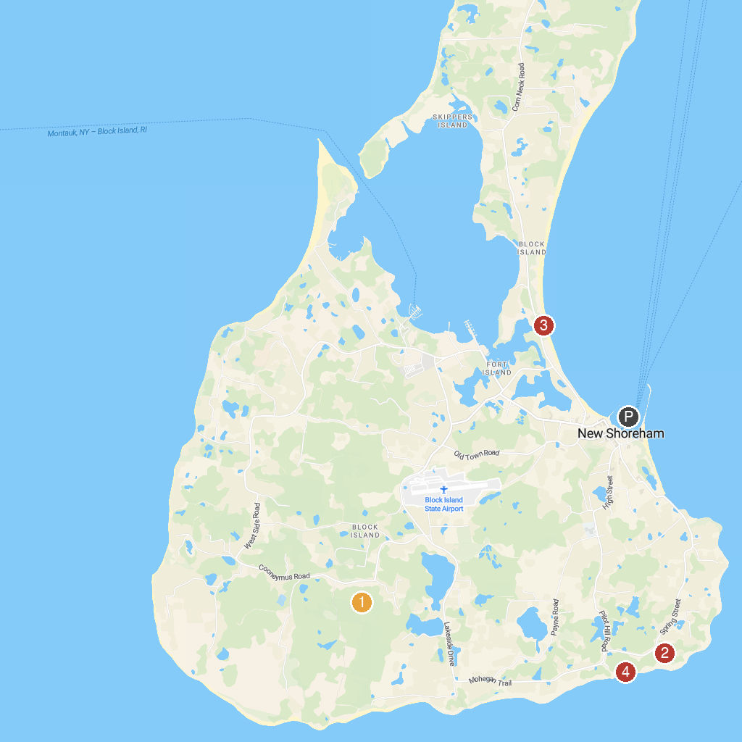
MAP KEY
1. Rodman's Hollow | 3. Frederick J. Benson Town Beach
2. Southeast Lighthouse | 4. Mohegan Bluffs
P. Cruise port / terminal
Map © MapTiler © OpenStreetMap contributors · cruiseports.org

